

NPVR BE

Design Specification V0.2

|  |  |
| --- | --- |
| Version: | 0.2 |
| Author: | Sube Singh |
| Contributors: | Rajesh Karna |

The document comprises 254 pages, all pages have version no 0.2

This issue was last saved on 16.07.2014 18:10.

This document was edited with MS WinWord version 11.0.

The filename of the main document file was E:\Projects\IPTV\NPVRBE_New\SVN_Sub_Project5-NPVR BE\Development\D-Spec\DSpec_NPVR BE V0.2.doc.

.

Copyright © 2014 Accenture

All rights reserved.

Confidential and Proprietary.

The reproduction, transmission or use of this code/document or its contents

is not permitted without prior express written consent of Accenture.

Offenders will be liable for damages. All rights, including but not

limited to rights created by patent grant or registration of a utility

model or design, are reserved.

Accenture reserves the right to modify technical specifications and features.

Technical specifications and features are binding only insofar as they

are specifically and expressly agreed upon in a written contract.

0 General Information 12

0.1 History 12

0.2 References 12

0.3 Tables and Figures 12

0.4 Keyword/Descriptor 17

1 Introduction 18

1.1 Document organization 18

2 Related FR 19

2.1 NPVR backend 19

2.1.1 Scope 19

2.1.2 Assumptions, Restrictions and Limitation: 19

2.1.3 Open points 19

3 Overview 20

3.1 NPVR backend 20

3.1.1 Architecture 20

3.1.2 Technical Data 21

3.1.2.1 Technical Solution Description 21

3.2 Component Interaction 23

4 Object Model 24

4.1 Use Case Modeling 24

4.1.1 Integrating nPVR BE with IM 24

4.1.2 Configuring nPVR backend settings 25

4.1.3 Configuring Media Type Profiles 26

4.1.4 Configuring Channels at nPVR BE 28

4.1.5 Removing channels from nPVR BE 30

4.1.6 nPVR user create request 31

4.1.7 nPVR user update request 33

4.1.8 nPVR user delete request 35

4.1.9 Add nPVR Recording Request 36

4.1.10 Update nPVR Recording Request 40

4.1.11 Delete nPVR Recordings Request 42

4.1.12 Get User Recordings Request 44

4.1.13 Stop nPVR Recording Request 45

4.1.14 Add nPVR Series Request 47

4.1.15 Update nPVR Series Request 51

4.1.16 Delete nPVR Series Request 53

4.1.17 Get Series Request 55

4.1.18 Get Recordings Request 56

4.1.19 Creating nPVR Reports 58

4.1.20 Processing Schedule updates 59

4.1.21 Processing Series updates 61

4.1.22 Processing program metadata updates 63

4.1.23 Receiving notifications from nPVR Mediator 66

4.1.23.1 Receiving notifications for RecordingDetailsUpdate 66

4.1.23.2 Receiving notifications for RecordingStatus 67

4.1.24 Reprocessing of recordings on channel update 68

4.1.25 Notifications to IM on User recording update 69

4.1.26 Get Metadata 70

4.1.27 Get User Quota 71

4.2 Use case modeling for NPVR BE Components and Processes 73

4.2.1 Communication with nPVR Mediator 73

4.2.1.1 Create Recording 73

4.2.1.2 Delete Recording 75

4.2.1.3 Update Recording 76

4.2.1.4 Recording Status 77

4.2.1.5 Recording Details Update 78

4.2.2 Background Processes 79

4.2.2.1 Manage Expired Recording Cleanup 79

4.2.2.2 nPVR User Quota Check Process 81

4.2.2.3 nPVR Failed Recordings Retrial Process 83

4.2.2.4 Reprocessing of Recordings on Channel Configuration Update 84

4.2.2.5 Manage Channel update and User update changes 85

4.3 NPVR Backend Interfaces 87

4.3.1 GUI Windows 87

4.3.2 Distributed Interface 87

4.3.3 Messages 87

4.3.4 General Concepts 87

4.3.4.1 Categories of Interfaces 87

4.3.4.2 Communication and Security 87

4.3.4.3 Error Responses 88

4.3.4.4 Standard HTTP Status Codes 88

4.3.5 Management Interfaces 88

4.3.6 External Interfaces 88

4.3.7 User Interfaces 89

4.4 Class Modeling 89

4.4.1 nPVR BE Framework 89

4.4.1.1 Converter Classes 91

4.4.1.2 Handler Classes 91

4.4.1.3 Processor Classes 92

4.4.2 nPVR BE Quota Check Classes 92

4.4.3 nPVR BE Dao Classes 93

4.4.4 nPVR BE Backend BL Classes 94

4.4.5 nPVR BE Middleware Interface Classes 95

5 Implementation 96

5.1 Integrating nPVR BE with IM 96

5.1.1 Flow Diagram 96

5.1.2 Sequence Diagram 97

5.1.3 Business Logic 97

5.1.3.1 com.acn.servlet.NPVRServlet.java 97

5.1.3.2 com.acn.application.processors.ChainProcessor.java 98

5.1.3.3 com.acn.handler.system.RegistrationHandler.java 98

5.1.3.4 com.acn.util.JAXBUtil.java 98

5.1.3.5 com.acn.beans.services.impl.ContextManagementBeanImpl.java 99

5.1.4 Objects to lock 100

5.1.5 Exceptions 100

5.1.5.1 com.acn.exceptions.BusinessException.java 100

5.1.5.2 com.acn.exceptions.ConversionException.java 100

5.1.5.3 com.acn.exceptions.HandlerConfigurationException.java 101

5.1.5.4 com.acn.exceptions.HandlerException.java 101

5.1.5.5 com.acn.exceptions.InvalidParameterFormatException.java 101

5.1.5.6 com.acn.exceptions.InvalidParameterValueException.java 101

5.1.5.7 com.acn.exceptions.ParameterException.java 101

5.1.5.8 com.acn.exceptions.ParameterRequiredException.java 102

5.1.5.9 com.acn.exceptions.UserException.java 102

5.1.5.10 com.acn.exceptions.ValidationException.java 102

5.1.6 Database Classes 102

5.1.6.1 com.acn.beans.dao.impl.ContextDaoImpl.java 102

5.2 Configuring nPVR backend settings 104

5.2.1 Flow Diagram 104

5.2.2 Sequence Diagram 105

5.2.3 Business Logic 106

5.2.3.1 com.acn.servlet.NPVRServlet.java 106

5.2.3.2 com.acn.application.processors 106

5.2.3.3 com.acn.handler.system.SystemConfigurationHandler.java 106

5.2.3.4 com.acn.util.JAXBUtil.java 106

5.2.3.5 com.acn.beans.services.impl.ContextManagementBeanImpl.java 106

5.2.4 Objects to lock 106

5.2.5 Exceptions 106

5.2.6 Database Classes 107

5.2.6.1 com.acn.beans.dao.impl.ContextDaoImpl.java 107

5.3 Configuring Media Type Profiles 108

5.3.1 Flow Diagram 108

5.3.2 Sequence Diagram 109

5.3.3 Business Logic 110

5.3.3.1 com.acn.servlet.NPVRServlet.java 110

5.3.3.2 com.acn.application.processors 110

5.3.3.3 com.acn.handler.system.SystemConfigurationHandler.java 110

5.3.3.4 com.acn.util.JAXBUtil.java 110

5.3.3.5 com.acn.beans.services.impl.ContextManagementBeanImpl.java 110

5.3.4 Objects to lock 110

5.3.5 Exceptions 110

5.3.6 Database Classes 110

5.3.6.1 com.acn.beans.dao.impl.ContextDaoImpl.java 110

5.4 Configuring Channels at nPVR BE 111

5.4.1 Flow Diagram 111

5.4.2 Sequence Diagram 112

5.4.3 Business Logic 113

5.4.3.1 com.acn.servlet.NPVRServlet.java 113

5.4.3.2 com.acn.application.processors 113

5.4.3.3 com.acn.handler.system.ChannelConfigurationHandler.java 113

5.4.3.4 com.acn.util.JAXBUtil.java 113

5.4.3.5 com.acn.beans.services.ChannelManagementBeanImpl.java 113

5.4.4 Objects to lock 114

5.4.5 Exceptions 114

5.4.6 Database Classes 115

5.4.6.1 com.acn.beans.dao.ChannelDaoImpl.java 115

5.5 Removing channels from nPVR BE 116

5.5.1 Flow Diagram 116

5.5.2 Sequence Diagram 117

5.5.3 Business Logic 117

5.5.3.1 com.acn.servlet.NPVRServlet.java 117

5.5.3.2 com.acn.application.processors 117

5.5.3.3 com.acn.handler.system.ChannelConfigurationHandler.java 117

5.5.3.4 com.acn.util.JAXBUtil.java 118

5.5.3.5 com.acn.beans.services.ChannelManagementBeanImpl 118

5.5.4 Objects to lock 118

5.5.5 Exceptions 118

5.5.6 Database Classes 118

5.5.6.1 com.acn.beans.dao.ChannelDaoImpl.java 118

5.6 nPVR user create request 119

5.6.1 Flow Diagram 119

5.6.2 Sequence Diagram 120

5.6.3 Business Logic 120

5.6.3.1 com.acn.servlet.NPVRServlet.java 120

5.6.3.2 com.acn.application.processors 120

5.6.3.3 com.acn.handler.system.UserConfigurationHandler.java 120

5.6.3.4 com.acn.util.JAXBUtil.java 121

5.6.3.5 com.acn.beans.services.UserManagementBeanImpl.java 121

5.6.4 Objects to lock 122

5.6.5 Exceptions 122

5.6.6 Database Classes 122

5.6.6.1 com.acn.beans.dao.UserDaoImpl.java 122

5.7 nPVR user update request 123

5.7.1 Flow Diagram 123

5.7.2 Sequence Diagram 124

5.7.3 Business Logic 124

5.7.3.1 com.acn.servlet.NPVRServlet.java 124

5.7.3.2 com.acn.application.processors 124

5.7.3.3 com.acn.handler.system.UserConfigurationHandler.java 125

5.7.3.4 com.acn.util.JAXBUtil.java 125

5.7.3.5 com.acn.beans.services.UserManagementBeanImpl.java 125

5.7.4 Objects to lock 125

5.7.5 Exceptions 125

5.7.6 Database Classes 125

5.7.6.1 com.acn.beans.dao.UserDaoImpl.java 125

5.8 nPVR user delete request 126

5.8.1 Flow Diagram 126

5.8.2 Sequence Diagram 127

5.8.3 Business Logic 127

5.8.3.1 com.acn.servlet.NPVRServlet.java 127

5.8.3.2 com.acn.application.processors 127

5.8.3.3 com.acn.handler.system.UserConfigurationHandler.java 127

5.8.3.4 com.acn.util.JAXBUtil.java 127

5.8.3.5 com.acn.beans.services.UserManagementBeanImpl.java 128

5.8.4 Objects to lock 128

5.8.5 Exceptions 128

5.8.6 Database Classes 128

5.8.6.1 com.acn.beans.dao.UserDaoImpl.java 128

5.9 Add nPVR Recording Request 129

5.9.1 Flow Diagram 129

5.9.2 Sequence Diagram 130

5.9.3 Business Logic 130

5.9.3.1 com.acn.servlet.NPVRServlet.java 130

5.9.3.2 com.acn.application.processors 130

5.9.3.3 com.acn.handler.user.UserHandler.java 130

5.9.3.4 com.acn.util.JAXBUtil.java 131

5.9.3.5 com.acn.beans.services.impl.RecordingBeanImpl 132

5.9.3.6 com.acn.communication.middleware.MiddlewareCommunicator.java 134

5.9.3.7 com.acn.util.RecordingUtil.java 134

5.9.3.8 com.acn.beans.services.impl.ContextManagementBeanImpl.java 137

5.9.4 Objects to lock 137

5.9.5 Exceptions 137

5.9.6 Database Classes 138

5.9.6.1 com.acn.beans.dao.impl.RecordingDaoImpl.java 138

5.10 Update nPVR Recording Request 140

5.10.1 Flow Diagram 140

5.10.2 Sequence Diagram 141

5.10.3 Business Logic 141

5.10.3.1 com.acn.servlet.NPVRServlet.java 141

5.10.3.2 com.acn.application.processors 141

5.10.3.3 com.acn.handler.user.UserHandler.java 141

5.10.3.4 com.acn.beans.services.impl.RecordingBeanImpl.java 142

5.10.4 Objects to lock 142

5.10.5 Exceptions 142

5.10.6 Database Classes 142

5.10.6.1 com.acn.beans.dao.impl.RecordingDaoImpl.java 142

5.11 Delete nPVR Recording Request 143

5.11.1 Flow Diagram 143

5.11.2 Sequence Diagram 144

5.11.3 Business Logic 144

5.11.3.1 com.acn.servlet.NPVRServlet.java 144

5.11.3.2 com.acn.application.processors 144

5.11.3.3 com.acn.handler.user.UserHandler.java 144

5.11.3.4 com.acn.util.JAXBUtil.java 145

5.11.3.5 com.acn.beans.services.impl.RecordingBeanImpl.java 145

5.11.4 Objects to lock 145

5.11.5 Exceptions 145

5.11.6 Database Classes 145

5.11.6.1 com.acn.beans.dao.impl.RecordingDaoImpl.java 145

5.12 Get User Recordings Request 146

5.12.1 Flow Diagram 146

5.12.2 Sequence Diagram 147

5.12.3 Business Logic 147

5.12.3.1 com.acn.servlet.NPVRServlet.java 147

5.12.3.2 com.acn.application.processors 147

5.12.3.3 com.acn.handler.user.UserHandler.java 147

5.12.3.4 com.acn.beans.services.impl.RecordingBeanImpl.java 147

5.12.4 Objects to lock 148

5.12.5 Exceptions 148

5.12.6 Database Classes 149

5.13 Stop nPVR Recording Request 149

5.13.1 Flow Diagram 149

5.13.2 Sequence Diagram 150

5.13.3 Business Logic 150

5.13.3.1 com.acn.servlet.NPVRServlet.java 150

5.13.3.2 com.acn.application.processors 150

5.13.3.3 com.acn.handler.user.UserHandler.java 150

5.13.3.4 com.acn.beans.services.impl.RecordingBeanImpl.java 151

5.13.4 Objects to lock 151

5.13.5 Exceptions 151

5.13.6 Database Classes 151

5.13.6.1 com.acn.beans.dao.impl.RecordingDaoImpl.java 151

5.14 Add nPVR Series Request 152

5.14.1 Flow Diagram 152

5.14.2 Sequence Diagram 153

5.14.3 Business Logic 153

5.14.3.1 com.acn.servlet.NPVRServlet.java 153

5.14.3.2 com.acn.application.processors 153

5.14.3.3 com.acn.handler.user.UserHandler.java 154

5.14.3.4 com.acn.beans.services.impl.RecordingBeanImpl.java 154

5.14.4 Objects to lock 154

5.14.5 Exceptions 154

5.14.6 Database Classes 154

5.14.6.1 com.acn.beans.dao.impl.RecordingDaoImpl.java 154

5.15 Update nPVR Series Request 155

5.15.1 Flow Diagram 155

5.15.2 Sequence Diagram 156

5.15.3 Business Logic 157

5.15.3.1 com.acn.servlet.NPVRServlet.java 157

5.15.3.2 com.acn.application.processors 157

5.15.3.3 com.acn.handler.user.UserHandler.java 157

5.15.3.4 com.acn.beans.services.impl.RecordingBeanImpl.java 157

5.15.4 Objects to lock 157

5.15.5 Exceptions 157

5.15.6 Database Classes 157

5.15.6.1 com.acn.beans.dao.impl.RecordingDaoImpl.java 157

5.16 Delete nPVR Series Request 158

5.16.1 Flow Diagram 158

5.16.2 Sequence Diagram 159

5.16.3 Business Logic 159

5.16.3.1 com.acn.servlet.NPVRServlet.java 159

5.16.3.2 com.acn.application.processors 160

5.16.3.3 com.acn.handler.user.UserHandler.java 160

5.16.3.4 com.acn.beans.services.impl.RecordingBeanImpl.java 160

5.16.4 Objects to lock 160

5.16.5 Exceptions 160

5.16.6 Database Classes 160

5.16.6.1 com.acn.beans.dao.impl.RecordingDaoImpl.java 160

5.17 Get Series Request 161

5.17.1 Flow Diagram 161

5.17.2 Sequence Diagram 162

5.17.3 Business Logic 162

5.17.3.1 com.acn.servlet.NPVRServlet.java 162

5.17.3.2 com.acn.application.processors 162

5.17.3.3 com.acn.handler.user.UserHandler.java 162

5.17.3.4 com.acn.beans.services.impl.RecordingBeanImpl.java 163

5.17.4 Objects to lock 163

5.17.5 Exceptions 163

5.17.6 Database Classes 163

5.18 Get Recordings Request 164

5.18.1 Flow Diagram 164

5.18.2 Sequence Diagram 165

5.18.3 Business Logic 165

5.18.3.1 com.acn.servlet.NPVRServlet.java 165

5.18.3.2 com.acn.application.processors 165

5.18.3.3 com.acn.handler.user.UserHandler.java 165

5.18.3.4 com.acn.beans.services.impl.RecordingBeanImpl.java 166

5.18.4 Objects to lock 166

5.18.5 Exceptions 166

5.18.6 Database Classes 166

5.19 Creating nPVR Reports 166

5.19.1 Get Physical Recording List 166

5.19.1.1 Flow Diagram 167

5.19.1.2 Sequence Diagram 168

5.19.1.3 Business Logic 168

5.19.1.4 Objects to lock 170

5.19.1.5 Exceptions 170

5.19.1.6 Database Classes 170

5.19.1.7 com.acn.beans.dao.ReportDaoImpl.java 170

5.19.2 Get System Recording List 171

5.19.2.1 Flow Diagram 172

5.19.2.2 Sequence Diagram 173

5.19.2.3 Business Logic 173

5.19.2.4 Objects to lock 174

5.19.2.5 Exceptions 174

5.19.2.6 Database Classes 174

5.19.2.7 com.acn.beans.dao.ReportDaoImpl.java 174

5.19.3 Get System Series Recording List 174

5.19.3.1 Flow Diagram 175

5.19.3.2 Sequence Diagram 176

5.19.3.3 Business Logic 176

5.19.3.4 Objects to lock 177

5.19.3.5 Exceptions 177

5.19.3.6 Database Classes 177

5.19.3.7 com.acn.beans.dao.ReportDaoImpl.java 177

5.19.4 Get User Recording List 177

5.19.4.1 Flow Diagram 178

5.19.4.2 Sequence Diagram 179

5.19.4.3 Business Logic 179

5.19.4.4 Objects to lock 180

5.19.4.5 Exceptions 180

5.19.4.6 Database Classes 180

5.19.4.7 com.acn.beans.dao.ReportDaoImpl.java 180

5.19.5 Get User Series Recording List 180

5.19.5.1 Flow Diagram 181

5.19.5.2 Sequence Diagram 182

5.19.5.3 Business Logic 182

5.19.5.4 Objects to lock 183

5.19.5.5 Exceptions 183

5.19.5.6 Database Classes 183

5.19.5.7 com.acn.beans.dao.ReportDaoImpl.java 183

5.20 Processing Schedule updates 184

5.20.1 Flow Diagram 184

5.20.2 Sequence Diagram 185

5.20.3 Business Logic 186

5.20.3.1 com.acn.handler.system.EventUpdateHandler 186

5.20.3.2 com.acn.servlet.NPVRServlet.java 186

5.20.3.3 com.acn.application.processors 186

5.20.3.4 com.acn.beans.services.impl.BackgroundTaskBeanImpl.java 186

5.20.3.5 com.acn.beans.services.EventUpdateBeanImpl.java 188

5.20.4 Objects to lock 188

5.20.5 Exceptions 189

5.20.6 Database Classes 189

5.21 Processing Series updates 190

5.21.1 Flow Diagram 190

5.21.2 Sequence Diagram 191

5.21.3 Business Logic 192

5.21.3.1 com.acn.handler.system.EventUpdateHandler 192

5.21.3.2 com.acn.servlet.NPVRServlet.java 192

5.21.3.3 com.acn.application.processors 192

5.21.3.4 com.acn.beans.services.impl.BackgroundTaskBeanImpl 192

5.21.3.5 com.acn.beans.services.EventUpdateBeanImpl 192

5.21.4 Objects to lock 192

5.21.5 Exceptions 192

5.21.6 Database Classes 192

5.22 Processing program metadata updates 193

5.22.1 Flow Diagram 193

5.22.2 Sequence Diagram 194

5.22.3 Business Logic 194

5.22.3.1 com.acn.handler.system.EventUpdateHandler.java 194

5.22.3.2 com.acn.servlet.NPVRServlet.java 195

5.22.3.3 com.acn.application.processors 195

5.22.3.4 com.acn.beans.services.impl.BackgroundTaskBeanImpl.java 195

5.22.3.5 com.acn.beans.services.EventUpdateBeanImpl.java 195

5.22.4 Objects to lock 195

5.22.5 Exceptions 195

5.22.6 Database Classes 195

5.23 Receiving notifications from nPVR Mediator 195

5.23.1 Receiving notifications for RecordingDetailsUpdate 195

5.23.1.1 Flow Diagram 195

5.23.1.2 Sequence Diagram 197

5.23.1.3 Business Logic 197

5.23.1.4 Objects to lock 198

5.23.1.5 Exceptions 198

5.23.1.6 Database Classes 198

5.23.2 Receiving notifications for RecordingStatus 199

5.23.2.1 Flow Diagram 199

5.23.2.2 Sequence Diagram 200

5.23.2.3 Business Logic 200

5.23.2.4 Objects to lock 201

5.23.2.5 Exceptions 201

5.23.2.6 Database Classes 201

5.24 Reprocessing of recordings on channel update 201

5.24.1 Flow Diagram 201

5.24.2 Sequence Diagram 201

5.24.3 Business Logic 201

5.24.3.1 com.acn.servlet.NPVRServlet.java 201

5.24.3.2 com.acn.application.processors 201

5.24.4 Objects to lock 201

5.24.5 Exceptions 202

5.24.6 Database Classes 203

5.25 Notifications to IM on User recording update 203

5.25.1 Flow Diagram 203

5.25.2 Sequence Diagram 204

5.25.3 Business Logic 204

5.25.3.1 com.acn.servlet.NPVRServlet.java 204

5.25.3.2 com.acn.application.processors 204

5.25.4 Objects to lock 205

5.25.5 Exceptions 205

5.25.6 Database Classes 205

5.26 Get Meta Data 206

5.26.1 Flow Diagram 206

5.26.2 Sequence Diagram 207

5.26.3 Business Logic 207

5.26.3.1 com.acn.servlet.NPVRServlet.java 207

5.26.3.2 com.acn.application.processors 207

5.26.3.3 com.acn.beans.dao.impl.RecordingDaoImpl.java 208

5.26.4 Objects to lock 208

5.26.5 Exceptions 208

5.26.6 Database Classes 208

5.27 Get User Quota 209

5.27.1 Flow Diagram 209

5.27.2 Sequence Diagram 210

5.27.3 Business Logic 210

5.27.3.1 com.acn.servlet.NPVRServlet.java 210

5.27.3.2 com.acn.application.processors 210

5.27.3.3 com.acn.handler.user.UserHandler.java 210

5.27.3.4 com.acn.beans.services.impl.RecordingBeanImpl.java 211

5.27.4 Objects to lock 211

5.27.5 Exceptions 211

5.27.6 Database Classes 211

5.28 Implementation for NPVR BE Components and Processes 211

5.28.1 Communication with nPVR Mediator 212

5.28.1.1 Create Recording 212

5.28.1.2 Delete Recording 215

5.28.1.3 Update Recording 218

5.28.1.4 Recording Status 220

5.28.1.5 Recording Details Update 222

5.28.2 Background Processes 225

5.28.2.1 Manage expired recording cleanup 225

5.28.2.2 nPVR user quota check process 228

5.28.2.3 nPVR Failed Recordings Retrial Process 230

5.28.2.4 Reprocessing of recordings on Channel Configuration update 233

5.28.2.5 Manage Channel update and User update changes 234

6 Configuration 235

6.1 JBoss 7.1.1 Configuration 235

6.1.1 Running JBoss 7 235

6.1.2 JBoss 7 – Standalone/Clustered Mode Deployment 236

6.2 MySQL Configuration 237

6.3 Trigger Server External Configuration 239

6.3.1 JBoss 7 - JMS configuration 239

6.3.2 JBoss 7 - Logging Configuration 239

6.3.3 JBoss 7 – Interfaces and Ports Configuration 239

6.3.4 JBoss 7 – Security Settings 240

7 Imported Interfaces 241

8 Database Migration/Upgrade 242

8.1 nPVR BE Data Model 243

8.1.1 Schema 244

8.1.2 Tables 244

8.1.3 DB Script 249

8.1.4 Database Patch 249

9 Installation 250

9.1 nPVR BE Deployment 250

10 Unit Tests 253

11 Design Specification Reviewers List & Template 254

# General Information

## History

|  |  |  |
| --- | --- | --- |
| **Version** | **Date** | **Reason for Changes** |
| 0.1 | 02-07-2014 | Initial Draft. |
| 0.2 | 14-07-2014 | Incorporated internal review comments |

Table 1: History

## References

|  |  |
| --- | --- |
| **No.** | **Reference** |
| 1 | NPVR Backend Functional Specifiation IUS (1.3)  https://teamforge.rsystems.com/sf/go/doc10031?nav=1 |
| 2 | RSpec_nPVR_Draft_V1 5_changemarks.docx  https://teamforge.rsystems.com/sf/go/doc10078?nav=1 |

Table 2: References

## Tables and Figures

**Figure 1:** Architecture 19

**Figure 2:** Component Interaction Diagram 22

**Figure 3:** Integrating nPVR BE with IM 23

**Figure 4:** Configuring nPVR backend settings 24

**Figure 5:** Configuring Media Type Profiles 25

**Figure 6:** Configuring Channels at nPVR BE 27

**Figure 7:** Removing channels from nPVR BE 29

**Figure 8:** nPVR user create request 30

**Figure 9:** nPVR user update request 32

**Figure 10:** nPVR user delete request 34

**Figure 11:** Add nPVR Recording Request 35

**Figure 12:** Update nPVR Recording Request 39

**Figure 13:** Delete nPVR Recordings Request 41

**Figure 14:** Get User Recordings Request 43

**Figure 15:** Stop nPVR Recording Request 44

**Figure 16:** Add nPVR Series Request 46

**Figure 17:** Update nPVR Series Request 50

**Figure 18:** Delete nPVR Series Request 52

**Figure 19:** Get Series Request 54

**Figure 20:** Get Recordings Request 55

**Figure 21:** Creating nPVR Reports 57

**Figure 22:** Processing Schedule updates 58

**Figure 23:** Processing Series updates 60

**Figure 24:** Processing program metadata updates 62

**Figure 25:** Receiving notifications for RecordingDetailsUpdate 65

**Figure 26:** Receiving notifications for RecordingStatus 66

**Figure 27:** Reprocessing of recordings on channel update 67

**Figure 28:** Notifications to IM on User recording update 68

**Figure 29:** Get Metadata 69

**Figure 30:** Get User Quota 70

**Figure 31:** Communication with nPVR Mediator for Create Recording 72

**Figure 32:** Communication with nPVR Mediator for Delete Recording 74

**Figure 33:** Communication with nPVR Mediator for Update Recording 75

**Figure 34:** Communication with nPVR Mediator for Recording Status 76

**Figure 35:** Communication with nPVR Mediator for Recording Details Update 77

**Figure 36:** Manage Expired Recording Cleanup 78

**Figure 37:** nPVR User Quota Check Process 80

**Figure 38:** nPVR Failed Recording Retrial Process 82

**Figure 39:** Reprocessing of Recording on Channel Configuration update 83

**Figure 40:** nPVR BE RequestHandler classes 89

**Figure 41:** Converter Classes 90

**Figure 42:** Handler Classes 90

**Figure 43:** Processor Classes 91

**Figure 44:** nPVR BE Quota Check Classes 91

**Figure 45:** Business Layer Dao Classes 92

**Figure 46:** nPVR BE Backend BL Classes 93

**Figure 47:** nPVR BE Middleware Interface Classes 94

**Figure 48:** Flow Diagram: Integrating nPVR BE with IM 95

**Figure 49:** Sequence Diagram: Integrating nPVR BE with IM 96

**Figure 50:** Flow Diagram: Configuring nPVR backend settings 102

**Figure 51:** Sequence Diagram: Configuring nPVR backend settings 103

**Figure 52:** Flow Diagram: Configuring Media Type Profiles 106

**Figure 53:** Sequence Diagram: Configuring Media Type Profiles 107

**Figure 54:** Flow Diagram: Configuring Channels at nPVR BE 109

**Figure 55:** Sequence Diagram: Configuring Channels at nPVR BE 111

**Figure 56:** Flow Diagram: Removing channels from nPVR BE 114

**Figure 57:** Sequence Diagram: Removing channels from nPVR BE 115

**Figure 58:** Flow Diagram: nPVR user create request 117

**Figure 59:** Sequence Diagram: nPVR user create request 118

**Figure 60:** Flow Diagram: nPVR user update request 121

**Figure 61:** Sequence Diagram: nPVR user update request 122

**Figure 62:** Flow Diagram: nPVR user delete request 124

**Figure 63:** Sequence Diagram: nPVR user delete request 125

**Figure 64:** Flow Diagram: Add nPVR Recording Request 127

**Figure 65:** Sequence Diagram: Add nPVR Recording Request 128

**Figure 66:** Flow Diagram: Update nPVR Recording Request 136

**Figure 67:** Sequence Diagram: Update nPVR Recording Request 137

**Figure 68:** Flow Diagram: Delete nPVR Recording Request 139

**Figure 69:** Sequence Diagram: Delete nPVR Recording Request 140

**Figure 70:** Flow Diagram: Get User Recordings Request 142

**Figure 71:** Sequence Diagram: Get User Recordings Request 143

**Figure 72:** Flow Diagram: Stop nPVR Recording Request 145

**Figure 73:** Sequence Diagram: Stop nPVR Recording Request 146

**Figure 74:** Flow Diagram: Add nPVR Series Request 148

**Figure 75:** Sequence Diagram: Add nPVR Series Request 149

**Figure 76:** Flow Diagram: Update nPVR Series Request 151

**Figure 77:** Sequence Diagram: Update nPVR Series Request 152

**Figure 78:** Flow Diagram: Delete nPVR Series Request 154

**Figure 79:** Sequence Diagram: Delete nPVR Series Request 155

**Figure 80:** Flow Diagram: Get Series Request 157

**Figure 81:** Sequence Diagram: Get Series Request 158

**Figure 82:** Flow Diagram: Get Recordings Request 160

**Figure 83:** Sequence Diagram: Get Recordings Request 161

**Figure 84:** Flow Diagram: Get Physical Recording List 163

**Figure 85:** Sequence Diagram: Get Physical Recording List 164

**Figure 86:** Flow Diagram: Get System Recording List 167

**Figure 87:** Sequence Diagram: Get System Recording List 168

**Figure 88:** Flow Diagram: Get System Series Recording List 172

**Figure 89:** Sequence Diagram: Get System Series Recording List 173

**Figure 90:** Flow Diagram: Get User Recording List 177

**Figure 91:** Sequence Diagram: Get User Recording List 178

**Figure 92:** Flow Diagram: Get User Series Recording List 182

**Figure 93:** Sequence Diagram: Get User Series Recording List 183

**Figure 94:** Flow Diagram: Processing Schedule updates 187

**Figure** **95**: Sequence Diagram: Processing Schedule updates 189

**Figure 96:** Flow Diagram: Processing Series updates 192

**Figure 97:** Sequence Diagram: Processing Series updates 193

**Figure 98:** Flow Diagram: Processing program metadata updates 195

**Figure 99:** Sequence Diagram: Processing program metadata updates 196

**Figure 100:** Flow Diagram: Receiving notifications for RecordingDetailsUpdate 198

**Figure 101:** Sequence Diagram: Receiving notifications for RecordingDetailsUpdate 199

Figure 102: Flow Diagram: Receiving notifications for RecordingStatus 203

**Figure 103:** Sequence Diagram: Receiving notifications for RecordingStatus 204

**Figure 104:** Flow Diagram: Notifications to IM on User recording update 207

**Figure 105:** Sequence Diagram: Notifications to IM on User recording update 208

**Figure 106:** Flow Diagram: Get Meta Data 211

**Figure 107:** Sequence Diagram: Get Meta Data 212

**Figure 108:** Flow Diagram: Get User Quota 214

**Figure 109:** Sequence Diagram: Get User Quota 215

**Figure 110:** Flow Diagram: Communication with nPVR Mediator for Create Recording 217

**Figure 111:** Sequence Diagram: Create Recording 218

**Figure 112:** Flow Diagram: Communication with nPVR Mediator for Delete Recording 220

**Figure 113:** Sequence Diagram: Delete Recording 221

**Figure 114:** Flow Diagram: Communication with nPVR Mediator for Update Recording 223

**Figure 115:** Sequence Diagram: Update Recording 224

**Figure 116:** Flow Diagram: nPVR Mediator communication with BE for Recording Status 225

**Figure 117:** Sequence Diagram: Recording Status 226

**Figure 118:** Flow Diagram: nPVR Mediator communication with BE for Recording Detail Update 227

**Figure 119:** Sequence Diagram: Recording Details Update 228

**Figure 120:** Flow Diagram: Manage expired recording cleanup 230

**Figure 121:** Sequence Diagram: Manage expired recording cleanup 231

**Figure 122:** Flow Diagram: nPVR user quota check process 233

**Figure 123:** Sequence Diagram: nPVR user quota check process 234

**Figure 124:** Flow Diagram: nPVR Failed recordings retrial process 235

**Figure 125:** Sequence Diagram: nPVR Failed recordings retrial process 236

**Figure 126:** Flow Diagram: Reprocessing of recordings on Channel configuration update 238

**Figure 127:** Directory structure of JBoss 7.1.1 Final 240

**Figure 128:** Contents of module – com.mysql.main 241

**Figure 129:** Contents of module – org.apache.xmlrpc.main 241

**Figure 130:** Datasource configuration in standalone-full.xml / standalone-full-ha.xml243

**Figure 131** JMS Queue Settings 245

**Figure 132:** JBoss - Logging Configuration 245

**Figure 133:** JBoss Interfaces and Port settings (in standalone-full.xml/standalone-full-ha.xml) 245

**Figure 134:** Cluster Settings 246

**Figure 135** Jboss Availability from different machine 246

**Figure 136**: Security Settings 246

**Figure 137:** nPVRBE Unit Test 259

Table 1: History 12

Table 2: References 12

Table 3: Abbreviations 17

Table 4: Standard HTTP Status Codes 88

Table 5: NPVRServlet.java 98

Table 6: ChainProcessor.java 98

Table 7: RegistrationHandler.java 98

Table 8: JAXBUtil.java 99

Table 9: ContextManagementBeanImpl.java 100

Table 10: BusinessException.java 100

Table 11: ConversionException.java 101

Table 12: HandlerConfigurationException.java 101

Table 13: HandlerException.java 101

Table 14: InvalidParameterFormatException.java 101

Table 15: InvalidParameterValueException.java 101

Table 16: ParameterException.java 102

Table 17: ParameterRequiredException.java 102

Table 18: UserException.java 102

Table 19: ValidationException.java 102

Table 20: ContextDaoImpl.java 103

Table 21: SystemConfigurationHandler.java 106

Table 22: ChannelConfigurationHandler.java 113

Table 23: ChannelManagementBeanImpl.java 114

Table 24 : ChannelDaoImpl.java 115

Table 25 : U UserConfigurationHandler.java 121

Table 26 : UserManagementBeanImpl.java 122

Table 27 : UserDaoImpl.java 122

Table 28: UserHandler.java 131

Table 29: RecordingBeanImpl.java 134

Table 30: MiddlewareCommunicator.java 134

Table 31: RecordingUtil.java 137

Table 32: RecordingDaoImpl.java 139

Table 33: ReportHandler.java 169

Table 34: ReportsBeanImpl.java 170

Table 35: ReportDaoImpl.java 171

Table 36: EventUpdateHandler.java 186

Table 37: BackgroundTaskBeanImpl.java 188

Table 38: EventUpdateBeanImpl.java 188

Table 39: RecordingServerServlet.java 197

Table 40: RecordingServlerHandler.java 198

Table 41: BackgroundProcess.java 227

Table 42: MidnightProcess.java 227

Table 43: QuotaCheckProcess.java 229

Table 44: FailedRecordRetryProcess.java 232

Table 45: DB Migration effects 242

Table 46: nPVR Backend Scheme properties 244

Table 47: Attachement: DB Script - nPVR Backend 249

Table 48: Unit Tests 253

Glossary and Abbreviations

|  |  |
| --- | --- |
| DB | Database |
| IM | Integrated Middleware |
| HTTP | Hypertext Transport Protocol |
| IP | Internet Protocol |
| IPTV | Internet Protocol Television |
| API | Application Programming Interface |
| EPG | Electronic Program Guide |
| MDP | Media Distribution Profile |
| SOAP | Simple Object Access Protocol |
| OCI | Open Client Interface |
| OPI | Open Portal Interface |
| OTT | Over-The-Top, means media delivery via unmanaged IP networks |
| MTP | Media Type Profile |
| TM | Total Manage |
| UI | User Interface |
| NPVR | Network based Person Video Recorder |
| URL | Universal Resource Locator |
| AVS | Accenture Video Solution |
| BL | Business Layer |
| DAL | Data Access Layer |
|  |  |

Table 3: Abbreviations

## Keyword/Descriptor

# Introduction

This document is the "System Design Specification" for New NPVR BE project and it joins all feature design contributions from the engineering group.

This document is comprisesed of all the design information that will drive the implementation phase of NPVR BE.

## Document organization

The feature requirements expected by the development will be restricted to include the project FRs mentioned in RS and FS (FSpec_IPTV4.0_nPVR Backend IUS 1.3_TrackChanges.docx).

Regarding the document contributions it is expected from development that the features to be realized be distributed considering the design phase:

- Analysis, consisting in the “FSpec_IPTV4.0_nPVR Backend IUS 1.3_TrackChanges.docx" contributions, meaning chapters:  
 General Information  
 Introduction  
 Related FR  
 Object Model (excluding only the Use Cases subchapter Class Diagram)  
 Exported Interfaces  
 Imported Interfaces  
  
- Design, consisting in the remaining "Design Specification" contributions, meaning chapters:  
 Object Model (only the Use Cases subchapter Class Diagram)  
 Implementation  
 Configuration  
 Database Migration/Upgrade  
 Installation  
  
See document chapter "History" for more information.

# Related FR

This chapter describes in brief how the FR is interpreted and what are impacts on the involved sub systems.

## NPVR backend

NPVR BE application is a standalone application to cater NPVR functionality for different systems.

This document outlines the design, structure and communication among the objects to fulfil the requirement from a new backend component to provide the nPVR services.

### Scope

The scope of the document is to provide a detailed design of the NPVR BE in terms of use case, structure of the class and communication among themselves as per the functionality defined in the functional specification. The below overall use cases is considered in the design document however a detailed use case analysis and its sequence provided.

* User recordings
* Series recordings
* Impact on recordings due to EPG Event update
* nPVR background processes
* IPTV and Multiscreen nPVR based on several Media Type Profiles (MTPs).
* Limiting nPVR usage by nPVR users based on following considerations.
  + User nPVR quota
  + Number of concurrent recordings permitted to user

### Assumptions, Restrictions and Limitation:

* This document covers only the implementation of nPVR backend and does not consider any impacts on any middleware being integrated with nPVR BE.
* nPVR BE shall never interact directly with end-user client applications. It will always receive requests redirected from IM.
* In AVS IPTV solution, Security options like Macrovision are not in use after HE 3.0. Hence the security settings are ignored in nPVR BE implementation.
* The time in IM and nPVR BE should be synchronized. The IM will maintain the time difference between nPVR BE and itself. The requests received and response sent by nPVR BE would always be synchronized with nPVR BE time zone.
* This document does not cover the implementation of IM.

### Open points

None

# Overview

## NPVR backend

### Architecture

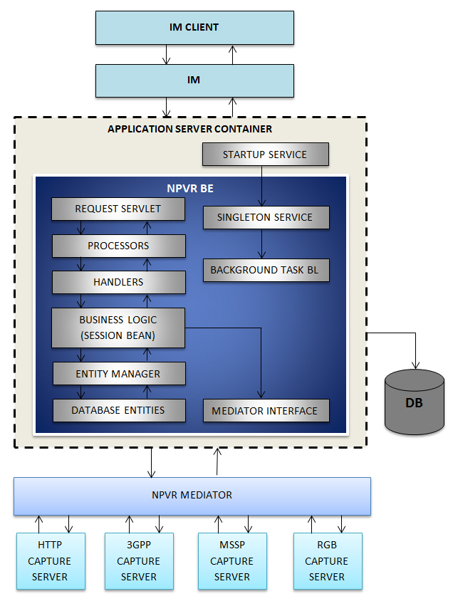

**Figure 1:** Architecture

### Technical Data

NPVR BE does not have any front-end interface and its main interaction points will be its backend web servlets.

* NPVR BE component is hosted on JBoss7 application server.
* NPVR BE data store is a partitioned MySQL DB.

NPVR BE Software Stack consists of:

* JBoss Application Server 7.1.1 final
* MySQL 5.6.19
* Java 1.07.0_55
* Servlets 3.0.1
* Hibernate JPA 2.0
* Maven 3.0.4
* Log4j 1.2.17
* TestNG 6.8
* Mockito 1.9.5

#### Technical Solution Description

* NPVRServlet is the controller and it receives all the requests on NPVR BE and forwards the request to appropriate Handler using processors based on the request context in the URL.
* Validation filter validates all request parameters and throws error message for invalid parameter values.
* Processors process the parameters and identify the appropriate handler. Converter Processor convert parameters to the expected types. ErrorInvokerProcessor handles the call to the error method of a handler. InvokerProcessor is responsible for actually invoking the handler method. JaxbProcessor is responsible for marshalling JAXB responses. MethodFindingProcessor is responsible for finding the method that matches the request. ParameterProcessor is responsible for retrieving parameters from the request.
* Handler works an interface to access Business Layer. It also validates post request body and looks up session bean and call appropriate business method. Build response as per response format(XML/Object)
* Session bean performs required business logic. Prepares the input for data access layer and calls the appropriate DAO methods.
* BL converts the DAL layer response data into an appropriate Value Object and propagates it back to the Handler.
* SessionBeanDao handle accesses the database, to get data model, find record, peform commit, persist, rollback operations with the help EntityManager.java.
* Handler then transforms the VO into a JAXB/required Object and sends response back to the JAXBProcessor. Finally JAXBProcessor gives the response to the NPVRServlet.

## Component Interaction

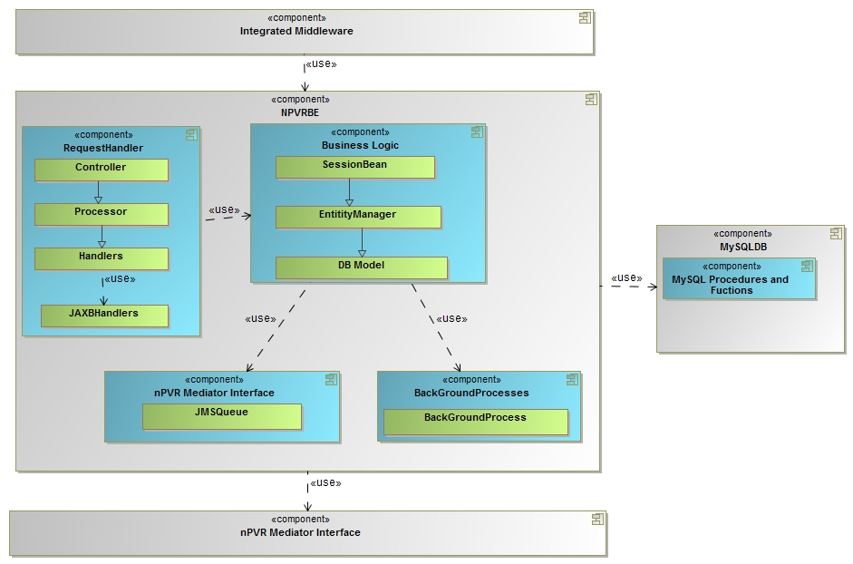

**Figure 2:** Component Interaction Diagram

# Object Model

## Use Case Modeling

### Integrating nPVR BE with IM

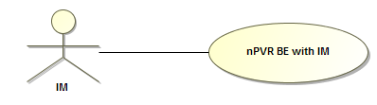

**Figure 3:** Integrating nPVR BE with IM

|  |  |
| --- | --- |
| **Actor** | IM |
| **Information** | This use case describes the flow of events occurring at nPVR BE for IM registration. |
| **Pre-Condition** | 1. nPVR BE is up and running. 2. The requesting IM is still not registered in nPVR BE. |
| **Flow of events from TM** | 1. nPVR BE receives a HTTP post request from IM on servlet for IM registration with request parameters ContextId in the URL, and  Server Name, Communication Address, Callback Required in the request body. The request body should be according to RegisterMiddlewareRequest.xsd. The ResponseFormat may also come in the request. 2. On receiving this request the servlet will call processors for method finding, parameter validations, and error handling. 3. The processors forward this request to respective handler which further delegates this request to BL. 4. BL verifies contextId of the requesting IM with the help of DAL, if it is not registered in SERVERCONTEXT table of nPVR BE, BL would use DAL to insert a record into the SERVERCONTEXT. 5. On successfully completing the step 1 to 4 the servlet at nPVR BE would acknowledge requesting IM with 200 OK HTTP responses. |
| **Alternative Flow of Events** | None |
| **Post-Condition** | Once the IM is registration process is completed nPVR BE shall accept all the nPVR requests from that IM with default settings. |
| **Exception** | If the IM tries to register itself with an existing context Id then the request would be declined with an error code NBE011 and error message stating that ‘Context Id already exists in nPVR BE’. |
| **Reference** | FSpec_IPTV4.0_nPVR Backend IUS 1.3.docx |

### Configuring nPVR backend settings

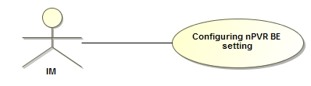

**Figure 4:** Configuring nPVR backend settings

|  |  |
| --- | --- |
| **Actor(s)** | IM |
| **Information** | This use case describes the flow of events occurring at nPVR BE for nPVR backend settings corresponding to an IM. |
| **Pre-Condition** | 1. nPVR BE is up and running. 2. The context id of the requesting IM already exists in nPVR BE database. |
| **Flow of events** | 1. nPVR BE receives a HTTP post request from IM on servlet for nPVR backend settings with request parameters ContextId and ReponseFormat in request header, and parameters Indefinite Retention, nPVR Keep Days, Pre Minutes, Post Minutes, Enable Start Stop Mark, Concurrent Recordings Limit, nPVR Finite Retention Timestamp, Keep Failed Recording Days, Http Recording Path, Smooth Streaming Recording Path, 3gpp Recording Path in the request body. The request body should be according to SystemConfigurationRequest.xsd 2. On receiving this request the servlet will call processors for method finding, parameter validations, and error handling. 3. The processors forward this request to respective handler which further delegates this request to BL. 4. BL verifies contextId of the requesting IM with the help of DAL, if it is registered in SERVERCONTEXT table of nPVR BE. 5. BL verifies by using DAL if existing entry of settings for requesting IM context id is already present in DB then the settings will be updated and stored in table SYSTEMCONFIG in DB. 6. If existing entry of settings for requesting IM context id is not present in DB then new settings shall be submitted into the SYSTEMCONFIG table in database against the context Id. 7. On successfully completing the step 1 to 6 the servlet at nPVR BE would acknowledge requesting IM with 200 OK HTTP responses. |
| **Post Condition** | 1. For all the further requests new/updated setting parameters will be used. |
| **Alternative flow of events** | 1. None of the settings are mandatory and therefore if the IM configures/updates only some of the properties then the default values will be used for rest of the nPVR properties. 2. BL checks if value of indefinite retention is being updated from true to false and IM does not provide the NPVR Finite Retention Timestamp in the request then, nPVR BE should populate this field itself with current time at nPVR BE. |
| **Exception** | 1. If requested context id is not present in DB then request shall be declined with and error code NBE001 and error message ‘No context exists for requesting middleware’. |
| **Reference** | FSpec_IPTV4.0_nPVR Backend IUS 1.3.docx |

### Configuring Media Type Profiles

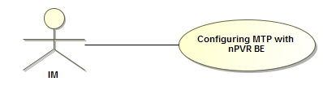

**Figure 5:** Configuring Media Type Profiles

|  |  |
| --- | --- |
| **Actor(s)** | IM |
| **Information** | This use case describes the flow of events occurring at nPVR BE for Media Type Profile settings corresponding to an IM. |
| **Pre-Condition** | 1. nPVR BE is up and running. 2. The context id of the requesting IM already exists in nPVR BE database. |
| **Flow of events** | 1. nPVR BE receives a HTTP post request from IM on servlet for Media Type Profile configuration with request parameters ContextId and ReponseFormat in request header, and parameters External Id, Transport Protocol, Bit Rate, NPVR Keep Days, Included MTPs in the request body. The request body should be according to SystemConfigurationRequest.xsd 2. On receiving this request the servlet will call processors for method finding, parameter validations, and error handling. 3. The processors forward this request to respective handler which further delegates this request to BL. 4. BL verifies contextId of the requesting IM with the help of DAL, if it is registered in SERVERCONTEXT table of nPVR BE. 5. BL verifies by using DAL if media type profiles for the corresponding context Id is not present in MEDIATYPEPROFILES table then provided MTPs will be submitted in MEDIATYPEPROFILES table in DB for requesting contextId. 6. If MTPs already exist for the context Id then the existing MTP list will over ridden by the new MTP list. All the existing MTPs will be replaced by new MTPs in MEDIATYPEPROFILES table in DB for requesting contextId. 7. On successfully completing the step 1 to 6 the servlet at nPVR BE would acknowledge requesting IM with 200 OK HTTP response. |
| **Post Condition** | 1. The new MTPs stored in database shall be used for all the requests and will be applicable on new recordings only. |
| **Alternative flow of events** | N/A |
| **Exception** | 1. If requested context id is not present in DB then request shall be declined with an error code and error message ‘No context exists for requesting middleware’. 2. BL checks if any of the included MTPs is not defined in the same request then the whole request would be declined with an error code NBE015 and error message ‘Included MTP is not defined’. 3. MTP inclusion criteria is also checked at BL layer:    1. If an included MTP and parent MTP are in same recording sub-system then request shall be declined with an error code NBE012 and error message ‘Included MTP does not follow the inclusion criteria’.    2. If an included MTP is including any other MTP for requested context then request shall be declined with an error code NBE012 and error message ‘Included MTP does not follow the inclusion criteria’..    3. If an included MTP is included in another parent MTP for requesting context then request shall be declined with an error code NBE012 and error message ‘Included MTP does not follow the inclusion criteria’.. |
| **Reference** | FSpec_IPTV4.0_nPVR Backend IUS 1.3.docx |

### Configuring Channels at nPVR BE

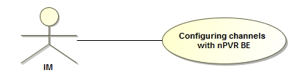

**Figure 6:** Configuring Channels at nPVR BE

|  |  |
| --- | --- |
| **Actor(s)** | IM |
| **Information** | This use case describes the flow of events occurring at nPVR BE for configuration of channel/s, corresponding channel streams and included channels. |
| **Pre-Condition** | 1. nPVR BE is up and running. 2. The context id of the requesting IM already exists in nPVR BE database. |
| **Flow of events** | 1. nPVR BE receives a HTTP post request from IM on servlet for channel/s configuration(add/update) with request parameters ContextId and ReponseFormat in request header, OpCode in request URL, and parameters Channel External Id, Enable nPVR, Enable Trick play, Enable Skip Jump, Language, Channel Streams, Included Channels in the request body. The request body should be according to ChannelConfigurationRequest.xsd. 2. On receiving this request the servlet will call processors for method finding, parameter validations, and error handling. 3. The processors forward this request to respective handler which further delegates this request to BL. 4. BL verifies contextId of the requesting IM with the help of DAL, if it is registered in SERVERCONTEXT table of nPVR BE. 5. BL verifies the existence of channel settings for the corresponding context Id by using DAL. 6. If existing entry of channel for requesting IM context id is already present in DB then the channel will be completely over written by the new channel settings in CHANNEL, CHANNELSTREAM, CHANNELSTREAMMAPPING, and INCLUDEDCHANNELS tables. 7. If existing entry of channel for requesting IM context id is not present in DB then the new channel details shall be stored in CHANNEL, CHANNELSTREAM, CHANNELSTREAMMAPPING, and INCLUDEDCHANNELS tables into the database against the context Id. 8. After successfully completing the step 1 to 7 the servlet at nPVR BE would acknowledge requesting IM with 200 OK HTTP responses. |
| **Post Condition** | 1. nPVR BE shall be equipped to process the request from IM on configured channels. |
| **Alternative flow of events** | None |
| **Exception** | 1. If requested context id is not present in DB then request shall be declined with an error code NBE001 and error message ‘No context exists for requesting middleware’. 2. If any of the channel streams have a media type which is not configured for the IM then nPVR BE would throw an error with an error code NBE010 and error message ‘Unsupported media type’. 3. If any of the included channels do not exist in nPVR BE for the requesting context and even is not defined in the same request then the request for the including channel would be declined with an error code NBE013 and error message ‘Included channel does not exist’. 4. If any of the channel streams contains a MTP, and its child MTP is also assigned to any other channel stream of the same channel then request for that channel would be declined with an error code NBE014 and error message ‘Channel streams does not follow the MTP inclusion criteria’. |
| **Reference** | FSpec_IPTV4.0_nPVR Backend IUS 1.3.docx |

### Removing channels from nPVR BE

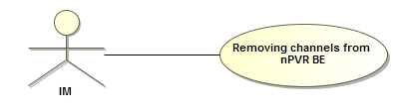

**Figure 7:** Removing channels from nPVR BE

|  |  |
| --- | --- |
| **Actor(s)** | IM |
| **Information** | This use case describes the flow of events occurring at nPVR BE for removal of channel/s configurations. |
| **Pre-Condition** | 1. nPVR BE is up and running. 2. The context id of the requesting IM already exists in nPVR BE database. |
| **Flow of events** | 1. nPVR BE receives a HTTP post request from IM on servlet for channel/s removal with request parameters ContextId and ReponseFormat in request header, OpCode in request URL, and parameters Channel External Id in the request body. The request body should be according to RemoveChannelRequest.xsd. 2. On receiving this request the servlet will call processors for method finding, parameter validations, and error handling. 3. The processors forward this request to respective handler which further delegates this request to BL. 4. BL verifies contextId of the requesting IM with the help of DAL, if it is registered in SERVERCONTEXT table of nPVR BE. 5. BL verifies the existence of channel settings for the corresponding context Id by using DAL. 6. If existing entry of channel for requesting IM context id is already present in DB then the channel is removed from database(from CHANNEL, CHANNELSTREAM, CHANNELSTREAMMAPPING, and INCLUDEDCHANNELS tables). 7. All the recordings on the channel finished, ongoing or future recordings are removed from tables SYSTEMNPVRRECORDING, USERNPVRRECORDING, SYSTEMNPVRSERIESRECORDING, USERNPVRSERIESRECORDING, and NPVRASSET. 8. nPVR BE will send the instructed not to record any future recording on this channel to Mediator. 9. After successfully completing the step 1 to 5 the servlet at nPVR BE would acknowledge requesting IM with 200 OK HTTP responses. |
| **Post Condition** | 1. The channel is removed from DB and thus nPVR BE would no longer process any recording requests on this channel. |
| **Alternative flow of events** | None |
| **Exception** | 1. If nPVR BE receives a request for a context which does not exist at its end then the request shall be declined with an error code NBE001 and error message stating ‘No context exists for requesting middleware’. 2. If the channel does not exist for the requesting IM then request for that channel would be declined with an error code NBE029 and error message ‘Channel does not exist.’ |
| **Reference** | FSpec_IPTV4.0_nPVR Backend IUS 1.3.docx |

### nPVR user create request

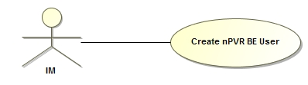

**Figure 8:** nPVR user create request

|  |  |
| --- | --- |
| **Actor(s)** | IM |
| **Information** | This use case describes the flow of events occurring at nPVR BE for creation of nPVR user/s |
| **Pre-Condition** | 1. nPVR BE is up and running. 2. The context id of the requesting IM already exists in nPVR BE database. |
| **Flow of events** | 1. nPVR BE receives a HTTP post request from IM on servlet for user/s creation with request parameters ContextId and ReponseFormat in request header, OpCode in request URL, and parameters Account Id, Series Enabled, Concurrent Recordings Limit, Total Minutes, Associated Channel list, NPVR Keep Days in the request body. The request body should be according to NPVRAddUserConfigurationRequest.xsd 2. On receiving this request the servlet will call processors for method finding, parameter validations, and error handling. 3. The processors forward this request to respective handler which further delegates this request to BL. 4. BL verifies contextId of the requesting IM with the help of DAL, if it is registered in SERVERCONTEXT table of nPVR BE. 5. BL verifies by using DAL if user detail for the corresponding context Id is not present in NPVRUSERDETAILS table then provided user/s will be submitted in NPVRUSERDETAILS table in DB for requesting contextId. 6. On successfully completing the step 1 to 5 the servlet at nPVR BE would acknowledge requesting IM with 200 OK HTTP responses. |
| **Post Condition** | 1. For all the further user recordings the newly created user will be used, their quota and maximum concurrent recordings will be evaluated. |
| **Alternative flow of events** | N/A |
| **Exception** | 1. If requested context id is not present in DB then request shall be declined with an error code NBE001 and error message ‘No context exists for requesting middleware’. 2. If any of the parameter is missing then it will throw errors with an error code NBE005 and error message ‘Mandatory parameter missing: {0}’ as all the above parameters are mandatory. 3. If the user already exists in nPVR BE database for the given context then an error is thrown with and error code NBE008 and error message ‘User already exists’. 4. If the number of users in the request exceed the configured maximum limit then nPVR BE shall throw an error code NBE009 and error message ‘Number of users exceed the maximum limit’. |
| **Reference** | FSpec_IPTV4.0_nPVR Backend IUS 1.3.docx |

### nPVR user update request

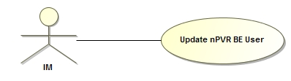

**Figure 9:** nPVR user update request

|  |  |
| --- | --- |
| **Actor(s)** | IM |
| **Information** | This use case describes the flow of events occurring at nPVR BE for updating of nPVR user/s |
| **Pre-Condition** | 1. nPVR BE is up and running. 2. The context id of the requesting IM already exists in nPVR BE database. |
| **Flow of events** | 1. nPVR BE receives a HTTP post request from IM on servlet for user/s updating with request parameters ContextId and ReponseFormat in request header, OpCode in request URL, and parameters Account Id, Series Enabled, Concurrent Recordings Limit, Total Minutes, Keep Failed Recording Days, NPVR Keep Days, Discontinue NPVR, Remove recordings for channel list/Associated Channel list in the request body. The request body should be according to NPVRUpdateUserConfigurationRequest.xsd. 2. On receiving this request the servlet will call processors for method finding, parameter validations, and error handling. 3. The processors forward this request to respective handler which further delegates this request to BL. 4. BL verifies contextId of the requesting IM with the help of DAL, if it is registered in SERVERCONTEXT table of nPVR BE. 5. BL verifies by using DAL if user detail for the corresponding context Id is present in NPVRUSERDETAILS table then provided user/s will be updated in NPVRUSERDETAILS table in DB for requesting contextId. 6. If value of discontinue NPVR is ‘All’ in the request then all the recordings of the user from USERNPVRRECORDING table will be removed and user quota will be updated to 0 in TotalMinutes column of NPVRUSERDETAILS table to disable any further recordings. 7. If value of discontinue NPVR is ‘Future’ in the request then only the future recordings of user from USERNPVRRECORDING table will be removed and user quota will be updated to 0 in TotalMinutes column of NPVRUSERDETAILS table to disable any further recording. 8. If Series Enabled parameter is updated to false then all the future series recordings shall be cancelled and user shall not be able to schedule any series recordings any further. 9. Channel exclusion for subscriber/s:   9.1 All the future recordings for subscriber/s on requested excluded channel shall be cancelled in USERNPVRRECORDING table.  9.2 All the ongoing recordings for subscriber/s on requested excluded channel shall be stopped and marked as Incomplete in USERNPVRRECORDING table.   1. On successfully completing the step 1 to 10 the servlet at nPVR BE would acknowledge requesting IM with 200 OK HTTP responses. |
| **Post Condition** | 1. The new user detail shall be used to evaluate user recordings w.r.t. their quota and maximum concurrent recordings. |
| **Alternative flow of events** | N/A |
| **Exception** | 1. If requested context id is not present in DB then request shall be declined with and error code NBE001 and error message ‘No context exists for requesting middleware’. 2. An error is thrown if requested user for the context id is not present in nPVR database with an error code NBE007 and error message ‘User does not exist’. 3. An error is thrown with an error code NBE005 and error message ‘Mandatory parameter missing: {0}’ if any of the mandatory parameters are missing. 4. If the number of users in the request exceed the configured maximum limit then nPVR BE shall throw an error with error code NBE009 and error message ‘Number of users exceed the maximum limit’. |
| **Reference** | FSpec_IPTV4.0_nPVR Backend IUS 1.3.docx |

### nPVR user delete request

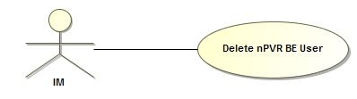

**Figure 10:** nPVR user delete request

|  |  |
| --- | --- |
| **Actor(s)** | IM |
| **Information** | This use case describes the flow of events occurring at nPVR BE for deletion of nPVR user/s |
| **Pre-Condition** | 1. nPVR BE is up and running. 2. The context id of the requesting IM already exists in nPVR BE database. |
| **Flow of events** | 1. nPVR BE receives a HTTP post request from IM on servlet for user/s deletion with request parameters ContextId and ReponseFormat in request header, OpCode in request URL, and parameters Account Id, of user in the request body. The request body should be according to NPVRRemoveUserConfigurationRequest.xsd. 2. On receiving this request the servlet will call processors for method finding, parameter validations, and error handling. 3. The processors forward this request to respective handler which further delegates this request to BL. 4. BL verifies contextId of the requesting IM with the help of DAL, if it is registered in SERVERCONTEXT table of nPVR BE. 5. BL verifies by using DAL if user detail for the corresponding context Id is present in NPVRUSERDETAILS table then provided user/s will be deleted from NPVRUSERDETAILS table and user recordings from table USERNPVRRECORDING. 6. On successfully completing the step 1 to 5 the servlet at nPVR BE would acknowledge requesting IM with 200 OK HTTP responses. |
| **Post Condition** | 1. nPVR BE shall not entertain any more recording specific requests for this user any more. |
| **Alternative flow of events** | N/A |
| **Exception** | 1. If requested context id is not present in DB then request shall be declined with and error code NBE001 and error message ‘No context exists for requesting middleware’. 2. An error is thrown if requested user for the context id is not present in nPVR database with an error code NBE007 and error message ‘‘User does not exist’. |
| **Reference** | FSpec_IPTV4.0_nPVR Backend IUS 1.3.docx |

### Add nPVR Recording Request

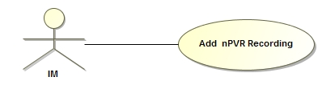

**Figure 11:** Add nPVR Recording Request

|  |  |
| --- | --- |
| **Actor(s)** | IM |
| **Information** | This use case describes the flow of events occurring at nPVR BE for scheduling an individual recording. This interface can be used to schedule multiple user recordings for a subscriber. |
| **Pre-Condition** | 1. The nPVR BE should be up and running. 2. The ContextId of the requesting IM should be available in nPVR BE database. 3. The following validation is not required to perform at nPVR BE:    1. User has valid nPVR subscription.    2. Channel is nPVR enabled.    3. Program is not blocked for nPVR.    4. Requested schedule is a valid. |
| **Flow of events** | 1. At nPVR BE the servlet receives a request from IM for scheduling an individual recording with request parameters OpCode and AccountId in the URL, ContextId and ResponseFormat in the header and ChannelExternalId, ProgramId, ProgramStartTime, and DeleteWhenSpaceNeeded in the request body. The request body should be according to NPVRAddRecordingsRequest.xsd. 2. On receiving this request the servlet will call processors for method finding, parameter validations, error handling. 3. The processor forwards this request to respective handler which further delegates this request to BL. 4. BL verifies context ID of the requesting IM if it is registered in SERVERCONTEXT table of nPVR BE database through data access layer. 5. BL would retrieve user details from NPVRUSERDETAILS table through data access layer on the basis of user AccountId provided through request and ContextId of requesting IM. 6. BL would retrieve channel details from CHANNEL table through data access layer on the basis of ChannelExternalId provided through request and ContextId of requesting IM. 7. BL would retrieve CONCURRENTRECORDINGSLIMIT from user details through data access layer. If CONCURRENTRECORDINGSLIMIT is not defined for the user it will retrieve the same from SYSTEMCONFIG table. After retrieving CONCURRENTRECORDINGSLIMIT the BL checks the concurrent recording of user. If programStartTime of existing user recording is less than scheduled program end time and program end time of existing user recording is greater than scheduled program end time, this case is treated as recording overlapping. 8. If overlapping of recordings is equal to or greater than CONCURRENTRECORDINGSLIMIT the recording is not scheduled for user and in the response the information about conflict recordings is displayed. 9. BL checks if a system recording already exists for requested parameters on the basis of CHANNELID, PROGRAMEXTERNALID and PROGRAMSTARTTIME in SYSTEMNPVRRECORDING table through data access layer and on non-existence:    1. BL would retrieve metadata for schedule and program metadata from the requesting IM through getMetadata method by passing GetMetadataRequest and ContextId as parameters.    2. The GetMetadataRequest should be according to GetMetadataRequest.xsd.    3. The GetMetadataRequest keeps the information about porgramIds.    4. Once the program metadata is received from requesting IM the program metadata is stored in PROGRAMDETAILS table through data access layer.    5. BL creates system recording through data access layer along with nPVR assets on all MTPs, provided that at least one asset could be created, assigned to the channel and included channels except the one which are assigned to MDPs which are blackout for schedule.    6. For every airing (CHANNELID + PROGRAMEXTERNALID+ PROGRAMSTARTTIME) only one entry is done in SYSTEMNPVRRECORDING table.    7. For each MTP assigned to channel on which recording is requested an assets are created. For each asset an entry is done in NPVRASSET table. If MTP has child MTPs, they will also be inserted into NPVRASSET table. The value of parentAssetId of child MTPs will be the Id of parent MTP. The value of parentAssetId of parent MTPs will be null.    8. If channel has the included channel the assets for included channel’s MTPs are also created into NPVRASSET table. 10. BL would perform quota validation for user if program is ongoing. If time required for the recording is found to be less the BL can delete the old recordings which have the value of DeleteWhenSpaceNeeded field true. Records are only deleted if by deleting records required time could be availed. If required time could not be availed the recording is not scheduled. 11. BL creates a User Recording through data access layer w.r.t the system recording in USERNPVRRECORDING table. 12. Start Delta for ongoing user recording is determined on basis of “start stop mark enable” flag. The BL will determine it itself the start delta based on the time elapsed after the system recording start time. For future recordings this value is always set to zero. 13. Finally BL sends a request to mediator to create physical assets only if this program scheduled first time by any user. The assets for which requests are being send to mediator should have parentAssetId null. The communication with mediator is done through XML-RPC protocol. The URL for communication with mediator is retrieved from npvr.properties file. The BL passes parameters NpvrAssetId, MulticastAddress, Port, StartTime, Duration, Bitrate, Filename, EpgVersion, TransportProtocol, AccessUrl, RecordingSubsystem, mcSourceIPlist, RecordPath while calling mediator. |
| **Post Condition** | 1. User recording are scheduled successfully and nPVR BE sends a response to requesting IM. 2. The response should be according to NPVRAddRecordingsResponse.xsd. 3. If the value for ResponseFormat is found to be ‘object’ the response is returned as Object. If the value of ResponseFormat is ‘xml’ the response will be returned as xml. 4. The response may keep the information about successful recording, failed recording and deleted recordings. 5. In the case of ongoing recording when time quota is insufficient the old recording can be deleted to avail the sufficient recording time. In this case the response also keeps the information about deleted recordings. |
| **Alternative flow of events** | 1. If system recording already exists use the same recording to create the user recording. No need to create physical assets and schedule the same on nPVR mediator. 2. If user recording already exists send the same recording data in response and no new entry is created. Also no validations are done on user recordings. 3. If any of the channel stream is associated to a parent MTP then nPVR BE will create the assets corresponding to the parent MTP as well as its entire child MTPs. However, nPVR BE shall send the request to mediator only for the asset corresponding to the parent MTP and not for its child MTPs. Please refer Flow of events section for more information. 4. In cases where it is required to delete recording(s) in order to make space for the requested recording to happen for the user. Please refer Flow of events section for more information. For complete information refer section 5.28.2.2. |
| **Exception** | 1. If request parameters OpCode, AccountId and ContextId are not coming in the request the request shall be declined with an error code ‘NBE005’ and error message stating ‘Mandatory parameter missing: ParameterName’. 2. If request body is not according to NPVRAddRecordingsRequest.xsd the request shall be declined with an error code ‘NBE006’ and error message stating ‘Improper request’. 3. If nPVR BE receives a request for ContextId which does not exist at its end then the request shall be declined with an error code ‘NBE001’ and error message stating ‘No context exists for requesting middleware’. 4. If the user AccountId in the request does not exist for ContextId in nPVR BE database the request shall be declined with an error code ‘NBE007’ and error message stating ‘User does not exist’. 5. If required channel is not found the response is formed with an error code ‘NBE029’ and error message stating ‘Channel does not exist’. 6. In the case when recording not found for the schedule and the information of program schedule is retrieved by giving the request to IM from getMetada method and no program schedule is found in the response sent by IM, the response is formed with an error code ‘NBE025’ and error message stating ‘Program does not exist’. 7. If requested schedule is in past the response is formed with an error code ‘NBE031’ and error message stating ‘Requested schedule is in past’. 8. If maximum concurrent limit for the user is reached the request shall be declined with an error code ‘NBE024’ and error message stating ‘Recording not allowed, exceeding the concurring recording limit’. 9. If requested recording duration exceeds system limit the response is formed with an error code ‘NBE023 ’ and error message stating ‘Excessive recording duration’. 10. If no NpvrAsset is created due to some reason for example MDP blackout or channel stream unavailability, the response is formed with an error code ‘NBE033’ and error message stating ‘Recording not allowed’. 11. If user quota is not sufficient for ongoing recording the response is formed with an error code ‘NBE022’ and error message stating ‘User quota exceeded’. 12. If application is unavailable to process the request the system exception is thrown with an error code ‘NBE000’ and error message stating ‘System Exception’. |
| **Reference** | FSpec_IPTV4.0_nPVR Backend IUS 1.3_TrackChanges |

### Update nPVR Recording Request

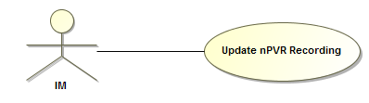

**Figure 12:** Update nPVR Recording Request

|  |  |
| --- | --- |
| **Actor(s)** | IM |
| **Information** | This use case describes the flow of events occurring at nPVR BE for updating an already scheduled individual recording. |
| **Pre-Condition** | * + - 1. nPVR BE should be up and running.       2. The ContextId of the requesting IM should be there in nPVR BE database. |
| **Flow of events** | 1. At nPVR BE the servlet receives a request from IM for updating an already scheduled individual recording with request parameters OpCode, AccountId, RecordID, StartDeltaTime, and DeleteWhenSpaceNeeded in the url and ContextId of requesting IM in request header. 2. On receiving this request the servlet will call processors for method finding, parameter validations, error handling. 3. The processor forwards this request to respective handler which further delegates this request to BL. 4. BL verifies context ID of the requesting IM if it is registered in SERVERCONTEXT table of nPVR BE database through data access layer. 5. BL would retrieve user detail from NPVRUSERDETAILS table through data access layer on the basis of user account number provided through request and context ID of requesting IM. 6. BL would retrieve user recording from USERNPVRRECORDING table through data access layer on the basis of RecordID and StartDeltaTime provided through request. 7. BL would update the field DeleteWhenSpaceNeeded of USERNPVRRECORDING table through data access layer. |
| **Post Condition** | 1. User recording is updated successfully and nPVR BE sends a response to requesting IM. 2. If the value for ResponseFormat is found to be ‘object’ the response is returned as Object. If the value of ResponseFormat as ‘xml’ the response will be returned in xml. 3. The response should be according to NPVRAddRecordingsResponse.xsd. |
| **Alternative flow of events** | None |
| **Exception** | 1. If request parameters OpCode, AccountId, RecordID, StartDeltaTime, DeleteWhenSpaceNeeded, and ContextId are not coming in the request the request shall be declined with an error code ‘NBE005’ and error message stating ‘Mandatory parameter missing: ParameterName’. 2. If nPVR BE receives a request for ContextId which does not exist at its end then the request shall be declined with an error code ‘NBE001’ and error message stating ‘No context exists for requesting middleware’. 3. If the user AccountId in the request does not exist for ContextId in nPVR BE database the request shall be declined with an error code ‘NBE007’ and error message stating ‘User does not exist’. 4. If the recording to be stopped does not exist in the database shall be declined with an error code ‘NBE021’ and error message stating ‘Recording does not exist’. 5. If application is unavailable to process the request the system exception is thrown with an error code ‘NBE000’ and error message stating ‘System Exception’. |
| **Reference** | FSpec_IPTV4.0_nPVR Backend IUS 1.3_TrackChanges |

### Delete nPVR Recordings Request

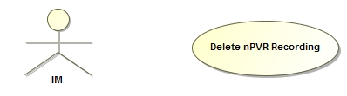

**Figure 13:** Delete nPVR Recordings Request

|  |  |
| --- | --- |
| **Actor(s)** | IM |
| **Information** | This use case describes the flow of events occurring at nPVR BE for deleting an already scheduled individual recording. |
| **Pre-Condition** | 1. nPVR BE should be up and running. 2. The ContextId of the requesting IM should be there in nPVR BE database. |
| **Flow of events** | 1. At nPVR BE the servlet receives a request from IM for deleting an already scheduled individual recording with request parameters OpCode, AccountId in the URL, ContextId and ResponseFormat in header and request body. The request body should be according to NPVRDeleteRecordingsRequest.xsd. The request body contains the list of records. The each record contains RecordID and StartDeltaTime. 2. On receiving this request the servlet will call processors for method finding, parameter validations, error handling. 3. The processor forwards this request to respective handler which further delegates this request to BL. 4. BL verifies context ID of the requesting IM if it is registered in SERVERCONTEXT table of nPVR BE database through data access layer. 5. BL would retrieve user detail from NPVRUSERDETAILS table through data access layer on the basis of user AccountId provided through request and ContextId of requesting IM. 6. BL would retrieve user recordings from USERNPVRRECORDING table through data access layer on the basis of RecordID and StartDeltaTime provided through request. 7. If user recording not found of the record which is coming in the list of request body, the record cannot be deleted and will be ignored. 8. BL would delete the user recordings from USERNPVRRECORDING table through data access layer. |
| **Post Condition** | 1. User recording is deleted successfully and nPVR BE sends a response to requesting IM containing a list of successfully deleted recordings. The response should be according to NPVRDeleteRecordingsResponse.xsd. 2. If the value for ResponseFormat is found to be ‘object’ the response is returned as Object. If the value of ResponseFormat as ‘xml’ the response will be returned in xml. 3. The recordings which could not be deleted shall not be returned in response. |
| **Alternative flow of events** | 1. If deleted user recording is the last recording referring the system recording, the record will be deleted from SYSTEMNPVRRECORDING, NPVRASSET AND USERNPVRRECORDING table through data access layer. BL should send delete request to nPVR mediator for parent nPVR assets. The program metadata is deleted from PROGRAMDETAILS table from nPVR BE database through background task, if not referred by any system recording. 2. On deletion of nPVR asset corresponding to a parent MTP, the corresponding assets of child MTPs are also removed for that recording. However mediator shall receive only the deletion request for the parent MTP asset. 3. The communication with mediator is done through XML-RPC protocol. The BL passes parameter NpvrAssetId while calling mediator. |
| **Exception** | 1. If OpCode, AccountId, ContextId is not coming in the request the request shall be declined with an error code ‘NBE005’ and error message stating ‘Mandatory parameter missing: ParameterName’. 2. If request body is not according to NPVRAddRecordingsRequest.xsd the request shall be declined with an error code ‘NBE006’ and error message stating ‘Improper request’. 3. If nPVR BE receives a request for ContextId which does not exist at its end then the request shall be declined with an error code ‘NBE001’ and error message stating ‘No context exists for requesting middleware’. 4. If the user AccountId in the request does not exist for ContextId in nPVR BE database the request shall be declined with an error code ‘NBE007’ and error message stating ‘User does not exist’. 5. If application is unavailable to process the request the system exception is thrown with an error code ‘NBE000’ and error message stating ‘System Exception’. |
| **Reference** | FSpec_IPTV4.0_nPVR Backend IUS 1.3_TrackChanges |

### Get User Recordings Request

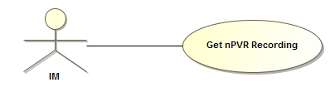

**Figure 14:** Get User Recordings Request

|  |  |
| --- | --- |
| **Actor** | IM |
| **Information** | This use case describes the flow of events occurring at nPVR BE for retrieving the quota information (total and used quota) of the user. |
| **Pre-Condition** | 1. nPVR BE should be up and running. 2. The ContextId of the requesting IM should be there in nPVR BE database. |
| **Flow of events from TM** | 1. nPVR BE receives a request from IM for getting user quota with request parameters OpCode, and AccountId in the URL and ContextId of requesting IM in request header. 2. On receiving this request, nPVR BE verifies ContextId of IM which is making request against ContextId registered in SERVERCONTEXT table. 3. nPVR BE would retrieve user detail from NPVRUSERDETAILS table on the basis of AccountId provided through request and ContextId of requesting IM. 4. The total minutes will be retrieved from NPVRUSERDETAILS table. 5. The used minutes is retrieved from the sum of ACTUALRECSECONDS field of USERNPVRRECORDING table and then divided by 60. |
| **Alternative Flow of Events** | None |
| **Post-Condition** | 1. User quota is retrieved successfully and nPVR BE sends a response to requesting IM. 2. If the value for ResponseFormat is found to be ‘object’ the response is returned in Object. If the value of ResponseFormat is ‘xml’ the response will be returned in xml. 3. The response should be according to NPVRGetUserQuotaResponse.xsd. |
| **Exception** | 1. If request parameters OpCode, AccountId, and ContextId are not coming in the request the request shall be declined with an error code ‘NBE005’ and error message stating ‘Mandatory parameter missing: ParameterName’. 2. If nPVR BE receives a request for ContextId which does not exist at its end then the request shall be declined with an error code ‘NBE001’ and error message stating ‘No context exists for requesting middleware’. 3. If the user AccountId in the request does not exist for ContextId in nPVR BE database the request shall be declined with an error code ‘NBE007’ and error message stating ‘User does not exist’. 4. If system is unavailable to process the request the system exception is thrown with an error code ‘NBE000’ and error message stating ‘System Exception’. |
| **Reference** | FSpec_IPTV4.0_nPVR Backend IUS 1.3.docx |

### Stop nPVR Recording Request

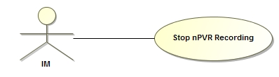

**Figure 15:** Stop nPVR Recording Request

|  |  |
| --- | --- |
| **Actor(s)** | IM |
| **Information** | This use case describes the flow of events occurring at nPVR BE for stopping an ongoing individual recording. |
| **Pre-Condition** | 1. nPVR BE should be up and running. 2. The ContextId of the requesting IM should be there in nPVR BE database. |
| **Flow of events** | 1. At nPVR BE the servlet receives a request from IM for stopping an ongoing individual recording with request parameters OpCode, AccountId, RecordID, StartDeltaTime, and StopDeltaTime in the URL and ContextId in the request header. 2. On receiving this request the servlet will call processors for method finding, parameter validations, error handling. 3. The processor forwards this request to respective handler which further delegates this request to BL. 4. BL verifies context ID of the requesting IM if it is registered in SERVERCONTEXT table of nPVR BE database through data access layer. 5. BL would retrieve user detail from NPVRUSERDETAILS table through data access layer on the basis of AccountId provided through request and ContextId of requesting IM. 6. BL would retrieve user recordings from USERNPVRRECORDING table through data access layer on the basis of RecordID and StartDeltaTime provided through request. 7. BL validates the StopDeltaTime provided through request against USERSTOPTDELTA stored in USERNPVRRECORDING table for that particular user record. 8. BL would retrieve ENABLESTARTSTOPMARK from SYSTEMCONFIG table through data access layer and check whether this flag is true or not. 9. BL would update stop delta of the user recording if ENABLESTARTSTOPMARK found to be true. The Status is set to “RecordSuccess” and StatusDetail is set to “Recording Successful”. 10. The value of ACTUALRECORDINGSECONDS will be 0 if user recording end time is less than program start time. If this is not the case the value of ACTUALRECORDINGSECONDS will be (UserStopDelta - UserStartDelta - preMin – postMin). 11. BL would update ACTUALRECORDINGSECONDS of user recording in USERNPVRRECORDING table through data access layer. |
| **Post Condition** | 1. User recording stop delta, status, status details and actual recording seconds are updated successfully and nPVR BE sends a response to requesting IM. 2. If the value for ResponseFormat is found to be ‘object’ the response is returned in Object. If the value of ResponseFormat is ‘xml’ the response will be returned in xml. |
| **Alternative flow of events** | 1. If “ENABLESTARTSTOPMARK” flag is not enabled the stop request is ignored and stop delta is not updated for user recording. No error is thrown. |
| **Exception** | 1. If request parameters OpCode, AccountId, StartDeltaTime, StopDeltaTime, and ContextId are not coming in the request the request shall be declined with an error code ‘NBE005’ and error message stating ‘Mandatory parameter missing: ParameterName’. 2. If nPVR BE receives a request for ContextId which does not exist at its end then the request shall be declined with an error code ‘NBE001’ and error message stating ‘No context exists for requesting middleware’. 3. If the user AccountId in the request does not exist for ContextId in nPVR BE database the request shall be declined with an error code ‘NBE007’ and error message stating ‘User does not exist’. 4. If the recording to be stopped does not exist in the database shall be declined with an error code ‘NBE021’ and error message stating ‘Recording does not exist’. 5. If Stop Time to set is not valid, i.e. stop delta is greater than USERSTOPTDELTA and less then USERSTARTDELTA of user recording shall be declined with an error code ‘NBE026’ and error message stating ‘Stop mark is not valid’. 6. If application is unavailable to process the request the system exception is thrown with an error code ‘NBE000’ and error message stating ‘System Exception’. |
| **Reference** | FSpec_IPTV4.0_nPVR Backend IUS 1.3_TrackChanges |

### Add nPVR Series Request

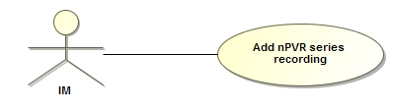

**Figure 16:** Add nPVR Series Request

|  |  |
| --- | --- |
| **Actor(s)** | IM |
| **Information** | This use case describes the flow of events occurring at nPVR BE for scheduling a series recording. |
| **Pre-Condition** | 1. nPVR BE is up and running. 2. ContextId of IM is already registered. 3. Request is already validated for following by IM:    1. User has valid nPVR subscription.    2. Channel is nPVR enabled.    3. Program is not blocked for nPVR.    4. Requested schedule is a valid entry and not in past. |
| **Flow of events** | 1. At nPVR BE servlet receives a request from IM for scheduling a series recording with request parameters (OpCode, AccountID, ChannelExternalId, SeriesReference, ChannelBound, EpisodeScope, DeleteWhenSpaceNeeded and NrEpisodesToKeep) and context Id of requesting IM in request header. The ResponseFormat may also come in the request. 2. On receiving this request the servlet will call processors for method finding, parameter validations, error handling. 3. The processors will forward this request to respective handler which further delegates this request to BL. 4. BL verifies context ID of the requesting IM if it is registered in SERVERCONTEXT table of nPVR BE. 5. BL verifies user existence by retrieving user detail from NPVRUSERDETAILS table on the basis of user account ID provided through request and context ID of requesting IM. 6. After validating user BL would checks if user series recording already exists for the user in USERNPVRSERIESRECORDING table on the basis of UserId and SeriesReference number. 7. BL verifies channel existence by retrieving channel detail from CHANNEL table on the basis of ChannelExternalId provided through request and context ID of requesting IM. 8. BL would verify whether NrEpisodesToKeep is within defined limit i.e. NrEpisodesToKeep should be greater than 0 and less than 99. 9. BL checks if a user series recording already exists for requested series on the basis of CONTEXTID ,CHANNELID, SERIESREFNO, EPISODESCOPE and CHANNELBOUND in USERNPVRSERIESRECORDING table and on non-existence:    1. BL would retrieve program metadata from PROGRAMDETAILS table. If no metadata found then it callback the requesting IM to retrieve metadata for schedule and program metadata using getMetadata interface.    2. Once BL gets program metadata from requesting IM, program metadata is stored in PROGRAMDETAILS table, except the one which are nPVR disallowed, PIP enabled and blackout for schedule.    3. nPVR BE creates system recording along with nPVR assets on all MTPs, assigned to the channel and included channels, except the one which are nPVR disallowed and PIP enabled. Also skips the MTPs which are assigned to MDPs which are blackout for schedule.    4. BL will invoke data access layer to insert one entry for requested series in SYSTEMNPVRSERIESRECORDING table.    5. BL will invoke data access layer to insert one entry per airing (CHANNELID + PROGRAMEXTERNALID+ PROGRAMSTARTTIME) in SYSTEMNPVRRECORDING table.    6. For each MTP assigned to channel on which recording is requested an asset is created. For each asset an entry is done in NPVRASSET table. 10. BL would retrieve CONCURRENTRECORDINGSLIMIT from user details. If CONCURRENTRECORDINGSLIMIT is not defined for the user BL will retrieve the same from SYSTEMCONFIG table. 11. BL would check for conflicts in the recordings on the basis of CONCURRENTRECORDINGSLIMIT. 12. If user series recording does not exist, BL will invoke data access layer to insert user series recording in USERNPVRSERIESRECORDING table. 13. BL will invoke data access layer to insert one entry per episode for user in USERNPVRRECORDING table. 14. If any episode is ongoing then BL would validate quota check for the user. 15. Finally nPVR BE sends a request to mediator to create physical assets only if this series is scheduled first time by any user. |
| **Post Condition** | 1. User series recording is scheduled successfully along with all episodes of the series and nPVR BE sends a response to requesting IM. |
| **Alternative flow of events** | 1. If system series recording already exists then use the same series recording to create the user series recording. 2. If system recording already exists then use the same recording to create the user recording. No need to create physical assets and schedule the same on nPVR mediator. 3. If a user individual recording already exists which is part of series then make it a series episode and no new user recording entry is created. 4. For each System Recording created, if any of the channel stream is associated to a parent MTP then nPVR BE will create the assets corresponding to the parent MTP as well as all of its child MTPs. However, nPVR BE shall send the request to mediator only for the asset corresponding to the parent MTP and not for its child MTPs. 5. In cases where it is required to delete recording(s) in order to make space for the requested recording to happen for the user.   Please refer section 5.28.2.2 for complete information.   1. If channel bound is set to false then series episodes are scheduled across multiple associated channels for the user otherwise episodes are scheduled only on channel on which the request is sent. Only first occurrence of an episode shall be scheduled.   If no associated channels exist for the user then value of this parameter is always set to true for the series by nPVR BE, even if passed otherwise in series request. |
| **Exception** | 1. If nPVR BE receives a request for a context which does not exist at its end then the request shall be declined with an error message having error code ‘NBE001’ and stating ‘No context exists for requesting middleware’. 2. An error is thrown if the user account id in the request does not exist for requested context id in database with an error message having error code ‘NBE007’ and stating ‘User does not exist’. 3. An error is thrown if series already exists for the user with an error message having error code ‘NBE027’ and stating ‘Series already scheduled’. 4. An error is thrown if channel not exists in database with an error message having error code ‘NBE029’ and stating ‘Channel does not exist’. 5. An error is thrown if quota fails for a recording with an error message having error code ‘NBE022’ and stating ‘User quota exceeded’. 6. An error is thrown if maximum concurrent limit for the user is reached with an error message having error code ‘NBE024’ and stating ‘Recording not allowed, exceeding the concurring recording limit’. 7. An error is thrown for invalid episode limit with an error message having error code ‘NBE028’ and stating ‘Invalid Episode limit’. |
| **Reference** | FSpec_IPTV4.0_nPVR Backend IUS 1.3_TrackChanges |

### Update nPVR Series Request

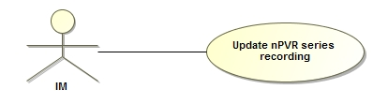

**Figure 17:** Update nPVR Series Request

|  |  |
| --- | --- |
| **Actor(s)** | IM |
| **Information** | This use case describes the flow of events occurring at nPVR BE for updating an already scheduled series recording. |
| **Pre-Condition** | 1. nPVR BE is up and running. 2. ContextId of requesting IM already exists in nPVR BE database. |
| **Flow of events** | 1. At nPVR BE servlet receives a request from IM for updating an already scheduled series recording with request parameters (OpCode, AccountId, SeriesId, EpisodeScope, ChannelBound, DeleteWhenSpaceNeeded and NrEpisodesToKeep) and context Id of requesting IM in request header. The ResponseFormat may also come in the request. 2. On receiving this request the servlet will call processors for method finding, parameter validations, error handling. 3. The processors will forward this request to respective handler which further delegates this request to BL. 4. BL verifies context ID of the requesting IM if it is registered in SERVERCONTEXT table of nPVR BE. 5. BL verifies user existence by retrieving user detail from NPVRUSERDETAILS table on the basis of user account ID provided through request and context ID of requesting IM. 6. BL would retrieve user series recording from USERNPVRSERIESRECORDING table on the basis of SeriesId and UserId provided through the request. 7. BL would verify whether NrEpisodesToKeep is within defined limit i.e. NrEpisodesToKeep should be greater than 0 and less than 99. 8. BL will invoke data access layer to update ChannelBound, EpisodesToKeep, DeleteWhenSpaceNeeded and EpisodeScope on the basis of parameters passed through the request in USERNPVRSERIESRECORDING table. |
| **Post Condition** | 1. User series recording is updated successfully and nPVR BE sends a response to requesting IM. |
| **Alternative flow of events** | 1. If ChannelBound or EpisodeScope is changed changed the nPVR BE determines new episodes to be scheduled:    1. Checks for maximum concurrent limit of user    2. Deletes future user episodes recordings.    3. For each airing episode creates a user recording.   If channel bound is updated to false then series episodes are scheduled across multiple associated channels for the user otherwise episodes are scheduled only on channel on which the request is sent. Only first occurrence of an episode shall be scheduled. If no associated channels exist for the user then value of this parameter is always updated to true for the series by nPVR BE, even if passed otherwise in series request.  If episode scope parameter is updated to ‘NEW’, the episodes whose schedule’s episode scope contains ‘NEW’ will only be scheduled otherwise all episodes will be scheduled.   1. If DeleteWhenSpaceNeeded is changed, all episode recordings of the series are updated with the changed value. 2. If EpisodeScope is changed to a lower value then some of the oldest episode recordings are deleted. |
| **Exception** | 1. If nPVR BE receives a request for a context which does not exist at its end then the request shall be declined with an error message having error code ‘NBE001’ and stating ‘No context exists for requesting middleware’. 2. An error is thrown if the user account id in the request does not exist for requested context id in database with an error message having error code ‘NBE007’ and stating ‘User does not exist’. 3. An error is thrown if the series to be updated does not exist for request context id and user in nPVR BE database with an error message having error code ‘NBE030’ and stating ‘Series does not exist’. 4. An error is thrown if maximum concurrent limit for the user is reached with an error message having error code ‘NBE024’ and stating ‘Recording not allowed, exceeding the concurring recording limit’. |
| **Reference** | FSpec_IPTV4.0_nPVR Backend IUS 1.3_TrackChanges |

### Delete nPVR Series Request

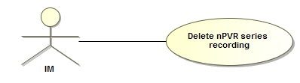

**Figure 18:** Delete nPVR Series Request

|  |  |
| --- | --- |
| **Actor(s)** | IM |
| **Information** | This use case describes the flow of events occurring at nPVR BE for deleting an already scheduled series. |
| **Pre-Condition** | 1. nPVR BE is up and running. 2. ContextId of requesting IM already exists in nPVR BE database. 3. KEEPRECORDINGS is false |
| **Flow of events** | 1. At nPVR BE servlet receives a request from IM for deleting an already scheduled series recording with request parameters (OpCode, AccountId, SeriesId and StartDeltaTime) and context Id of requesting IM in request header. The ResponseFormat may also come in the request. 2. On receiving this request the servlet will call processors for method finding, parameter validations, error handling. 3. The processors will forward this request to respective handler which further delegates this request to BL. 4. BL verifies context ID of the requesting IM if it is registered in SERVERCONTEXT table of nPVR BE. 5. BL verifies user existence by retrieving user detail from NPVRUSERDETAILS table on the basis of user account ID provided through request and context ID of requesting IM. 6. After validating user BL would checks if user series recording exists for the user in USERNPVRSERIESRECORDING table on the basis of UserId and SeriesId. 7. BL would retrieve all user recordings for the requested series from USERNPVRRECORDING table on the basis of SeriesId and UserId provided through request. 8. BL will invoke data access layer to delete user series recording from USERNPVRSERIESRECORDING table along with all its episode recordings from USERNPVRRECORDING. |
| **Post Condition** | 1. User series recording is deleted successfully along with user episode recordings and nPVR BE sends a response to requesting IM containing a list of successfully deleted recordings. |
| **Alternative flow of events** | 1. If “keepRecordings” parameter is null then BL will invoke data access layer to delete all the finished episode recordings from USERNPVRRECORDING table. User series recording is not deleted in this case. 2. If “keepRecordings” parameter is “true” then BL will invoke data access layer to delete user series recording from USERNPVRSERIESRECORDING table along with all the future scheduled episode recordings from USERNPVRRECORDING table. Finished and ongoing episode recordings are not deleted. 3. If deleted user series recording is the last recording referring the system series recording, then system series recording is deleted along with all nPVR assets of that recording. 4. nPVR BE sends delete request to nPVR mediator for each nPVR asset. 5. Program metadata is deleted from nPVR BE database, if not referred by any system recording. 6. On deletion of nPVR asset corresponding to a parent MTP, corresponding assets of child MTPs are also deleted. |
| **Exception** | 1. If nPVR BE receives a request for a context which does not exist at its end then the request shall be declined with an error message having error code ‘NBE001’ and stating ‘No context exists for requesting middleware’. 2. An error is thrown if the user account id in the request does not exist for requested context id in database with an error message having error code ‘NBE007’ and stating ‘User does not exist’. 3. An error is thrown if SeriesId in the request does not exists for corresponding userId in nPVR BE database with an error message having error code ‘NBE030’ and stating ‘Series does not exist’. |
| **Reference** | FSpec_IPTV4.0_nPVR Backend IUS 1.3_TrackChanges |

### Get Series Request

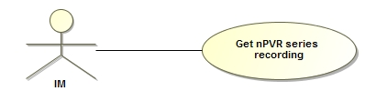

**Figure 19:** Get Series Request

|  |  |
| --- | --- |
| **Actor(s)** | IM |
| **Information** | This use case describes the flow of events occurring at nPVR BE to get list of series recordings. |
| **Pre-Condition** | 1. nPVR BE is up and running. 2. The context of the requesting IM already exists in nPVR BE database. |
| **Flow of events** | 1. At nPVR BE servlet receives a request to get list of series recordings from IM with request parameter (OpCode, AccountId, and SeriesID) and context Id of requesting IM in request header. The ResponseFormat may also come in the request. 2. On receiving this request the servlet will call processors for method finding, parameter validations, error handling. 3. The processors will forward this request to respective handler which further delegates this request to BL. 4. BL verifies context ID of the requesting IM if it is registered in SERVERCONTEXT table of nPVR BE. 5. BL verifies user existence by retrieving user detail from NPVRUSERDETAILS table on the basis of user account ID provided through request and context ID of requesting IM. 6. BL will call data access layer to retrieve all the user series recordings from USERNPVRSERIESRECORDING on the basis of UserId. 7. BL returns all user series recordings of the requesting user. |
| **Post Condition** | 1. nPVR BE sends a response to requesting IM with corresponding recordings. |
| **Alternative flow of events** | 1. Optionally seriesID may be specified in the request. In this case BL will call data access layer to retrieve all the user series recordings from USERNPVRSERIESRECORDING on the basis of UserId and SeriesId. |
| **Exception** | 1. If nPVR BE receives a request for a context which does not exist at its end then the request shall be declined with an error message having error code ‘NBE001’ and stating ‘No context exists for requesting middleware’. 2. An error is thrown if the user account id in the request does not exist for requested context id in database with an error message having error code ‘NBE007’ and stating ‘User does not exist’. |
| **Reference** | FSpec_IPTV4.0_nPVR Backend IUS 1.3_TrackChanges |

### Get Recordings Request



**Figure 20:** Get Recordings Request

|  |  |
| --- | --- |
| **Actor(s)** | IM |
| **Information** | This use case describes the flow of events occurring at nPVR BE to get list of system recordings with the selected filtering options. |
| **Pre-Condition** | 1. nPVR BE is up and running. 2. The context of the requesting IM already exists in nPVR BE database. |
| **Flow of events** | 1. At nPVR BE servlet receives a request to get list of system recordings from IM with request parameter (OpCode, ChannelExternalId, ProgramId, ProgramStartTime and EventUpdated) and context Id of requesting IM in request header. The ResponseFormat may also come in the request. 2. On receiving this request the servlet will call processors for method finding, parameter validations, error handling. 3. The processors will forward this request to respective handler which further delegates this request to BL. 4. BL verifies context ID of the requesting IM if it is registered in SERVERCONTEXT table of nPVR BE 5. BL will invoke data access layer to retrieve all the system recordings from SYSTEMNPVRRECORDING on the basis of passed filtering options. 6. If EventUpdated parameter is true, then return all system recordings which have EventUpdateStatus set as not null in database. 7. If EventUpdated parameter is false and no other filtering parameter is provided, then nothing will return. 8. If the request is based on Airing (i.e. ChannelExternalID, ProgramReferenceNumber and ProgramStartTime parameters are provided), then return the system recording matching to requested airing. 9. If EventUpdated parameter is false but airing parameters are provided, then return the system recording matching to requested airing and for which EventUpdateStatus set as null. 10. BL returns all system recordings of the requesting IM. |
| **Post Condition** | 1. nPVR BE sends a response to requesting IM with corresponding recordings. |
| **Alternative flow of events** | None |
| **Exception** | 1. If nPVR BE receives a request for a context which does not exist at its end then the request shall be declined with an error message having error code ‘NBE001’ and stating ‘No context exists for requesting middleware’. 2. If all parameters are missing then the request shall be declined with an error message having error code ‘NBE006’ and stating ‘Improper request: {0}’. 3. All three airing parameters shall be provided in group and if one of the airing parameters is missing then the request shall be declined with an error message having error code ‘NBE005’ and stating ‘Mandatory parameter missing: {0}’. |
| **Reference** | FSpec_IPTV4.0_nPVR Backend IUS 1.3_TrackChanges |

### Creating nPVR Reports

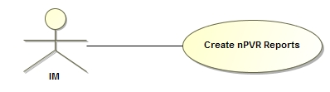

**Figure 21:** Creating nPVR Reports

|  |  |
| --- | --- |
| **Actor(s)** | IM |
| **Information** | This use case describes the flow of events occurring at nPVR BE to create reports. |
| **Pre-Condition** | 1. nPVR BE is up and running. 2. The context of the requesting IM already exists in nPVR BE database. |
| **Flow of events** | 1. At nPVR BE servlet receives a request for nPVR recordings report from IM with request parameter (Type, HowMany, StartIndex) and context Id of requesting IM in request header. The ResponseFormat may also come in the request. 2. On receiving this request the servlet will call processors for method finding, parameter validations, error handling. 3. The processors will forward this request to respective handler which further delegates this request to BL. 4. BL verifies context ID of the requesting IM if it is registered in SERVERCONTEXT table of nPVR BE. 5. BL will invoke data access layer to retrieve recordings depending TYPE passed through request and context ID of requesting IM. 6. If TYPE is ‘SystemNPVR’ then nPVR BE will fetch system recording from SYSTEMNPVRRECORDING table. 7. BL returns report with the corresponding recordings. |
| **Post Condition** | 1. nPVR BE responds back with the corresponding recordings. |
| **Alternative flow of events** | 1. If TYPE is ‘UserNPVR’ then nPVR BE will fetch user recording from USERNPVRRECORDING table. 2. If TYPE is ‘SystemSeries’ then nPVR BE will fetch records from SYSTEMNPVRSERIESRECORDING table. 3. If TYPE is ‘UserSeries’ then nPVR BE will fetch records from USERNPVRSERIESRECORDING table. 4. If TYPE is ‘PhysicalAssets’ then nPVR BE will fetch records from NPVRASSET table. |
| **Exception** | 1. If nPVR BE receives a request for a context which does not exist at its end then the request shall be declined with an error message having error code ‘NBE001’ and stating ‘No context exists for requesting middleware’. 2. If the page size provided in the request is greater than the configured maximum page size then a maximum of only configured number of items shall be returned and the request page size would be ignored. |
| **Reference** | FSpec_IPTV4.0_nPVR Backend IUS 1.3_TrackChanges |

### Processing Schedule updates

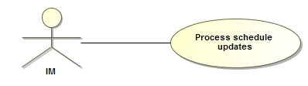

**Figure 22:** Processing Schedule updates

|  |  |
| --- | --- |
| **Actor(s)** | IM |
| **Information** | This use case describes the flow of events occurring at nPVR BE on every EPG data ingestion. |
| **Pre-Condition** | 1. nPVR BE is up and running. 2. The context of the requesting IM already exists in nPVR BE database. 3. New EPG data has been ingested in IM. |
| **Flow of events** | 1. At nPVR BE servlet receives a HTTP notification from IM on EPG data ingestion with request parameters (OpCode, RequestId) and context Id of requesting IM in request header. A list of all program Ids which have been shifted is supplied to nPVR BE in this notification by IM. The ResponseFormat may also come in the request. 2. On receiving this request the servlet will call processors for method finding, parameter validations, error handling. 3. The processors will forward this request to respective handler which further delegates this request to BL. 4. BL verifies context ID of the requesting IM if it is registered in SERVERCONTEXT table of nPVR BE. 5. BL would use the data access layer to insert a record into the EVENTUPDATES table with request type ‘ScheduleUpdate’. 6. On successfully completing the steps 1 to 5, the servlet at nPVR BE would acknowledge requesting IM with 200 OK HTTP response. 7. Thereafter the BL would start the schedule update process in background by retrieving a list of all effected recordings from SYSTEMNPVRRECORDING table. 8. After finding the list of all such programs which have been rescheduled the nPVR BE would retrieve the program and schedule metadata of all such programs from corresponding IM using the ‘getMetadata’ interface at IM on the basis of contextID and program list in the request with scope of retrieval limited to schedules only. 9. Once all the schedules are retrieved, it would be determined that which recordings are to be shifted as per the shift in corresponding schedules and which schedules are removed. 10. If the effected recording is a future recording then:- 11. If the start time of the airing has been modified for future recordings, then the filename for each asset shall be updated accordingly. If the affected assets contain any child nPVR asset then those assets are also updated for the filename, however nPVR Mediator shall not be notified for these child assets. 12. BL would invoke the data access layer to update the PROGRAMSTARTTIME, PROGRAMDURATION, RECORDINGSTARTTIME and RECORDINGDURATION of the shifted system recording in SYSTEMNPVRRECORDING table. 13. In SYSTEMNPVRRECORDING table set EVENTUPDATESTATUS to ‘Complete’ for updated recordings and set EVENTUPDATESTATUS to ‘Failed’ for removed schedules through data access layer. 14. In NPVRASSET table set STATUS and STATUSDETAILS to ‘ScheduleCancelled’ for removed schedules and set STATUS and STATUSDETAILS to ‘ReScheduleSuccess’ for updated recordings through data access layer. 15. In USERNPVRRECORDING table set STATUS and STATUSDETAILS to ‘ScheduleCancelled’ for removed schedules and set STATUS and STATUSDETAILS to ‘ReScheduleSuccess’ for updated recordings through data access layer. 16. BL layer would send a request to mediator to delete physical assets on the basis of asset ID for removed schedules. For updated recordings BL would send a request to mediator to update physical assets with parameters asset ID, start time, duration, filename and epgversion. |
| **Post Condition** | 1. nPVR BE shall notify to IM w.r.t the request Id to indicate that process has been completed only if call back is true. |
| **Alternative flow of events** | 1. All finished recordings remain untouched. 2. If the effected recording is ongoing then.    1. In SYSTEMNPVRRECORDING table set EVENTUPDATESTATUS to ‘Incomplete’.    2. In NPVRASSET table set STATUS and STATUSDETAILS to ‘Incomplete’.    3. In USERNPVRRECORDING table set STATUS and STATUSDETAILS to ‘Incomplete’. |
| **Exception** | 1. If nPVR BE receives a request for a context which does not exist at its end then the request shall be declined with an error message having error code ‘NBE001’ and stating ‘No context exists for requesting middleware’. |
| **Reference** | FSpec_IPTV4.0_nPVR Backend IUS 1.3.docx |

### Processing Series updates

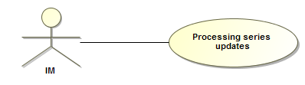

**Figure 23:** Processing Series updates

|  |  |
| --- | --- |
| **Actor(s)** | IM |
| **Information** | This use case describes the flow of events occurring at nPVR BE when the new series episodes have been added to EPG data. |
| **Pre-Condition** | 1. nPVR BE is up and running. 2. The context of the requesting IM already exists in nPVR BE database. 3. New EPG data has been ingested in IM. |
| **Flow of events** | 1. At nPVR BE servlet receives a HTTP notification from IM on EPG data ingestion with request parameters (OpCode, RequestId) and context Id of requesting IM in request header. A list of all the programs of new episodes (consisting of Program External Id, Series Reference Number and Episode Id) that have been added to any series is supplied to nPVR BE in this notification by IM. The ResponseFormat may also come in the request. 2. On receiving this request the servlet will call processors for method finding, parameter validations, error handling. 3. The processors will forward this request to respective handler which further delegates this request to BL. 4. BL verifies context ID of the requesting IM if it is registered in SERVERCONTEXT table of nPVR BE. 5. BL would use the data access layer to insert a record into the EVENTUPDATES table with request type ‘SeriesUpdate’. 6. On successfully completing the steps 1 to 5, the servlet at nPVR BE would acknowledge requesting IM with 200 OK HTTP response. 7. nPVR BE would start the process to find the series which have already been scheduled for recording at its end. 8. After finding the list of all such series which have been scheduled, the nPVR BE would retrieve the program and schedule metadata of all new episodes of scheduled series from corresponding IM using the ‘getMetadata’ interface at IM excluding the already scheduled episodes on the basis of contextID and program list in the request with scope of retrieval limited to ‘Both’. 9. Once all the schedules are retrieved, nPVR BE would then schedule the recordings for the newly added episodes. 10. BL layer would invoke data access layer to insert one entry per new episode per series in SYSTEMNPVRRECORDING table. 11. For each user who has already schedule for series one entry per new episode would be done in USERNPVRRECORDING table through data access layer. 12. Finally BL would send a request to mediator to create physical assets for every newly added episode. |
| **Post Condition** | 1. For all the new episodes system recordings, EventUpdateStatus is changed to ‘Complete’ in DB. 2. nPVR BE shall notify to IM w.r.t the request Id to indicate that process has been completed only if call back is true. |
| **Alternative flow of events** | None |
| **Exception** | 1. If nPVR BE receives a request for a context which does not exist at its end then the request shall be declined with an error message having error code ‘NBE001’ and stating ‘No context exists for requesting middleware’. |
| ***Class Diagram*** | 4.4 Class Modeling |
| **Reference** | FSpec_IPTV4.0_nPVR Backend IUS 1.3.docx |

### Processing program metadata updates

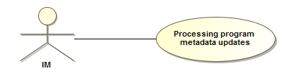

**Figure 24:** Processing program metadata updates

|  |  |
| --- | --- |
| **Actor(s)** | IM |
| **Information** | This use case describes the flow of events occurring at nPVR BE for scenarios when EPG data ingestion takes place at IM, the IMs shall notify the nPVR BE about the programs whose metadata have been updated along with enableNPVR update. This notification would then result in a background task to change the metadata at its end. |
| **Pre-Condition** | 1. nPVR BE should be up and running. 2. The ContextId of the requesting IM should be there in SERVERCONTEXT table of nPVR BE database. 3. The new EPG data should be ingested in IM. |
| **Flow of events** | 1. At nPVR BE the servlet receives a request from IM for processing program metadata with request parameters OpCode and RequestId in the URL, ContextId in the header and request body. The request body should be according to EPGUpdateRequest.xsd. 2. On receiving this request the servlet will call processors for method finding, parameter validations, error handling. 3. The processor forwards this request to respective handler which further delegates this request to BL. 4. The EPGUpdateRequest keeps the information about list of programs and epg version. The program keeps the information about the programId and SeriesId. 5. BL would insert a record into the EVENTUPDATES table through data access layer with RequestType ‘ProgramMetadataUpdate’ and RequestStatus ‘Received’. 6. The process of program metadata update will be executed in background task. 7. BL would find out the programIds on which recordings have been scheduled using SYSTEMNPVRRECORDING and USERNPVRRECORDING table through data access layer. 8. After finding the list of all such programs which are scheduled for recording, the BL would retrieve the program metadata of all such programs from corresponding IM using the ‘*getMetadata*’ interface at IM. 9. BL will send the parameters GetMetadataRequset and ContextId In the getMetadata request. 10. The GetMetadataRequset keeps the information about programIds which had been scheduled at nPVR BE. 11. The MetadataRequset should be according to GetMetadataRequest.xsd. 12. The IM will return the GetMetadataResponse. The GetMetadataResponse keeps the information about programs. The program keeps the information about EpisodeId, SeriesId and ProgramMetaInfo. 13. The field CURRENTEPGVERSION of SYSTEMCONFIG table is update with epg version value coming in the request through data access layer. 14. BL would then update the metadata of these programs by updating PROGRAMDETAILS table through data access layer. BL would also find out the programs which have come in the GetMetadataResponse and have the status of enbleNPVR false. These programs will be treated for nPVR blocking and the status of recordings on these programs will be modified. 15. The status of ongoing recording for enableNPVR false will be set to ‘Incomplete’ and StatusDetails to ‘Incomplete due to program metadata update’ for USERNPVRRECORDING AND NPVRASSET table. The EventUpdateStatus field of SYSTEMNPVRRECORDING table will be updated with ‘Incomplete’. This operation will be performed through data access layer. 16. The status of future recording for enableNPVR false will be set to ‘ScheduleCancelled’ and StatusDetails to ‘Schedule cancelled due to program metadata update due to program metadata update’ for USERNPVRRECORDING AND NPVRASSET table. The EventUpdateStatus field of SYSTEMNPVRRECORDING table will be updated with ‘Failed’. This operation will be performed through data access layer. 17. After the completion of background task the status of EVENTUPDATES table is set to ‘Processed’ through data access layer. |
| **Post Condition** | 1. Program metadata is updated in PROGRAMDETAILS table of nPVR BE database. 2. The system recordings failed due to disabling of nPVR on a program are updated for EventUpdateStatus field in SYSTEMNPVRRECORDING table of nPVR BE database. For all such future recordings this field value is updated to ‘Failed’ and the ongoing recordings are updated as ‘Incomplete’ 3. The nPVR BE shall notify to IM with reference to the request Id to indicate that process has been completed. For communication to IM the BL would form the address URL with communication address + “/recordingsUpdate”. The COMMUNICATIONADDRESS is retrieved from SERVERCONTEXT table. The parameter in the URL will be Reason and RequestId. The value of Reason will be ‘MetadataUpdate’ and the value of RequestId will be that which is coming in the request from IM. |
| **Alternative flow of events** | 1. If program is disabled for nPVR then    1. All the future recordings on that program are cancelled    2. All the finished recordings remain untouched.    3. And all the ongoing recordings are marked as ‘Incomplete’.    4. The tables SYSTEMNPVRRECORDING, USERNPVRRECORDING AND NPVRASSET are modified as explained in flow of event section. |
| **Exception** | 1. If request parameters ContextId is not coming in the request the request shall be declined with an error code ‘NBE005’ and error message stating ‘Mandatory parameter missing: ContextId’. 2. If nPVR BE receives a request for ContextId which does not exist at its end then the request shall be declined with an error code ‘NBE001’ and error message stating ‘No context exists for requesting middleware’. |
| **Reference** | FSpec_IPTV4.0_nPVR Backend IUS 1.3_TrackChanges |

### Receiving notifications from nPVR Mediator

#### Receiving notifications for RecordingDetailsUpdate

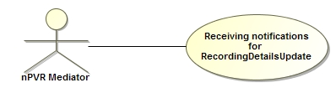

**Figure 25:** Receiving notifications for RecordingDetailsUpdate

|  |  |
| --- | --- |
| **Actor(s)** | Mediator |
| **Information** | This use case describes the flow of events occurring at nPVR BE to handle callback of Recording Details Update from nPVR Mediator. |
| **Pre-condition** | 1. nPVR BE is up and running. 2. nPVR Mediator is up and running and configured correctly with nPVR BE. 3. nPVR BE has scheduled some asset on nPVR Mediator. |
| **Flow of events** | 1. nPVR BE receives a XML RPC request from Mediator on servlet for notification of RecordingDetailsUpdate for an asset with request parameters assetId, recordingFileName and startDelta. 2. On receiving this request the servlet forward this request to respective handler which further delegates this request to BL. 3. BL checks if the recordingFileName provided by nPVR Mediator against pre-determined value in nPVR BE database and also check startDelta is greater than zero. 4. If any of the value is different than BL changes the values for the asset and their child asset of recordingStartTime and recordingDuration in SYSTEMNPVRRECORDING table and updates UserStartDelta, UserStopDelta in USERNPVRRECORDING table in nPVR BE.. 5. PVR BE sends notification to corresponding IM for all the users that are using the system recording of the affected asset. 6. After successfully completing the step 1 to 5 the servlet at nPVR BE would acknowledge requesting mediator with success response. |
| **Post Condition** | 1. nPVR BE shall commit new details of the asset/s in its database. 2. IM receives all the user notifications from nPVR BE. |
| **Alternative flow of events** | None |
| **Exception** | None |
| **Reference** | FSpec_IPTV4.0_nPVR Backend IUS 1.3.docx |

#### Receiving notifications for RecordingStatus

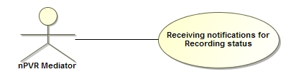

**Figure 26:** Receiving notifications for RecordingStatus

|  |  |
| --- | --- |
| **Actor(s)** | Mediator |
| **Information** | This use case describes the flow of events occurring at nPVR BE to handle callback of RecordingStatus from nPVR Mediator. |
| **Pre-condition** | 1. nPVR BE is up and running. 2. mPVR Mediator is up and running and configured correctly with nPVR BE. 3. nPVR BE has scheduled some asset on nPVR Mediator. |
| **Flow of events** | 1. nPVR BE receives a XML RPC request from Mediator on servlet for notification of RecordingStatus for an asset with request parameters assetId, status and status details. 2. On receiving this request the servlet forward this request to respective handler which further delegates this request to BL. 3. BL verifies npvrAssetId by using DAL from NPVRASSET table of nPVR BE. 4. If existing entry of asset is present then the status and status details are updated for asset and their child assets in asset table in nPVR BE DB. 5. PVR BE sends notification to corresponding IM for all the users that are using the system recording of the affected asset. 6. After successfully completing the step 1 to 6 the servlet at nPVR BE would acknowledge requesting mediator with success response. |
| **Post Condition** | 1. nPVR BE shall commit status of the asset/s in its database. 2. IM receives all the user notifications from nPVR BE. |
| **Alternative flow of events** | None |
| **Exception** | None |
| **Reference** | FSpec_IPTV4.0_nPVR Backend IUS 1.3.docx |

### Reprocessing of recordings on channel update

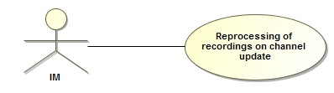

**Figure 27:** Reprocessing of recordings on channel update

|  |  |
| --- | --- |
| **Actor(s)** | nPVR BE |
| **Information** | This use case describes the flow of events occurring at nPVR BE to update the recordings on channel configuration update. |
| **Pre-Condition** | 1. nPVR BE is up and running. 2. Channel configurations are updated for a channel in nPVR BE. |
| **Flow of events** | 1. Updating channel configuration would result in a background process to update recording scheduled on channel. 2. If multicast IP/Port or access URL is modified for a channel stream then:- 3. BL would retrieve all future system recordings scheduled on that channel from SYSTEMNPVRRECORDING table on the basis of Channel ID. 4. For each future system recordings retrieved, BL will invoke data access layer to set EventUpdateStatus to ‘Complete’ in SYSTEMNPVRRECORDING. 5. For each future system recordings, BL will retrieve NPVR assets from NPVRASSET table. 6. BL will invoke data access layer to update NPVRASSET table. Set STATUS and STATUSDEATILS to ‘ReScheduleSuccess’ and ‘Reschedule Success’ respectively. ASSETURL is also updated according to new multicast IP/Port or access URL. 7. Finally BL would send a request to mediator to update physical assets accordingly. 8. If channel is disabled for nPVR then BL will invoke data access layer to update USERNPVRRECORDING table. For all ongoing recording set STATUS and STATUSDETAILS to "Incomplete" and "channel subscription cancelled" respectively. For all future recording set STATUS and STATUSDETAILS to "Cancelled" and "channel subscription cancelled" respectively. 9. If channel stream is disabled for nPVR then BL will invoke data access layer to update NPVRASSET table. For all ongoing recording set STATUS and STATUSDETAILS to "Incomplete" and "channel subscription cancelled" respectively. For all future recording set STATUS and STATUSDETAILS to "Cancelled" and "channel subscription cancelled" respectively |
| **Post Condition** | Recordings of the channels are updated and stored. |
| **Alternative flow of events** | None |
| **Exception** | If nPVR BE receives a request for a context which does not exist at its end then the request shall be declined with an error message having error code ‘NBE001’ and stating ‘No context exists for requesting middleware’. |
| **Reference** | FSpec_IPTV4.0_nPVR Backend IUS 1.3_TrackChanges |

### Notifications to IM on User recording update

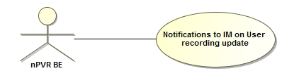

**Figure 28:** Notifications to IM on User recording update

|  |  |
| --- | --- |
| **Actor(s)** | nPVR BE |
| **Information** | This use case describes the flow of events occurring at nPVR BE for scenarios where nPVR BE shall send individual notifications to IM for recording updates of users. These notifications can then be forwarded by IM to user devices to update their recording listings. |
| **Pre-Condition** | 1. The nPVR BE should be up and running. 2. The IM application should be up and running. |
| **Flow of events** | 1. On user recording updates the flag CallbackRequired is checked from SERVERCONTEXT table through data access layer. 2. If CallbackRequired flag found to be false no notification is sent. 3. If CallbackRequired flag found to be true URL address is formed with COMMUNICATIONADDRESS + “/userRecordingsUpdate”. 4. The value of COMMUNICATIONADDRESS is retrieved from SERVERCONTEXT table through data access layer. 5. The User Recordings Update Notification xml should be sent in request body. This file should be according to UserRecordingsUpdateNotification.xsd. 6. The User Recordings Update Notification xml keeps the information of all the users. 7. By using this address URL notification is sent to IM. |
| **Post Condition** | 1. nPVR BE sends notification to IM. |
| **Alternative flow of events** | NONE |
| **Exception** |  |
| **Reference** | FSpec_IPTV4.0_nPVR Backend IUS 1.3_TrackChanges |

### Get Metadata

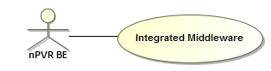

**Figure 29:** Get Metadata

|  |  |
| --- | --- |
| **Actor(s)** | nPVR BE |
| **Information** | This use case describes the flow of events occurring at nPVR BE for scenarios where nPVR BE shall send request to IM to get the information about scheduled program metadata. |
| **Pre-Condition** | 1. The nPVR BE should be up and running. 2. The IM application should be up and running. |
| **Flow of events** | 1. When metadata of scheduled program is required the BL communicate with IM to get the metadata response which keeps the information about scheduled program. 2. BL finds out ServerContext on the basis of ContextId from data base layer. 3. BL retrieve the COMMUNICATIONADDRESS from ServerContext. 4. The URL address is formed with COMMUNICATIONADDRESS + “/getMetadata”. 5. The GetMetadataRequest xml should be sent in request body. This file should be according to GetMetadataRequest.xsd. 6. The GetMetadataRequest xml keeps the information of programIds. 7. By using this address URL the BL communicates with IM. |
| **Post Condition** | 1. nPVR BE gets the GetMetadataResponse from IM. |
| **Alternative flow of events** |  |
| **Exception** | If application is unavailable to process the request the system exception is thrown with an error code ‘NBE000’ and error message stating ‘System Exception’. |
| **Reference** | FSpec_IPTV4.0_nPVR Backend IUS 1.3_TrackChanges |

### Get User Quota

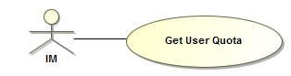

**Figure 30:** Get User Quota

|  |  |
| --- | --- |
| **Actor(s)** | IM |
| **Information** | This use case describes the flow of events occurring at nPVR BE for retrieving the quota information (total and used quota) of the user. |
| **Pre-Condition** | 1. nPVR BE should be up and running. 2. The ContextId of the requesting IM should be there in nPVR BE database. |
| **Flow of events** | 1. At nPVR BE the servlet receives a request from IM for getting user quota with request parameters OpCode, and AccountId in the URL and ContextId of requesting IM in request header. 2. On receiving this request the servlet will call processors for method finding, parameter validations, error handling. 3. The processor forwards this request to respective handler which further delegates this request to BL. 4. BL verifies context ID of the requesting IM if it is registered in SERVERCONTEXT table of nPVR BE database through data access layer. 5. BL would retrieve user detail from NPVRUSERDETAILS table through data access layer on the basis of AccountId provided through request and ContextId of requesting IM. 6. The total minutes will be retrieved from NPVRUSERDETAILS table. 7. The used minutes is retrieved from the sum of ACTUALRECSECONDS field of USERNPVRRECORDING table through data access layer and then divided by 60. |
| **Post Condition** | 1. User quota is retrieved successfully and nPVR BE sends a response to requesting IM. 2. If the value for ResponseFormat is found to be ‘object’ the response is returned as Object. If the value of ResponseFormat is ‘xml’ the response will be returned as xml. 3. The response should be according to NPVRGetUserQuotaResponse.xsd. |
| **Alternative flow of events** | NONE |
| **Exception** | 1. If request parameters OpCode, AccountId, and ContextId are not coming in the request the request shall be declined with an error code ‘NBE005’ and error message stating ‘Mandatory parameter missing: ParameterName’. 2. If nPVR BE receives a request for ContextId which does not exist at its end then the request shall be declined with an error code ‘NBE001’ and error message stating ‘No context exists for requesting middleware’. 3. If the user AccountId in the request does not exist for ContextId in nPVR BE database the request shall be declined with an error code ‘NBE007’ and error message stating ‘User does not exist’. 4. If application is unavailable to process the request the system exception is thrown with an error code ‘NBE000’ and error message stating ‘System Exception’. |
| **Reference** | FSpec_IPTV4.0_nPVR Backend IUS 1.3_TrackChanges |

## Use case modeling for NPVR BE Components and Processes

### Communication with nPVR Mediator

#### Create Recording

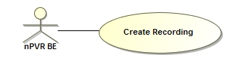

**Figure 31:** Communication with nPVR Mediator for Create Recording

|  |  |
| --- | --- |
| **Actor(s)** | nPVR BE |
| **Information** | This use case describes the flow of events occurring at nPVR BE for creating new recording (asset) in the VoD server by communicating with mediator. |
| **Pre-Condition** | 1. nPVR BE should be up and running. 2. Mediator application should be up and running. |
| **Flow of events** | 1. On creation of system recording a create request is sent to mediator by BL of nPVR BE so that assets can be created on VoD servers. 2. The communication with mediator is done through XML-RPC protocol. 3. The URL for communication with mediator is retrieved from npvr.properties file. 4. BL passes parameters NpvrAssetId, MulticastAddress, Port, StartTime, Duration, Bitrate, Filename, EpgVersion, TransportProtocol, AccessUrl, RecordingSubsystem, mcSourceIPlist, RecordPath while calling mediator. 5. The BL finds the information about these fields from SYSTEMNPVRRECORDNG, SYSTEMCONFIG, NPVRASSET, MEDIATYPEPROFILES AND CHANNELSTREAM tables through data access layer. 6. The recording subsystem is found out by BL of nPVR BE from the transport protocol of MTP given in MEDIATYPEPROFILES tables. If transport = MULTICAST (over UDP or RTP) = IPTV. If transport = UNICAST (over UDP or RTP) = 3GP. If transport = HTTP streaming or download = HTTP. If transport = IIS Smooth Streaming = MSSP. 7. If recording subsystem is IPTV or 3GP and streaming protocol contains the value RTP the transport protocol will be rtp. If this is not the case the transport protocol will be udp. 8. If recording subsystem is HTTP the transport protocol will be http. 9. If recording subsystem is MSSP the transport protocol will be “”. |
| **Post Condition** | 1. The mediator receives create recording (asset) request from nPVR BE. |
| **Alternative flow of events** | None |
| **Exception** |  |
| **Reference** | FSpec_IPTV4.0_nPVR Backend IUS 1.3_TrackChanges |

#### Delete Recording

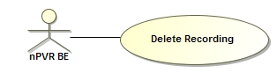

**Figure 32:** Communication with nPVR Mediator for Delete Recording

|  |  |
| --- | --- |
| **Actor(s)** | nPVR BE |
| **Information** | This use case describes the flow of events occurring at nPVR BE for communication with mediator when asset is to be deleted from VoD server. |
| **Pre-Condition** | 1. nPVR BE should be up and running. 2. Mediator application should be up and running. |
| **Flow of events** | 1. When deletion of asset is required the BL of nPVR BE sends delete request to mediator so that assets can be deleted from VoD server. 2. The communication with mediator is done through XML-RPC protocol. 3. The URL for communication with mediator is retrieved from npvr.properties file. 4. BL passes parameters NpvrAssetId while calling mediator. 5. The BL finds the information about NpvrAssetId from NPVRASSET table through data access layer. |
| **Post Condition** | 1. The mediator receives delete recording (asset) request from nPVR BE. |
| **Alternative flow of events** | None |
| **Exception** |  |
| **Reference** | FSpec_IPTV4.0_nPVR Backend IUS 1.3.docx |

#### Update Recording

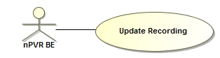

**Figure 33:** Communication with nPVR Mediator for Update Recording

|  |  |
| --- | --- |
| **Actor(s)** | nPVR BE |
| **Information** | This use case describes the flow of events occurring at nPVR BE for communication with mediator when properties of existing schedule is changed. |
| **Pre-Condition** | 1. nPVR BE should be up and running. 2. Mediator application should be up and running. |
| **Flow of events** | 1. On update of properties of existing scheduled recording the BL of nPVR BE sends update request to mediator so that properties at mediator’s end can also be modified. 2. Only those properties of scheduled recording are sent in the request which have undergone changes. 3. The communication with mediator is done through XML-RPC protocol. 4. The URL for communication with mediator is retrieved from npvr.properties file. 5. BL passes parameters NpvrAssetId, MulticastAddress, Port, StartTime, Duration, Bitrate, Filename, EpgVersion, TransportProtocol, AccessUrl, RecordingSubsystem, mcSourceIPlist, RecordPath while calling mediator. 6. The BL finds the information about these fields from SYSTEMNPVRRECORDNG, SYSTEMCONFIG, NPVRASSET, MEDIATYPEPROFILES AND CHANNELSTREAM tables through data access layer. 7. The recording subsystem is found out by BL of nPVR BE from the transport protocol of MTP given in MEDIATYPEPROFILES tables. If transport = MULTICAST (over UDP or RTP) = IPTV. If transport = UNICAST (over UDP or RTP) = 3GP. If transport = HTTP streaming or download = HTTP. If transport = IIS Smooth Streaming = MSSP. 8. If recording subsystem is IPTV or 3GP and streaming protocol contains the value RTP the transport protocol will be rtp. If this is not the case the transport protocol will be udp. 9. If recording subsystem is HTTP the transport protocol will be http. 10. If recording subsystem is MSSP the transport protocol will be “”. |
| **Post Condition** | 1. The mediator receives update recording request from nPVR BE. |
| **Alternative flow of events** | None |
| **Exception** |  |
| **Reference** | FSpec_IPTV4.0_nPVR Backend IUS 1.3.docx |

#### Recording Status

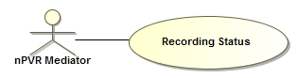

**Figure 34:** Communication with nPVR Mediator for Recording Status

|  |  |
| --- | --- |
| **Actor(s)** | Mediator |
| **Information** | This use case describes the flow of events occurring at nPVR BE to handle callback of RecordingStatus from nPVR Mediator. |
| **Pre-condition** | 1. nPVR BE is up and running. 2. mPVR Mediator is up and running and configured correctly with nPVR BE. 3. nPVR BE has scheduled some asset on nPVR Mediator. |
| **Flow of events** | 1. nPVR BE receives a XML RPC request from Mediator on servlet for notification of RecordingStatus for an asset with request parameters assetId, status and status details. 2. On receiving this request the servlet forward this request to respective handler which further delegates this request to BL. 3. BL verifies npvrAssetId by using DAL from NPVRASSET table of nPVR BE. 4. If existing entry of asset is present then the status and status details are updated for asset and their child assets in asset table in nPVR BE DB. 5. PVR BE sends notification to corresponding IM for all the users that are using the system recording of the affected asset. 6. After successfully completing the step 1 to 6 the servlet at nPVR BE would acknowledge requesting mediator with success response. |
| **Post Condition** | 1. nPVR BE shall commit status of the asset/s in its database. 2. IM receives all the user notifications from nPVR BE. |
| **Alternative flow of events** | None |
| **Exception** | None |
| **Reference** | FSpec_IPTV4.0_nPVR Backend IUS 1.3.docx |

#### Recording Details Update

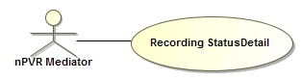

**Figure 35:** Communication with nPVR Mediator for Recording Details Update

|  |  |
| --- | --- |
| **Actor(s)** | Mediator |
| **Information** | This use case describes the flow of events occurring at nPVR BE to handle callback of Recording Details Update from nPVR Mediator. |
| **Pre-condition** | 1. nPVR BE is up and running. 2. mPVR Mediator is up and running and configured correctly with nPVR BE. 3. nPVR BE has scheduled some asset on nPVR Mediator. |
| **Flow of events** | 1. nPVR BE receives a XML RPC request from Mediator on servlet for notification of RecordingDetailsUpdate for an asset with request parameters assetId, recordingFileName and startDelta. 2. On receiving this request the servlet forward this request to respective handler which further delegates this request to BL. 3. BL checks if the recordingFileName provided by nPVR Mediator against pre-determined value in nPVR BE database and also check startDelta is greater than zero. 4. If any of the value is different than BL changes the values for the asset and their child asset of recordingStartTime and recordingDuration in SYSTEMNPVRRECORDING table and updates UserStartDelta, UserStopDelta in USERNPVRRECORDING table in nPVR BE.. 5. PVR BE sends notification to corresponding IM for all the users that are using the system recording of the affected asset. 6. After successfully completing the step 1 to 5 the servlet at nPVR BE would acknowledge requesting mediator with success response. |
| **Post Condition** | 1. nPVR BE shall commit new details of the asset/s in its database. 2. IM receives all the user notifications from nPVR BE. |
| **Alternative flow of events** | None |
| **Exception** | None |
| **Reference** | FSpec_IPTV4.0_nPVR Backend IUS 1.3.docx |

### Background Processes

#### Manage Expired Recording Cleanup

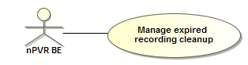

**Figure 36:** Manage Expired Recording Cleanup

|  |  |
| --- | --- |
| **Actor(s)** | nPVR BE |
| **Information** | This use case describes the flow of events occurring at nPVR BE to delete the expired recordings. |
| **Pre-Condition** | 1. nPVR BE is up and running. 2. INDEFINITERETENTION is null. |
| **Flow of events** | 1. nPVR BE starts a background process at a configurable interval to delete the expired recordings . 2. nPVR BE scans the USERNPVRRECORDING table; if a user recording is found to be expired then the user recording record is removed from the USERNPVRRECORDING table. A user recording is considered expired if sum of RecordingStartTime, RecordingDuration and NPVRKeepDays is less than configured time. 3. NPVRKeepDays can be retrieved from NPVRUSERDETAILS table for specific user as well as from SYSTEMCONFIG table for specific IM but only NPVRKeepDays having lower value is considered for retention time. 4. nPVR BE scans NPVRASSET table, if a recording asset is expired with respect to corresponding MTP/context level retention period, then nPVR BE sends a request to mediator to delete physical assets and remove the asset entry from NPVRASSET table. An nPVR asset is considered expired if sum of RecordingStartTime, RecordingDuration and NPVRKeepDays is less than configured time. 5. NPVRKeepDays can be retrieved from MEDIATYPEPROFILES table for specific mtp as well as from SYSTEMCONFIG table for specific IM but only NPVRKeepDays having lower value is considered for retention time. 6. nPVR BE scans SYSTEMNPVRRECORDING table, if a recording is found for which there is no asset in NPVRASSET table or for which there is no user recording in USERNPVRRECORDING table then the following steps should be performed:- 7. BL will invoke data access layer to delete all the assets associated to the system recording from NPVRASSET table. 8. BL will send a request to mediator to delete physical assets. 9. BL will invoke data access layer to delete all the user recordings associated to the system recording from USERNPVRRECORDING table. 10. BL will invoke data access layer to delete system recording from SYSTEMNPVRRECORDING table. 11. Finally BL will invoke data access layer to delete the program record from PROGRAMDETAILS table if it is no longer referenced by any other system recordings. |
| **Post Condition** | All the expired records should delete from database. |
| **Alternative flow of events** | 1. In case the asset being removed is a parent asset then all of its child assets should also be removed at the same time. Note that no notification would be sent for these child assets to mediator. 2. If INDEFINITERETENTION is false and sum of RecordingStartTime and RecordingDuration is less than NPVRFiniteRetentionTimeStamp then. 3. A user recording is considered expired if sum of NPVRFiniteRetentionTimeStamp and NPVRKeepDays is less than configured time. 4. Otherwise a user recording is considered expired if sum of RecordingStartTime, RecordingDuration and NPVRKeepDays is less than configured time. |
| **Exception** | None |
| **Reference** | FSpec_IPTV4.0_nPVR Backend IUS 1.3_TrackChanges |

#### nPVR User Quota Check Process

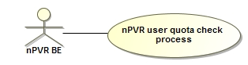

**Figure 37:** nPVR User Quota Check Process

|  |  |
| --- | --- |
| **Actor(s)** | nPVR BE |
| **Information** | This use case describes the flow of events occurring at nPVR BE for quota check.  For an ongoing airing quota check is performed at the time of request.  For a future recording quota check is performed at just about the time when the recording is going to start. |
| **Pre-Condition** | 1. nPVR BE is up and running. |
| **Flow of events** | 1. Determine the recording duration of the recording going to start. 2. Calculate used minutes for user. Retrieve all records for user from USERNPVRRECORDING where STATUS is ‘RecordSuccess’ or ‘Incomplete’. Add duration of all such records to obtain used minutes. 3. Retrieve TOTALMINUTES for user from NPVRUSERDETAILS table on the basis of ACCOUNTID and CONTETID. 4. Calculate whether user quota is sufficient for the recording i.e. if remaining minutes (total minutes – used minutes) is more than needed minutes. 5. If user has enough quotas then set status of the user recording in the USERNPVRRECORDING table to “RecordSuccess”. 6. If user has not enough quotas to allow the recording going to start then calculate the time that can be freed with auto-delete. 7. Only those user recordings for which DELETEWHENSPACENEEDED is true are considered for auto deletion. 8. If the time that can be freed with auto-delete is sufficient to allow the recording going to start then:-    * + - 1. From all the recordings which are eligible for auto-delete, determine the oldest ones shall be deleted to free-up user quota. This selection of the oldest recording shall happen independent of the fact the recording to be deleted is an episode of a series or an individual recording.          2. Delete the oldest recordings eligible for auto deletion, until enough space to allow new recording.          3. Set status of the user recording in the USERNPVRRECORDING table to “RecordSuccess”. 9. If the time that can be freed with auto-delete is not sufficient to allow the recording going to start then set status of the user recording in the USERNPVRRECORDING table to “FailedDueToNoSpace”. 10. Send a notification to IM for user nPVR update referring to nPVR user whose recordings have been updated if callback is enabled for the IM. |
| **Post Condition** | Status of user recording in the USERNPVRRECORDING table will set to either “RecordSuccess” or “FailedDueToNoSpace” and a notification will be sent to IM. |
| **Alternative flow of events** | None |
| **Exception** | None |
| **Reference** | FSpec_IPTV4.0_nPVR Backend IUS 1.3.docx |

#### nPVR Failed Recordings Retrial Process

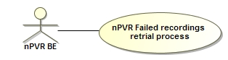

**Figure 38:** nPVR Failed Recording Retrial Process

|  |  |
| --- | --- |
| **Actor(s)** | nPVR BE |
| **Information** | This use case describes the flow of events occurring at nPVR BE to perform a recordings retrial process. |
| **Pre-Condition** | 1. nPVR BE is up and running. |
| **Flow of events** | 1. nPVR BE starts a background at a configured period to retry scheduling of those recordings which could not be conveyed to nPVR mediator due to any reason. 2. BL retrieves all system recording from SYSTEMNPVRRECORDING table for which STATUS is either 'ScheduleFailed' or 'ReScheduleFailed'. 3. If the RecordingStartTime is less than current time then BL will invoke data access layer to update SYSTEMNPVRRECORDING table. Set STATUS and STATUSDETAILS to "RecordFailed" and "Recording Failed" respectively. For all asset of this recording update NPVRASSET table set STATUS and STATUSDETAILS to "RecordFailed" and "Recording Failed" respectively. 4. Otherwise BL will send a request to mediator for updating assets if STATUS is ReScheduleFailed. If STATUS is 'ScheduleFailed' then BL will send a request to mediator for creating new asset. |
| **Post Condition** | All the expired records should delete from database. |
| **Alternative flow of events** | 1. In case the asset being updated is a parent asset then all of its child assets should also be updated at the same time. Note that no notification would be sent for these child assets to mediator. |
| **Exception** | None |
| **Reference** | FSpec_IPTV4.0_nPVR Backend IUS 1.3.docx |

#### Reprocessing of Recordings on Channel Configuration Update

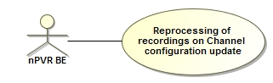

**Figure 39:** Reprocessing of Recording on Channel Configuration update

|  |  |
| --- | --- |
| **Actor(s)** | nPVR BE |
| **Information** | This use case describes the flow of events occurring at nPVR BE to update the recordings on channel configuration update. |
| **Pre-condition** | 1. nPVR BE is up and running. 2. Channel configurations are updated for a channel in nPVR BE. |
| **Flow of events** | 1. Updating channel configuration would result in a background process to update recording scheduled on channel. 2. If multicast IP/Port or access URL is modified for a channel stream then:- 3. BL would retrieve all future system recordings scheduled on that channel from SYSTEMNPVRRECORDING table on the basis of Channel ID. 4. For each future system recordings retrieved, BL will invoke data access layer to set EventUpdateStatus to ‘Complete’ in SYSTEMNPVRRECORDING. 5. For each future system recordings, BL will retrieve NPVR assets from NPVRASSET table. 6. BL will invoke data access layer to update NPVRASSET table. Set STATUS and STATUSDEATILS to ‘ReScheduleSuccess’ and ‘Reschedule Success’ respectively. ASSETURL is also updated according to new multicast IP/Port or access URL. 7. Finally BL would send a request to mediator to update physical assets accordingly. 8. If channel is disabled for nPVR then BL will invoke data access layer to update USERNPVRRECORDING table. For all ongoing recording set STATUS and STATUSDETAILS to "Incomplete" and "channel subscription cancelled" respectively. For all future recording set STATUS and STATUSDETAILS to "Cancelled" and "channel subscription cancelled" respectively. 9. If channel stream is disabled for nPVR then BL will invoke data access layer to update NPVRASSET table. For all ongoing recording set STATUS and STATUSDETAILS to "Incomplete" and "channel subscription cancelled" respectively. For all future recording set STATUS and STATUSDETAILS to "Cancelled" and "channel subscription cancelled" respectively |
| **Post Condition** | Recordings of the channels are updated and stored. |
| **Alternative flow of events** | None |
| **Exception** | If nPVR BE receives a request for a context which does not exist at its end then the request shall be declined with an error message having error code ‘NBE001’ and stating ‘No context exists for requesting middleware’. |
| **Reference** | FSpec_IPTV4.0_nPVR Backend IUS 1.3_TrackChanges |

#### Manage Channel update and User update changes

|  |  |  |  |  |
| --- | --- | --- | --- | --- |
| nPVR BE Action | Finished Recordings | Ongoing Recordings | Future Recording | Referred use cases |
| Channel Exclusion for an nPVR User. | Recordings remain in content listings. Recordings are retained according to the nPVR retention period or until user deletes them. | Recording stopped, marked as ”incomplete”, reason “channel subscription cancelled”. Recordings are retained according to the nPVR retention period or until user deletes them. | Recording Cancelled, marked as “cancelled”, reason “channel subscription cancelled”. | 4.1.7 nPVR user update request |
| Channel disabled from nPVR | Same as above. | Same as above with system message “Associated channel not available for PVR” | Same as above with system message “Associated channel not available for PVR” | 4.1.4 Configuring Channels at nPVR BE |
| User removal from nPVR BE | All the user recordings are removed from nPVR BE. | All the user recordings are removed from nPVR BE. | All the user recordings are removed from nPVR BE. | 4.1.8 nPVR user delete request |
| Channel multicast address/port, channel access URL is updated | None | Recording continues using the former channel data | Scheduled recording will be updated with new channel data | 4.2.2.4 Reprocessing of recordings on Channel configuration update |
| Channel npvr trick play setting is updated | None | None | None | None |
| Recording path is updated for the context. | None | None | The recording will use the updated path for storage | 4.1.2 Configuring nPVR backend settings |
| Series is disabled for nPVR user | No effect. Series listings still available. Series episodes still available. | No effect. | Future episodes of the Series are cancelled. No more episodes are scheduled for the series. | 4.1.7 nPVR user update request |
| Series again enabled for nPVR user | No effect | No effect | No effect on already cancelled scheduled episode recordings on associated channel even if start time or end time is greater than current time. They still remain in content listing as cancelled (if not deleted by user in the meantime). | 4.1.7 nPVR user update request |
| Channel stream disabled from nPVR | Recording asset remains in content listings. | Recording asset marked as “incomplete”, with system message “Associated channel stream not available for PVR” | Recording asset Cancelled, marked as “cancelled”, with system message “Associated channel stream not available for PVR” | 4.2.2.4 Reprocessing of recordings on Channel configuration update |

## NPVR Backend Interfaces

### GUI Windows

N/A

### Distributed Interface

### Messages

Several Interfaces are exposed by nPVR BE to provide various services and CRUD operations that can be performed on nPVR BE resources.

### General Concepts

#### Categories of Interfaces

#### Communication and Security

nPVR BE can be configured to support HTTPs, HTTP or both at the same time. It shall support both HTTP and secured HTTP (HTTPS) communication.

Two separate ports 9001 and 9002 should be configured to work in HTTP and HTTPS respectively.

For maintaining the confidentiality and integrity of user data secured communication should be ensured between nPVR BE and IM using HTTPS. The port serving secured HTTP communication shall authenticate the requests/notifications with TLS network layer security mechanism (client-server authentication mechanism).

Shared Client certificates should be used for secured communication for TLS between IM and nPVR BE.

#### Error Responses

In general the following error handling concept is used:

* In case of a general HTTP error:   
  A standard HTTP error status code is sent.
* In case of an application layer error:  
  the HTTP status code indicates success and the body of this HTTP response contains an XML file, which is a general error response with format, error codes and error descriptions as specified in the interface definitions. The schema of response is attached herewith



#### Standard HTTP Status Codes

A subset of the standard HTTP status codes like the ones given in the table below are used in the nPVR BE responses. Please refer to the HTTP protocol specification of standard error codes in <HTTP://www.w3.org/Protocols/rfc2616/rfc2616-sec10.html#sec10>.

| **Standard HTTP status code** | **Semantics** |
| --- | --- |
| 100 Continue | Standard status code, see reference |
| 200 OK | Standard response status code for successful HTTP requests |
| 404 Not Found | Standard status code |
| 408 | Request Timeout |
| 500 | Internal Server Error |

Table 4: Standard HTTP Status Codes

**4.1.4 Common data types**



### Management Interfaces

### External Interfaces

### User Interfaces

## Class Modeling

### nPVR BE Framework

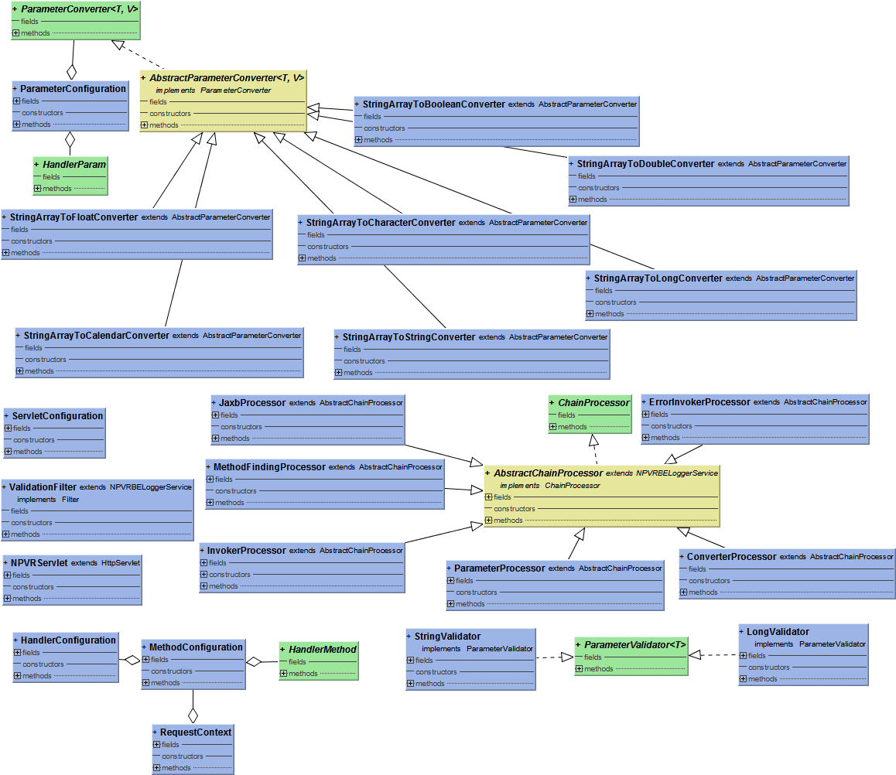

**Figure 40:** nPVR BE RequestHandler classes

#### Converter Classes

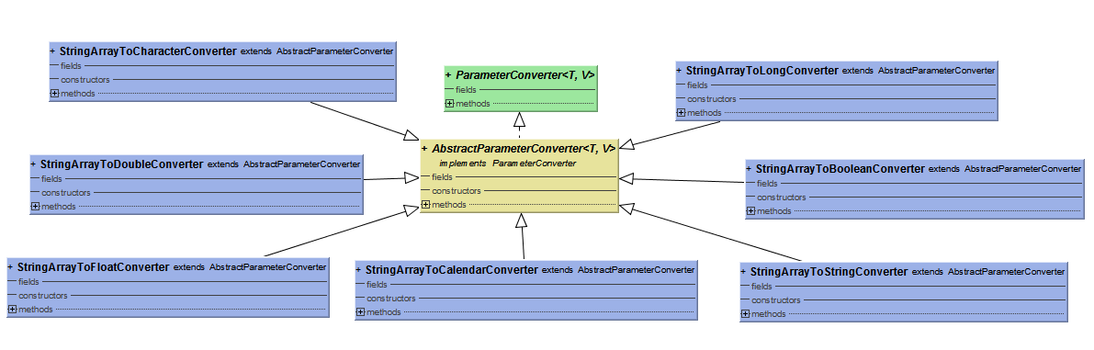

**Figure 41:** Converter Classes

#### Handler Classes

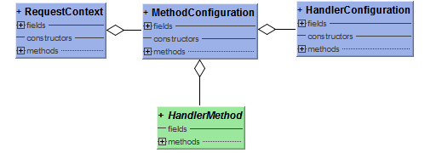

**Figure 42:** Handler Classes

#### Processor Classes

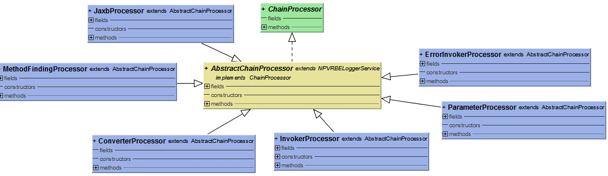

**Figure 43:** Processor Classes

### nPVR BE Quota Check Classes

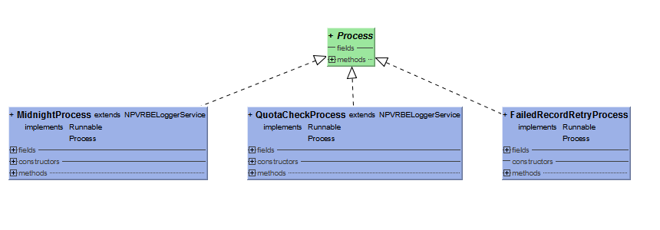

**Figure 44:** nPVR BE Quota Check Classes

### nPVR BE Dao Classes

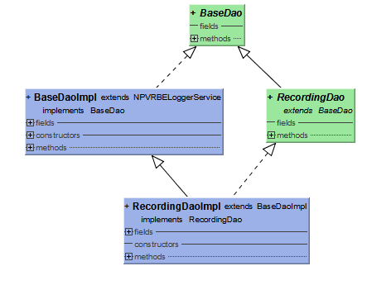

**Figure 45:** Business Layer Dao Classes

### nPVR BE Backend BL Classes

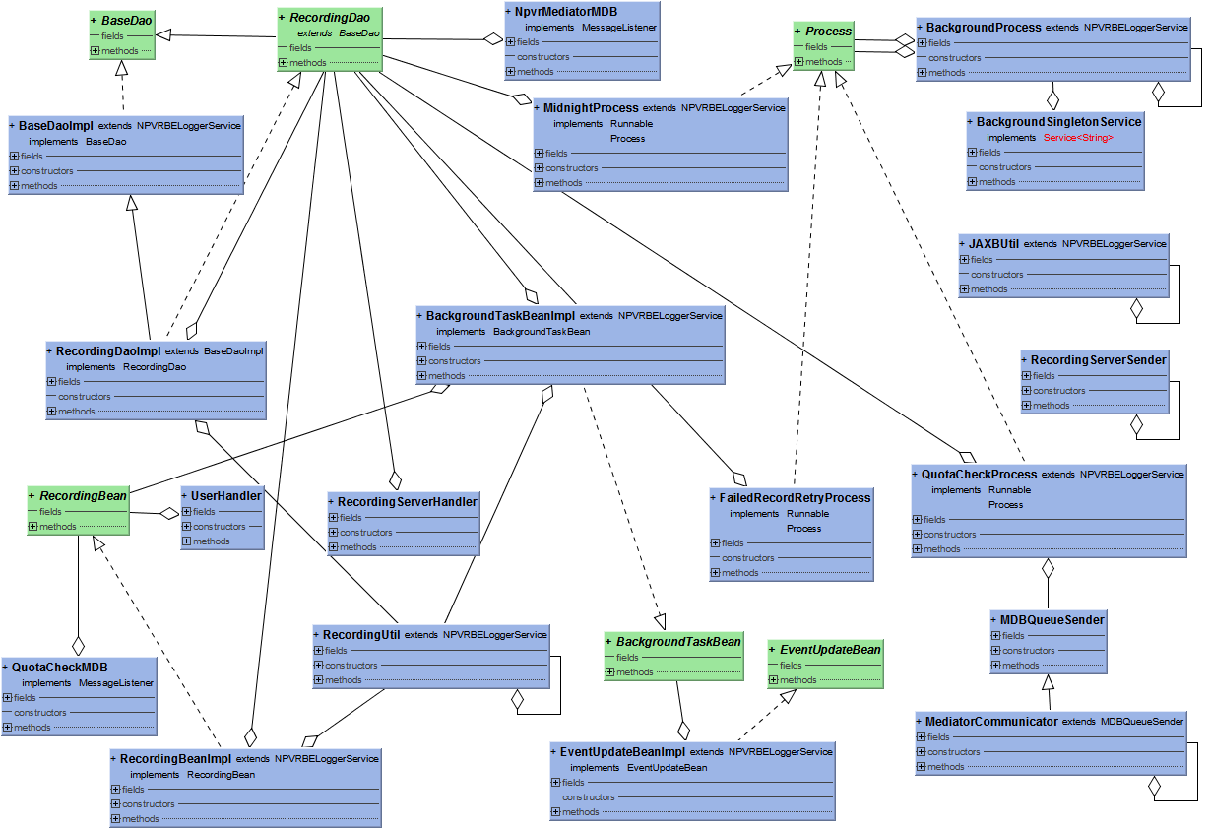

**Figure 46:** nPVR BE Backend BL Classes

### nPVR BE Middleware Interface Classes

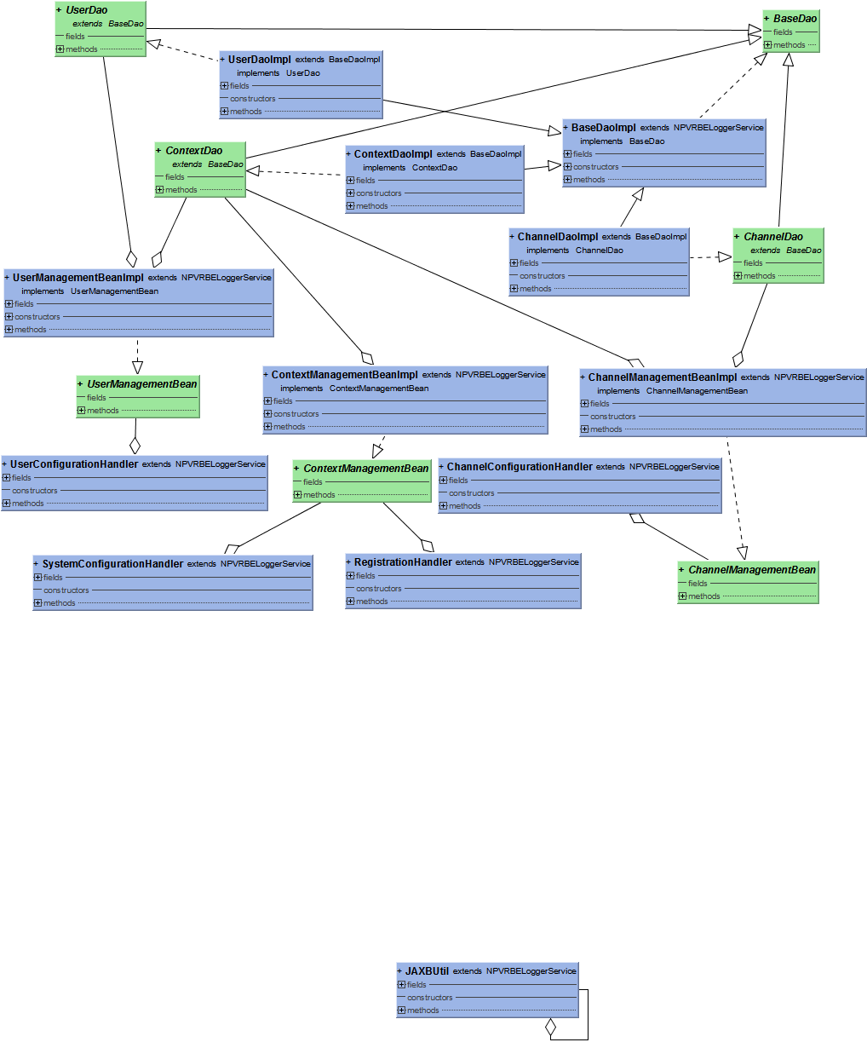

**Figure 47:** nPVR BE Middleware Interface Classes

# Implementation

## Integrating nPVR BE with IM

### Flow Diagram



**Figure 48:** Flow Diagram: Integrating nPVR BE with IM

### Sequence Diagram

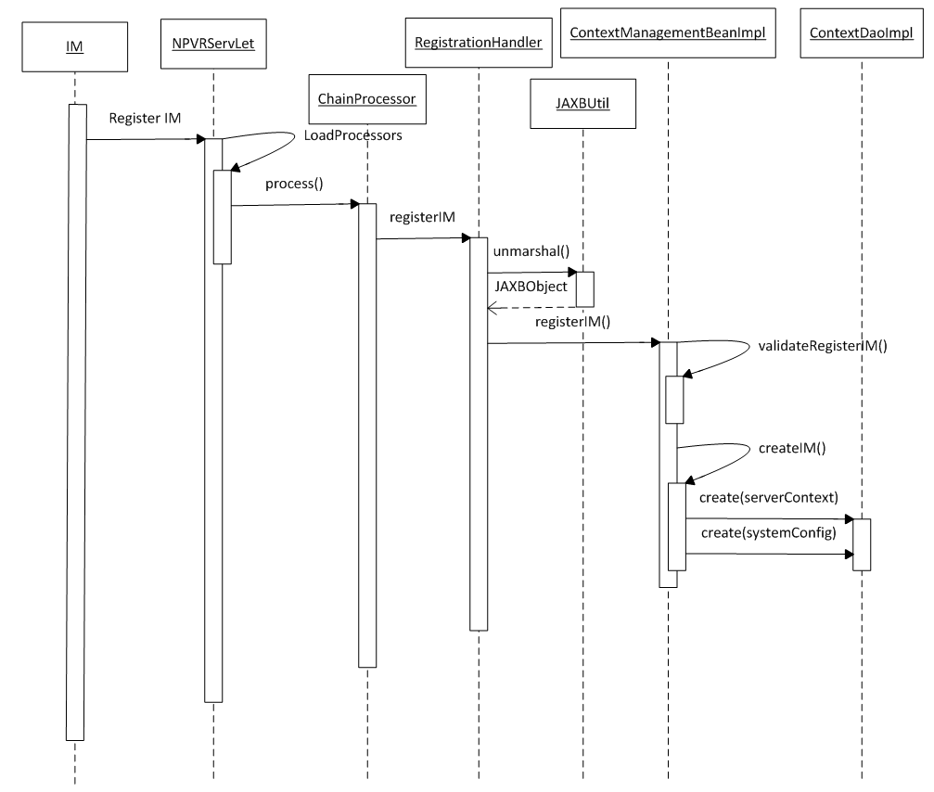

**Figure 49:** Sequence Diagram: Integrating nPVR BE with IM

### Business Logic

#### com.acn.servlet.NPVRServlet.java

NPVRServlet is the controller and it receives all the requests on NPVR BE and forwards the request to appropriate Handler using processors based on the request context in the URL.

|  |  |  |
| --- | --- | --- |
| ***Creating Method*** | ***Description*** | ***Exception*** |
| public void init() | Called by the servlet container to indicate to a servlet that the servlet is being placed into service. In this method initialization of processer and config file loading is being done. | None |
| private void sendError(HttpServletResponse response, int code) | Sends an error response to the client using the specified status code. | None |
| public void service(HttpServletRequest request, HttpServletResponse response) | Called by the servlet container to allow the servlet to respond to a request. This method is responsible to call each processor ‘s process method. | None |

Table 5: NPVRServlet.java

#### com.acn.application.processors.ChainProcessor.java

ChainProcessor is the interface for classes responsible for the various request processing steps. Classes that implement this interface are ConverterProcessor.java, ErrorInvokerProcessor.java, InvokerProcessor.java, JaxbProcessor.java, MethodFindingProcessor.java and ParameterProcessor.java.

|  |  |  |
| --- | --- | --- |
| ***Creating Method*** | ***Description*** | ***Exception*** |
| void configure(Map<String, Object> properties) | Configure processors properties. | None |
| void process(RequestContext ctx) | Process nPVRBE request. | None |

Table 6: ChainProcessor.java

#### com.acn.handler.system.RegistrationHandler.java

RegistrationHandler class is used as handler for register an IM in its system.

|  |  |  |
| --- | --- | --- |
| ***Creating Method*** | ***Change Description*** | ***Exception*** |
| public void registerIM(String contextId, String postData) | Initiate registration of IM, validate and unmarshal request xml, and call method of session bean. | None |
| public Object error(Exception e) | Create and return error object to client. | None |

Table 7: RegistrationHandler.java

#### com.acn.util.JAXBUtil.java

This is a singleton class.JAXBUtil class is being used as utility class for the marshaling, unmarshaling and validation of schemas.

|  |  |  |
| --- | --- | --- |
| ***Creating Method*** | ***Description*** | ***Exception*** |
| private void init() | Method used as Iinitialize the jaxb context and loading of schema for the purpose of validation. | None |
| public static JAXBUtil getInstance() | Provide a single instance of JAXBUtil class. | None |
| private Marshaller getMarshaller() | Get the marshaller object on the basis of jaxb context. | None |
| public String marshall(Object jaxbObject) | This method is used to marshal the jaxb object to get xml | None |
| public void marshall(Object jaxbObject, Writer writer) | Marshal request taking input as jaxb object and writer | None |
| private Unmarshaller getUnMarshller() | Get the unmarshaller object on the basis of jaxb context | None |
| public Object validateAndUnmarshall(String postRequestContent,JAXBSchema jaxbShcema) | Validate and unmarshal the post data receive in post request. | None |
| private void loadJAXBSchema() | Method is used to load all schemas at the time of initialization of jaxbutil class. Using these schemas validation process is being done. | None |

Table 8: JAXBUtil.java

#### com.acn.beans.services.impl.ContextManagementBeanImpl.java

ContextManagementBeanImpl is used as business logic layer for the entire request related to context managent, configuring backend setting and configuring MDPs.

|  |  |  |
| --- | --- | --- |
| ***Creating Method*** | ***Change Description*** | ***Exception*** |
| public void registerIM(String contextId, RegisterMiddlewareRequest registerMiddlewareRequest) | Validate data and call createIM() method to save IM data into database | None |
| private void validateRegisterIM( String contextId, RegisterMiddleware registerMiddleware) | Validate parameters for registration | None |
| private ServerContext createIM(String contextId, RegisterMiddleware registerMiddleware) | This method saves new server context data into serverContext table | None |
| public void configureSettings(String contextId, SystemConfigurationRequest systemConfigurationRequest, String responseFormat) | Validate configuration parameters and configureSettings() method to save configure parameter for IM | None |
| private void validateConfigurationParams(String contextId) | Validates system configuration parameters | None |
| private void configureSettings(String contextId, com.acn.resources.SystemConfigurationRequest.SystemConfig systemConfigResource) | This method calls mediaTypeProfilesConfiguration() and npvrSystemConfiguration() method for MTP and npvr system configuration for request context. | None |
| private void npvrSystemConfiguration(String contextId, SystemConfig systemConfig, NpvrConfig npvrConfig) | Saves data for system configuration for requesting contextid | None |
| private void notifyMediatorOnRecordingPathChange (List<SystemNpvrRecording> sysRecs, boolean changedRecordPath3GP,  boolean changedRecordPathHTTP,  boolean changedRecordPathISS ) | This method notifies mediator on recording path change. | None |
| private void mediaTypeProfilesConfiguration(String contextId, List<MTP> mtpList) | Saves data for MTPs for requesting contextid | None |
| public String getRecordingSubsystemByTransportProtocol(String transportProtocol) | Convert transport protocol to recording sub system | None |
| public SystemConfig findSystemConfigValue(String contextId) | This method returns SystemConfig values for contextId.If value for any field is null then it will set default context value for that field. | None |

Table 9: ContextManagementBeanImpl.java

### Objects to lock

None

### Exceptions

#### com.acn.exceptions.BusinessException.java

This is the base class for npvrbe business layer exceptions. You should, as a rule subclass this to create a more specific exception.

|  |  |  |
| --- | --- | --- |
| ***Creating Method*** | ***Description*** | ***Exception*** |
| public String getErrorCode() | Get error code | None |
| public void setErrorCode(String errorCode) | Set error code | None |

Table 10: BusinessException.java

#### com.acn.exceptions.ConversionException.java

This is the exception class for data type conversion exceptions.

|  |  |  |
| --- | --- | --- |
| ***Creating Method*** | ***Description*** | ***Exception*** |
| public String getParameter() | Get parameter | None |
| public void setParameter(String parameter) | Set parameter | None |
| public Class<?> getType() | Get type | None |
| public void setType(Class<?> type) | Set type | None |
| public Object getInput() | Get input | None |
| public void setInput(Object input) | Set input | None |

Table 11: ConversionException.java

#### com.acn.exceptions.HandlerConfigurationException.java

This is the exception class for handling exception during handler configuration.

|  |  |  |
| --- | --- | --- |
| ***Creating Method*** | ***Description*** | ***Exception*** |
| None | None | None |

Table 12: HandlerConfigurationException.java

#### com.acn.exceptions.HandlerException.java

This is the exception class for handling exception during handler process the request.

|  |  |  |
| --- | --- | --- |
| ***Creating Method*** | ***Description*** | ***Exception*** |
| public String getPathInfo() | Get pathInfo | None |
| public void setPathInfo(String pathInfo) | Set pathInfo | None |
| public Map<String, Object> getInputParameters() | Get inputParameters | None |
| public void setInputParameters(Map<String, Object> inputParameters) | Set inputParameters | None |
| public Long getCode() | Get code | None |
| public void setCode(Long code) | Set code | None |

Table 13: HandlerException.java

#### com.acn.exceptions.InvalidParameterFormatException.java

This exception class is intended for use when the parameters are not set as expected.

|  |  |  |
| --- | --- | --- |
| ***Creating Method*** | ***Description*** | ***Exception*** |
| None | None | None |

Table 14: InvalidParameterFormatException.java

#### com.acn.exceptions.InvalidParameterValueException.java

This exception class is intended for use when the parameter value are not set as expected

|  |  |  |
| --- | --- | --- |
| ***Creating Method*** | ***Description*** | ***Exception*** |
| None | None | None |

Table 15: InvalidParameterValueException.java

#### com.acn.exceptions.ParameterException.java

This is the base class for parameter exceptions. You should, as a rule subclass this to create a more specific exception.

|  |  |  |
| --- | --- | --- |
| ***Creating Method*** | ***Description*** | ***Exception*** |
| **public** String getParameter() | Get the parameter | None |

Table 16: ParameterException.java

#### com.acn.exceptions.ParameterRequiredException.java

This exception class is intended for use when the parameter required (mandatory) are not set as expected

|  |  |  |
| --- | --- | --- |
| ***Creating Method*** | ***Description*** | ***Exception*** |
| None | None | None |

Table 17: ParameterRequiredException.java

#### com.acn.exceptions.UserException.java

This exceptions class is intended for use when there is no user.

|  |  |  |
| --- | --- | --- |
| ***Creating Method*** | ***Description*** | ***Exception*** |
| public Object getObj() | Get the object | None |

Table 18: UserException.java

#### com.acn.exceptions.ValidationException.java

This exception class is intended for use when the validations of parameter are not as expected.

|  |  |  |
| --- | --- | --- |
| ***Creating Method*** | ***Description*** | ***Exception*** |
| None | None | None |

Table 19: ValidationException.java

### Database Classes

#### com.acn.beans.dao.impl.ContextDaoImpl.java

ContextDaoImpl class is used as data access layer for the request related to context managent, configuring backend setting and configuring MDPs.

|  |  |  |
| --- | --- | --- |
| ***Creating Method*** | ***Change Description*** | ***Exception*** |
| boolean isServerContextValid(String contextId) | Validates the server context and returns true or false value on the basis of server context id. | None |
| public MediaTypeProfile findMediaTypeprofileBycontextIdAndExternalId(String contextId, String externalId) | Returns MediaTypeProfile by contextId and externalId | None |
| public int removeMediaTypeProfileByContextId(String contextId) | Remove MTPs by contextId | None |
| public ServerContext findServerContextByName(String serverName) | Finds server context by name | None |
| public List<MediaTypeProfile> findMediaTypeProfileListByContextId(String contextId) | Returns MediaTypeProfile by contextId | None |
| public List<SystemConfig> findSystemConfigValue(String contextId) | This method returns SystemConfig for requested contextId and default context. | None |

Table 20: ContextDaoImpl.java

## Configuring nPVR backend settings

### Flow Diagram



**Figure 50:** Flow Diagram: Configuring nPVR backend settings

### Sequence Diagram



**Figure 51:** Sequence Diagram: Configuring nPVR backend settings

### Business Logic

#### com.acn.servlet.NPVRServlet.java

Refer section 5.1.3.1

#### com.acn.application.processors

Refer section 5.1.3.2

#### com.acn.handler.system.SystemConfigurationHandler.java

SystemConfigurationHandler class is used as handler for configuration of setting for IM in its system.

|  |  |  |
| --- | --- | --- |
| ***Creating Method*** | ***Change Description*** | ***Exception*** |
| public void configureSettings(String contextId, String postData, String responseFormat) | Initiate configuration of settings for IM, validate and unmarshal request xml, and calls method of session beans. | None |
| public Object error(Exception e) | Create and return error object. | None |

Table 21: SystemConfigurationHandler.java

#### com.acn.util.JAXBUtil.java

Refer section 5.2.3.3 com.acn.util.JAXBUtil.java

#### com.acn.beans.services.impl.ContextManagementBeanImpl.java

Refer section 5.1.3.5

### Objects to lock

None

### Exceptions

Refer section 5.1.5

### Database Classes

#### com.acn.beans.dao.impl.ContextDaoImpl.java

Refer section 5.1.6.1

## Configuring Media Type Profiles

### Flow Diagram



**Figure 52:** Flow Diagram: Configuring Media Type Profiles

### Sequence Diagram



**Figure 53:** Sequence Diagram: Configuring Media Type Profiles

### Business Logic

#### com.acn.servlet.NPVRServlet.java

Refer section 5.1.3.1

#### com.acn.application.processors

Refer section 5.1.3.2

#### com.acn.handler.system.SystemConfigurationHandler.java

Refer section 5.2.3.3

#### com.acn.util.JAXBUtil.java

Refer section 5.2.3.3 com.acn.util.JAXBUtil.java

#### com.acn.beans.services.impl.ContextManagementBeanImpl.java

Refer section 5.1.3.5

### Objects to lock

None

### Exceptions

Refer section 5.1.5

### Database Classes

#### com.acn.beans.dao.impl.ContextDaoImpl.java

Refer section 5.1.6.1

## Configuring Channels at nPVR BE

### Flow Diagram



**Figure 54:** Flow Diagram: Configuring Channels at nPVR BE

### Sequence Diagram



**Figure 55:** Sequence Diagram: Configuring Channels at nPVR BE

### Business Logic

#### com.acn.servlet.NPVRServlet.java

Refer section 5.1.3.1

#### com.acn.application.processors

Refer section 5.1.3.2

#### com.acn.handler.system.ChannelConfigurationHandler.java

ChannelConfigurationHandler class is used as handler for configuration of channel and its respective channel streams on which the recording could be requested in future.

|  |  |  |
| --- | --- | --- |
| ***Creating Method*** | ***Change Description*** | ***Exception*** |
| public Object configureChannel(String opCode, String contextId, String postData, String responseFormat) | Initiate channel configuration, validate request xml data, calls bean method and get/return response from bean | None |
| public Object removeChannel(String opCode, String contextId, String postData, String responseFormat) | Initiate channel removal, validate request xml data, calls bean method and get/return response from bean | None |
| public Object error(Exception e) | Create and return error object. | None |

Table 22: ChannelConfigurationHandler.java

#### com.acn.util.JAXBUtil.java

Refer section 5.2.3.3 com.acn.util.JAXBUtil.java

#### com.acn.beans.services.ChannelManagementBeanImpl.java

ChannelManagementBeanImpl is used as business logic layer for the entire request related to channel and its stream managent.

|  |  |  |
| --- | --- | --- |
| ***Creating Method*** | ***Change Description*** | ***Exception*** |
| public Object removeChannel(String contextId, RemoveChannelRequest removeChannelRequest, String responseFormat) | This method validates data and deletes channels and their recordings. | None |
| private GeneralErrorResponse validateRemoveChannel(com.acn.resources.RemoveChannelRequest.RemoveChannel.Channel channel, Channel channelModel) | Validates channel data for channel removal. | None |
| private GeneralErrorResponse channelErrorResponse(String channelExternalId, String errorCode, String errorDesc) | Generate error response for channel. | None |
| public Object configureChannels(String contextId, ChannelConfigurationRequest channelConfigurationRequest, String responseFormat) | This method Validates channel data and saves channels, and its supporting data into DB for requesting IM. | None |
| private GeneralErrorResponse validateChannel(String contextId,  ChannelConfigurationRequest.Channels.Channel channelConfig, HashSet<String> channelExternalIdList) | This method validates channel data i.e channelStream, channelStreamMapping, and includedChannels. | None |
| private void rebuildOrCreateChannelData(String contextId, Long channelId, List<ChannelConfigurationRequest.Channels.Channel.ChannelStreams.ChannelStream> channelStreamsList, ChannelConfigurationRequest.Channels.Channel.IncludedChannels includedChannels, List<ChannelStream> newUpdatedChannelStream) | This method saves data for channelStream and channelStreamMapping into database. | None |
| private void notifyMediatorOnChannelStreamUpdate (String contextId, List<Long> channelIds, List<ChannelStream> newUpdatedChannelStream) | This method notifies mediator for channel stream data change. | None |

Table 23: ChannelManagementBeanImpl.java

### Objects to lock

None

### Exceptions

Refer section 5.1.5

### Database Classes

#### com.acn.beans.dao.ChannelDaoImpl.java

ChannelDaoImpl class is used as data access layer for the request related to channel and its stream management.

|  |  |  |
| --- | --- | --- |
| ***Creating Method*** | ***Change Description*** | ***Exception*** |
| List<ChannelStream> findChannelStreams(long channelId, boolean fetchIncludedChannel) | Find channel stream data by channelId and/or included channelId | None |
| public int removeChannels(List channelExtIdList) | This method remove all channels and their recordings for external ids | None |
| public ChannelStream findChannelStreamByChannelIdAndMTPExternalId(long channelId, String mtpExternalId) | Finds ChannelStream by channelId and MTPExternalId | None |
| public List<ChannelStream> findChannelStreamByChannelId(Long channelId) | Finds list of channel Streams by channelId | None |
| public int removeChannelStreamMappingsByChannelId(Long channelId) | Removes channelstreammapping by channelId | None |
| public int removeChannelStreamsByChannelId(Long channelId) | Remove channelstreams by channelId | None |
| public int removeIncludedChannelByChannelId(Long channelId) | Remove includedchannels by channelId | None |
| public void removeChannel(Long channelId) | This method remove channel by channelId | None |

Table 24 : ChannelDaoImpl.java

## Removing channels from nPVR BE

### Flow Diagram



**Figure 56:** Flow Diagram: Removing channels from nPVR BE

### Sequence Diagram

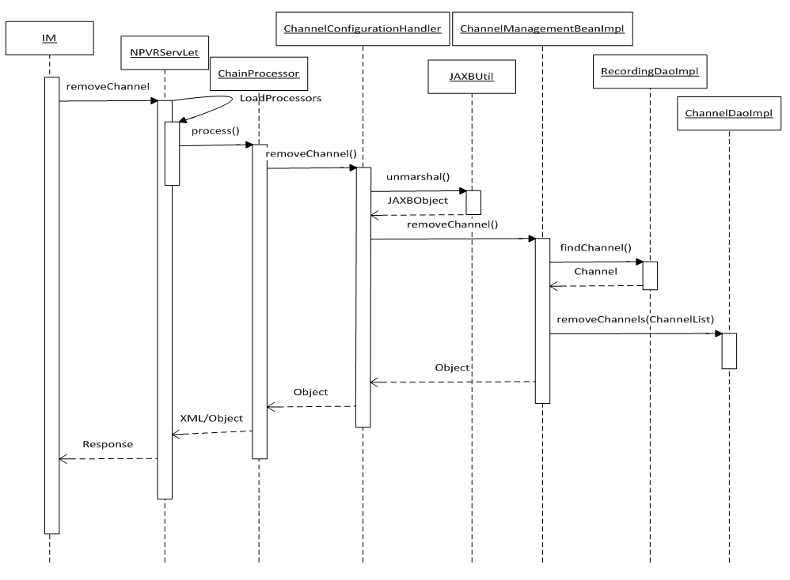

**Figure 57:** Sequence Diagram: Removing channels from nPVR BE

### Business Logic

#### com.acn.servlet.NPVRServlet.java

Refer section 5.1.3.1

#### com.acn.application.processors

Refer section 5.1.3.2

#### com.acn.handler.system.ChannelConfigurationHandler.java

Refer section 5.4.3.3

#### com.acn.util.JAXBUtil.java

Refer section 5.2.3.3 com.acn.util.JAXBUtil.java

#### com.acn.beans.services.ChannelManagementBeanImpl

Refer section 5.4.3.5

### Objects to lock

None

### Exceptions

Refer section 5.1.5

### Database Classes

#### com.acn.beans.dao.ChannelDaoImpl.java

Refer section 5.4.6.1

## nPVR user create request

### Flow Diagram



**Figure 58:** Flow Diagram: nPVR user create request

### Sequence Diagram

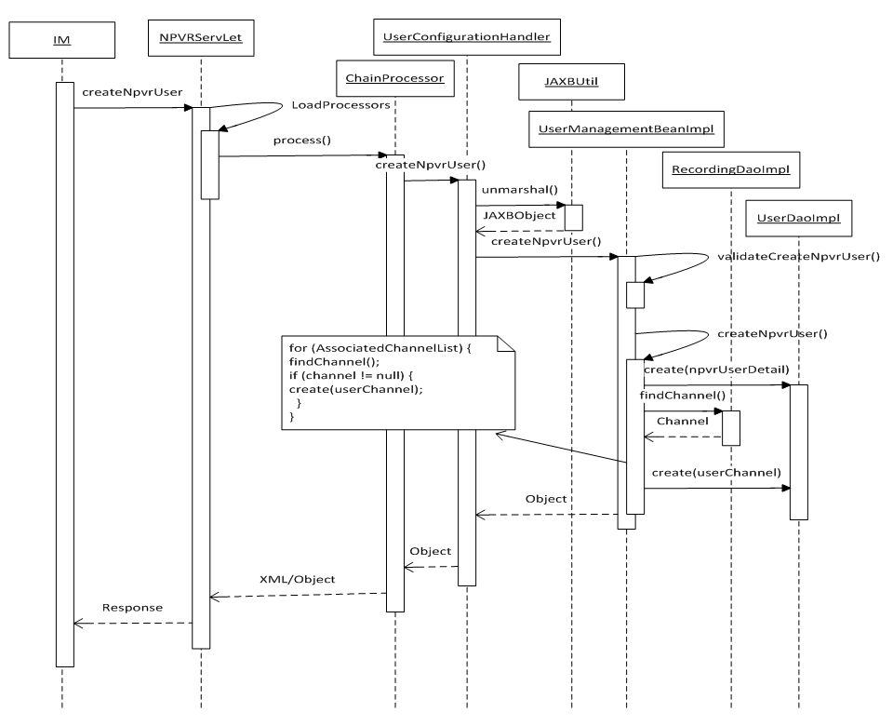

**Figure 59:** Sequence Diagram: nPVR user create request

### Business Logic

#### com.acn.servlet.NPVRServlet.java

Refer section 5.1.3.1

#### com.acn.application.processors

Refer section 5.1.3.2

#### com.acn.handler.system.UserConfigurationHandler.java

UserConfigurationHandler class is used as handler to receive request for configuration of user in system.

|  |  |  |
| --- | --- | --- |
| ***Creating Method*** | ***Change Description*** | ***Exception*** |
| public Object createNpvrUser(String opCode, String contextId, String postData, String responseFormat) | Initiate npvr user creation, validate and unmarshal xml request, call forwarded to session bean and return response. | None |
| public Object removeNpvrUser(String opCode, String contextId, String postData, String responseFormat) | Initiate npvr user deletion, validate and unmarshal xml request, call forwarded to session bean and returns response. | None |
| public Object updateNpvrUser(String opCode, String contextId, String postData, String responseFormat) | Initiate npvr user updation, validate and unmarshal xml request, call forwarded to session bean and returns response. | None |
| public Object error(Exception e) | Create and return error object. | None |

Table 25 : U UserConfigurationHandler.java

#### com.acn.util.JAXBUtil.java

Refer section 5.2.3.3 com.acn.util.JAXBUtil.java

#### com.acn.beans.services.UserManagementBeanImpl.java

UserManagementBeanImpl class is used as business logic layer for configuration of user in system.

|  |  |  |
| --- | --- | --- |
| ***Creating Method*** | ***Change Description*** | ***Exception*** |
| public Object createNpvrUser(String contextId, NPVRAddUserConfigurationRequest nPVRAddUserConfigurationRequest, String responseFormat) | This method validates and creates user data and saves into DB. | None |
| private GeneralErrorResponse validateCreateNpvrUser(String contextId, NpvrUser npvrUser) | This method performs all validations for create user request and generates error response. | None |
| private GeneralErrorResponse userErrorResponse(String accountId, String errorCode, String errorDesc) | This method generates error response for user. | None |
| private void createNpvrUser(String contextId, NpvrUser npvrUser) | This method finally saves data for user into data base. | None |
| public Object removeNpvrUser(String contextId, NPVRRemoveUserConfigurationRequest nPVRRemoveUserConfigurationRequest, String responseFormat) | This method validates and deletes npvr user data from DB. | None |
| private GeneralErrorResponse validateRemoveNpvrUser(com.acn.resources.NPVRRemoveUserConfigurationRequest.NpvrRemoveUserConfig.NpvrUser npvrUserResource, NpvrUserDetail npvrUserModel) | This method validate user request for user removal. | None |
| public Object updateNpvrUser(String contextId, NPVRUpdateUserConfigurationRequest nPVRUpdateUserConfigurationRequest, String responseFormat) | This method validates and updates npvr user data in DB. | None |
| private GeneralErrorResponse validateUpdateNpvrUser(String contextId, com.acn.resources.NPVRUpdateUserConfigurationRequest.NpvrUpdateUserConfig.NpvrUser npvrUserResource, NpvrUserDetail npvrUserDetailsModel) | This method validate user request for user update. | None |
| private void updateNpvrUser(com.acn.resources.NPVRUpdateUserConfigurationRequest.NpvrUpdateUserConfig.NpvrUser pvrUserResource,  NpvrUserDetail npvrUserDetailsModel) | This method updates values for user in db. | None |
| private void UpdateRecordingForRemovedChannels(  NpvrUserDetail npvrUserDetailsModel,  List<String> channelExternalIdList) | This method changes status of user recordings as cancel for future recordings and incomplete for ongoing recordings for user. | None |

Table 26 : UserManagementBeanImpl.java

### Objects to lock

None

### Exceptions

Refer section 5.1.5

### Database Classes

#### com.acn.beans.dao.UserDaoImpl.java

UserDaoImpl class is used as data access layer for configuration of user in system.

|  |  |  |
| --- | --- | --- |
| ***Creating Method*** | ***Change Description*** | ***Exception*** |
| public int removeUsers(List userIdList) | Remove user for all external ids | None |
| public boolean userChannelExists(Long userId) | Checks existence of userChannels | None |

Table 27 : UserDaoImpl.java

## nPVR user update request

### Flow Diagram



**Figure 60:** Flow Diagram: nPVR user update request

### Sequence Diagram

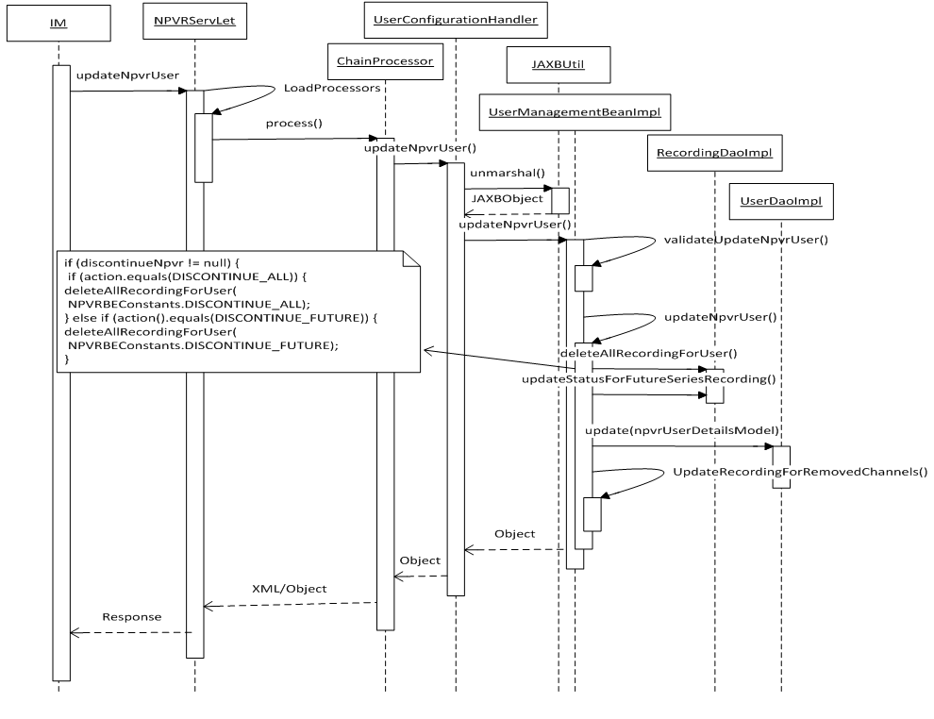

**Figure 61:** Sequence Diagram: nPVR user update request

### Business Logic

#### com.acn.servlet.NPVRServlet.java

Refer section 5.1.3.1

#### com.acn.application.processors

Refer section 5.1.3.2

#### com.acn.handler.system.UserConfigurationHandler.java

Refer section 5.6.3.3

#### com.acn.util.JAXBUtil.java

Refer section 5.2.3.3 com.acn.util.JAXBUtil.java

#### com.acn.beans.services.UserManagementBeanImpl.java

Refer section 5.6.3.5

### Objects to lock

None

### Exceptions

Refer section 5.1.5

### Database Classes

#### com.acn.beans.dao.UserDaoImpl.java

Refer section 5.6.6.1

## nPVR user delete request

### Flow Diagram



**Figure 62:** Flow Diagram: nPVR user delete request

### Sequence Diagram

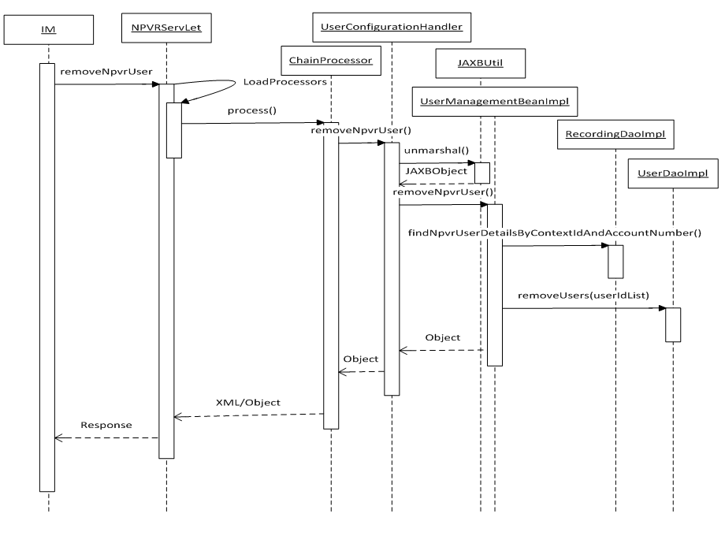

**Figure 63:** Sequence Diagram: nPVR user delete request

### Business Logic

#### com.acn.servlet.NPVRServlet.java

Refer section 5.1.3.1

#### com.acn.application.processors

Refer section 5.1.3.2

#### com.acn.handler.system.UserConfigurationHandler.java

Refer section 5.6.3.3

#### com.acn.util.JAXBUtil.java

Refer section 5.2.3.3 com.acn.util.JAXBUtil.java

#### com.acn.beans.services.UserManagementBeanImpl.java

Refer section 5.6.3.5

### Objects to lock

None

### Exceptions

Refer section 5.1.5

### Database Classes

#### com.acn.beans.dao.UserDaoImpl.java

Refer section 5.6.6.1

## Add nPVR Recording Request

### Flow Diagram

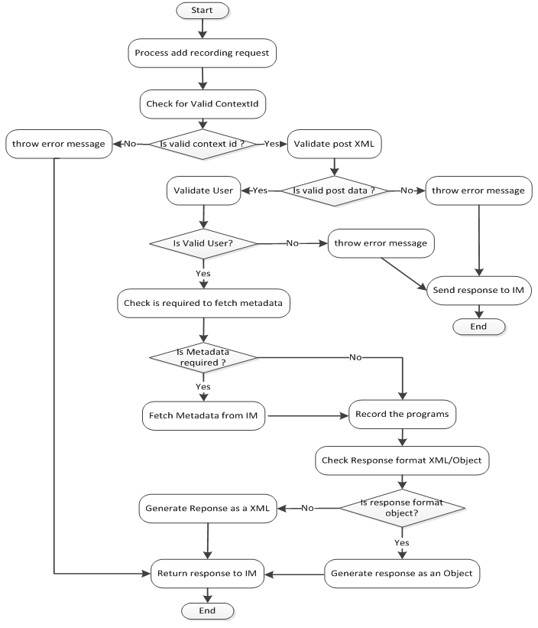

**Figure 64:** Flow Diagram: Add nPVR Recording Request

### Sequence Diagram

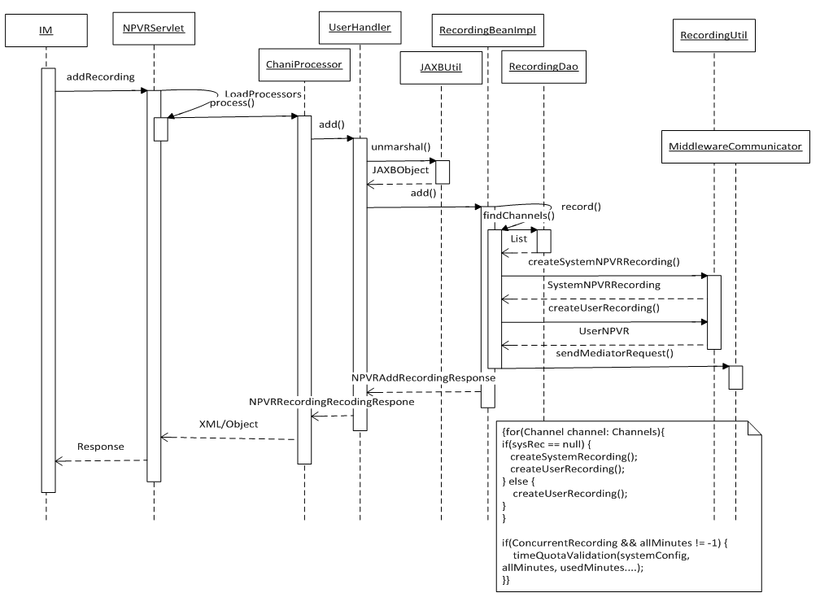

**Figure 65:** Sequence Diagram: Add nPVR Recording Request

### Business Logic

#### com.acn.servlet.NPVRServlet.java

Refer section 5.1.3.1

#### com.acn.application.processors

Refer section 5.1.3.2

#### com.acn.handler.user.UserHandler.java

UserHandler class is used as handler to receive request for handling of entire npvr recording request.

|  |  |  |
| --- | --- | --- |
| ***Creating Method*** | ***Description*** | ***Exception*** |
| public NPVRAddRecordingsResponse add(String opCode, String accountNumber, String contextId, String responseFormat, String postData) | This method creates recordings. | RuntimeException |
| public NPVRDeleteRecordingsResponse delete(String opCode, String accountNumber, String contextId, String responseFormat, String postData) | This method deletes recordings. | RuntimeException |
| public NPVRUserRecordingResponse update(String opCode, String accountNumber, Long recordId, Long startDeltaTime, Boolean deleteWhenSpaceNeeded, String contextId, String responseFormat) | This method updates recording. | RuntimeException |
| public NPVRUserRecordingResponse stop(String opCode, String accountNumber, Long recordId, Long startDeltaTime, Long stopDeltaTime, String contextId, String responseFormat) | This method stops recording. | RuntimeException |
| public NPVRGetUserQuotaResponse getUserQuota(String opCode, String accountNumber, String contextId, String responseFormat) | This method is used to get user quota. | RuntimeException |
| public NPVRGetRecordingsResponse getRecordings(String opCode, String contextId, String channelExternalId, String programId, String programStartTime, Boolean eventUpdated) | This method is used to get system recording on the basis of filetring parameters. | RuntimeException |
| public NPVRGetUserRecordingsResponse getuserrecordings(String opCode, String accNumber, String contextId, Long startIdx, Long howMany, Long recordId, Long seriesId, String recordType, String recordStatus, String sortBy, String mtpListStr, Long startAfter, Long startBefore, String responseFormat, String title) | This method is used to get user recording on the basis of filetring parameters. | None |
| public NPVRAddUpdateSeriesRecordingResponse addseries(String opCode, String accountNumber, String contextId, String channelExternalId, String seriesReference, Boolean deleteWhenSpaceNeeded, Boolean channelBound, String episodeScope, Long nrEpisodesToKeep, String responseFormat) | This method cerates series recording. | None |
| public NPVRAddUpdateSeriesRecordingResponse updateSeries(String opCode, String accNum, String contextId, Long seriesId, String episodeScope, Boolean channelBound, Boolean deleteWhenSpaceRequired, Long nrEpisodesToKeep, String responseFormat) | This method updates an already scheduled series recording. | None |
| public NPVRDeleteSeriesRecordingResponse deleteSeries(String opCode, String accNum, String contextId, Long seriesId, Boolean keepRecordings, String responseForamt) | This method deletes an already scheduled series recording. | None |
| public NPVRGetSeriesRecordingResponse getseries(String opCode, String accNum, String contextId, Long seriesId, String responseFormat) | This method is used to get details of series recording. | None |

Table 28: UserHandler.java

#### com.acn.util.JAXBUtil.java

Refer section 5.2.3.3 com.acn.util.JAXBUtil.java

#### com.acn.beans.services.impl.RecordingBeanImpl

RecordingBeanImpl class is used as business logic layer for entire npvr recording request.

|  |  |  |
| --- | --- | --- |
| Creating Method | Change Description | Exception |
| public  NPVRAddRecordingsResponse add() | This method may create multiple recordings in one request and returns NPVRAddRecordingsResponse. This method calls record method to create recording. | Catches business exception  thrown from record method and  makes  NPVRAddRecordingsResponse  on the basis of business exception. |
| Private  UserNpvr record() | This method creates recording and returns UserNpvr. | Catches business exception  thrown from calling methods  and throws business exception  for called method. If exception is  other than business exception the  system exception is thrown to  called method with an error code ‘NBE000’ and error message stating ‘System Exception’. |
| private int  generateUserRecordResponse() | This method generates user recording response. | None |
| Public void  sendMediatorRequest () | This method sends request to mediator to create asset on VoD server. | None |
| private boolean  timeQuotaValidation () | This method does time quota validation of ongoing recording. | None |
| public  NPVRUserRecordingResponse  update() | This method updates the field DeleteWhenSpaceNeeded of User Npvr Recording. This method returns NPVRUserRecordingResponse. | None |
| private int  generateUserRecordResponse() | This method generates user recording response. | None |
| public  NPVRUserRecordingResponse  stop() | This method updates the field UserStopDelta, Status, StatusDetails and actualRecSeconds of User Npvr Recording. This method returns NPVRUserRecordingResponse. | None |
| private int  generateUserRecordResponse() | This method generates user recording response. | None |
| public  NPVRDeleteRecordingsResponse  delete() | This method may delete multiple recordings in one request. This method returns NPVRDeleteRecordingsResponse. | None |
| public NPVRAddUpdateSeriesRecordingResponse updateSeries(String contextId, String accNum, long seriesId, String episodeScope, Boolean channelBound, Boolean deleteWhenSpaceRequired, Long nrEpisodesToKeep) | This method updates already scheduled series. This method returns NPVRAddUpdateSeriesRecordingResponse. | None |
| public NPVRAddUpdateSeriesRecordingResponse recordSeries(String contextId, String accNum, String channelIdExternalId, String seriesRefNo, String episodeScope, Boolean channelBound, Boolean deleteWhenSpaceRequired, Long nrEpisodesToKeep) | This method creates series recording. This method returns NPVRAddUpdateSeriesRecordingResponse. | None |
| public NPVRDeleteSeriesRecordingResponse deleteSeries(String contextId, String accNum, long seriesId, Boolean keepRecordings) | This method deletes already scheduled series. This method returns NPVRDeleteSeriesRecordingResponse. | None |
| public NPVRGetRecordingsResponse getRecordings(String contextId,String channelExternalId,String programId,String programStartTime, Boolean eventUpdated) | This method is used to retrieve system recording on the basis of filtering parameters. This method returns NPVRGetRecordingsResponse. | None |
| private int generateGetRecordingResponse(List<Object[]> listData, List<SystemRecording> sysRecordingList) | This method generates get recording request’s response. | None |
| private NPVRAddUpdateSeriesRecordingResponse generateSeriesResponse(long userId, long seriesId) | This method generates response for add/update series request. | None |
| public NPVRGetUserQuotaResponse getUserQuota() | This method gives the user quota information and returns NPVRGetUserQuotaResponse. | None |

Table 29: RecordingBeanImpl.java

#### com.acn.communication.middleware.MiddlewareCommunicator.java

MiddlewareCommunicator is used for communication between integrated middleware (IM).

|  |  |  |
| --- | --- | --- |
| Creating Method | Change Description | Exception |
| public GetMetadataResponse getMetadata() | This method gives the metadata information based on getMetaDataRequest and contextId and returns GetMetadataResponse. | None |
| public String sendRequest(String contextId, String urlString,  String postData) | This method is used for sending request to integrated middleware based on url contextId and post data. | None |
| public String sendRequest(String contextId, String urlString,  String postData, String requestMethod) | This method is used for sending request to integrated middleware based on url contextId, post data and request method. | None |
| public void notificationToIM(List<String> accountNumbers, String contextId,RecordingDao recordingDao) | This Method is being used for sending notification to integrated middleware. | None |

Table 30: MiddlewareCommunicator.java

#### com.acn.util.RecordingUtil.java

RecordingUtil class is utility class used for common npvr recording functionality.

|  |  |  |
| --- | --- | --- |
| **Creating Method** | **Change Description** | **Exception** |
| public static RecordingUtil getInstance() | Returns instance of RecordingUtil. | None |
| public SystemNpvrRecording getCurrentSystemNpvrRecording(String contextId, Long channelId, String progRefNo, Calendar startTime, RecordingDao recordingDao) | Returns current system npvr recording. | None |
| public SystemNpvrRecording createNewSystemRecording(SystemConfig systemConfig, GetMetadataResponse.Programs.Program program, Schedule schedule, Channel channel, String progRefNo, Calendar programStartTime, boolean npvrSkipJump,  EventUpdateStatus epgStatus, String contextId, RecordingDao recordingDao) | Create new system recording. | None |
| public UserNpvr createNewUserRecording(Long userId, SystemNpvrRecording systemRec, SystemConfig systemConfig, Long startDelta, Long programStartTime, Boolean deleteWhenSpaceNeeded, Long seriesId, RecordingDao recordingDao) | This method creates new user recording. | None |
| private RecordEvent[] createEvents(ArrayList<ArrayList<Long>> overlapRecordings) | This method creates event for overlap recordings. | None |
| public void updateSystemRecordingReferences(List<Long> deletedRecordIds, RecordingDao recordingDao) | Update the system recording reference counter. When the system recording is no longer referenced, delete the related program meta info before deleting the system recording. | None |
| public Conflict getConflictRecording(int MAX_CONCURRENT_REC, Long userId, Long channelID, String programRefNo, Calendar startTime, Calendar endTime, RecordingDao recordingDao) | Returns conflict recording. | None |
| private long[] checkConflicts(int maxLimit, RecordEvent[] eventArray, ArrayList<ArrayList<Long>> overlapRecordings) | Checks conflict for user recordings. | None |
| private Conflict populateConflictData(long[] conflictWindow, long requestedStart, long requestedEnd, ArrayList<ArrayList<Long>> overlapRecods) | Populates conflict data for conflict object. | None |
| public List<List<SystemNpvrRecording>> createSystemRecordings(SystemConfig systemConfig, List<GetMetadataResponse.Programs.Program> programList, HashMap<String, HashSet<String>> seriesChannelMap, String contextId, String episodeScope, Channel channel, boolean channelBound, boolean triggerSeriesUpdate, RecordingDao recordingDao) | Create system recordings. | None |
| public boolean syncNpvrAssetWith(int npvrAssetId, boolean recSuccess, String statusDetails, RecordingDao recordingDao) | Handle callback of RecordingStatus from nPVR Mediator, and sync npvr asset with nPVR Mediator. | None |
| private void callBackToIM(long npvrAssetId, RecordingDao recordingDao) | This method calls back to Integrated middleware. | None |
| public boolean syncNpvrAssetWith(int npvrAssetId, String fileName, int startDelta, RecordingDao recordingDao) | Handle callback of RecordingDetailsUpdate from nPVR Mediator, and sync npvr asset with nPVR Mediator. | None |
| private void updateChildAssetUrlAndStartDelta(long parentAssetId, char toAppend, Long startDelta, RecordingDao recordingDao) | This method used to update child asset URL and start delta. | None |
| public String[] getRequiredTransportInfo(String streaming_protocol) | This method is used to get transport info (which includes transport protocol and recording subsystem) for streaming protocol. | None |
| public String generateRecordingFilename(SystemConfig systemConfig, String ip, Long port, String accessUrl, Calendar startTime, String recordingSubsystem) | Returns the CCOR(Recording file name) filename | None |
| public String getRecordingPath(SystemConfig systemConfig, String recordingSubsystem) | Find out the Recording Path as per RecordingSystem. | None |
| public NpvrUserDetail validateContextAndUserAcc(String contextId, String accNum, ContextDao contextDao, RecordingDao recordingDao) | This method validates Context And User Account. | None |
| public void validateContext(String contextId, ContextDao contextDao) | This method validates ContextId. | None |
| private void validateServerContext(String contextId, ContextDao contextDao) | This method validates the context id. | None |
| private void validateAccountNumber(String accountNumber) | This method validates the account number. | None |
| private NpvrUserDetail validateUser(String contextId, String accountNumber, RecordingDao recordingDao) | This method validates user. | None |
| public ContextManagementBean findContextManagementBean() | This method finds ContextManagementBean. | None |
| public char findAppenedCharacter(String fileName) | This method Finds Appened Character. | None |
| private String generateNewFileName(char chToAppend, String fileName) | This method generates new file name. | None |

Table 31: RecordingUtil.java

#### com.acn.beans.services.impl.ContextManagementBeanImpl.java

Refer section 5.1.3.5

### Objects to lock

None

### Exceptions

Refer section 5.1.5

### Database Classes

#### com.acn.beans.dao.impl.RecordingDaoImpl.java

RecordingDaoImpl class is used as data access layer for entire request of npvr recordings.

|  |  |  |
| --- | --- | --- |
| Creating Method | Change Description | Exception |
| public Channel findChannel() | The method returns the value of Channel on the basis of ContextId and ChannelExternalId. | None |
| public SystemNpvrRecording createSystemRecording() | The method creates system Npvr recording and returns SystemNpvrRecording. | None |
| public ArrayList<ArrayList<Long>> getOverlapRecordings() | This method returns the information about the list of list which contains the information about conflict recording: ProgramStartTime, RecordingEndTime, RecordingStartTime, RecordngEndTime and StartDelta. | None |
| public List<Object[]> findUserRecords() | This method returns the list of object which keeps the information about user records. | None |
| public <T> T find() | This method finds UserNpvr on the basis of UserNpvrId. | None |
| public List<UserNpvr> findUserNpvrByUserIdAndRecordIds() | The method returns the list of UserNpvr on the basis of userId and recordIds. | None |
| public boolean delete() | The method deletes User Npvr recording. | None |
| public long createNewUserSeries(String contextId, long userId, long channelId, String seriesRefNo, String episodeScope, boolean channelBound, boolean deleteWhenSpaceRequired, long nrEpisodesToKeep) | This method schedules series recording for a user. | None |
| public void updateSeries(String contextId, long userId, String seriesRefNo, long seriesId, String episodeScope, boolean channelBound, boolean deleteFlagChanged, boolean episodeLimitChanged, boolean deleteWhenSpaceRequired, long channelId, long nrEpisodesToKeep) | This method updates an already scheduled series recording. | None |
| public int validateAndRemoveEpisodeRecords(Long seriesId, Long userId, int episodeLimit) | This method validates episode limit for a user series. If episode limit violates, it removes episodes in FIFO order. | None |
| public boolean createNewEpisodesForAllUser(String contextId) | This method creates user recordings for newly added episodes. | None |
| public void deleteSystemSeriesRecords(long seriesId) | This method deletes an already scheduled series. | None |
| public long calculateUsedMinutes() | The method calculates used minutes of user. | None |
| public void updateChildNpvrAssetStatus(Long parentAssetId, String status, String statusDetails) | Update child npvr asset status and status details | None |
| public String cleanupRecordings() | This method is used to delete all expired recordings (User recordings, System recordings, NPVR assets) | None |
| public List<Object[]> findNearestRecordingStart(long recQuotaCheckDelay) | This method is used to find upcoming scheduled recordings for which its required to need user quota. | None |
| public void updateStartAndStopDelta(long recordId, long startDelta) | Update user start delta and user stop delts for a record. | None |

Table 32: RecordingDaoImpl.java

## Update nPVR Recording Request

### Flow Diagram

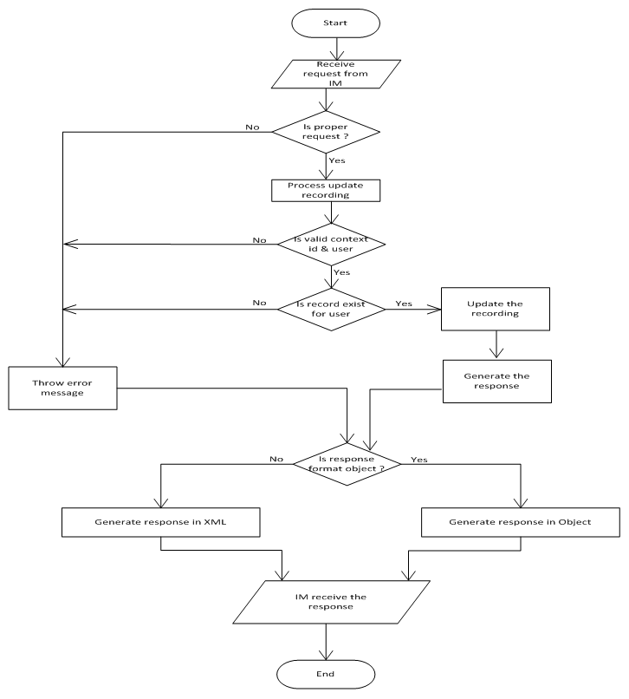

**Figure 66:** Flow Diagram: Update nPVR Recording Request

### Sequence Diagram

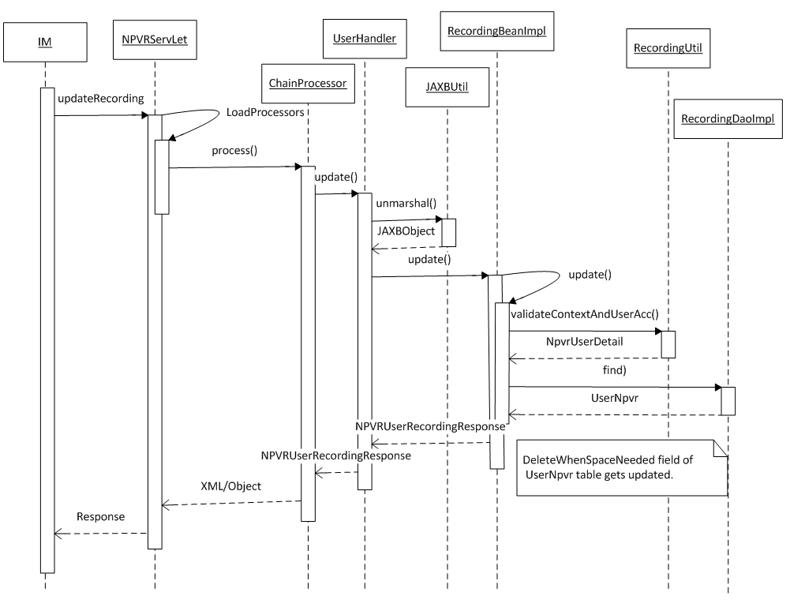

**Figure 67:** Sequence Diagram: Update nPVR Recording Request

### Business Logic

#### com.acn.servlet.NPVRServlet.java

Refer section 5.1.3.1

#### com.acn.application.processors

Refer section 5.1.3.2

#### com.acn.handler.user.UserHandler.java

Refer section 5.9.3.3

#### com.acn.beans.services.impl.RecordingBeanImpl.java

Refer section 5.9.3.5

### Objects to lock

None

### Exceptions

None

### Database Classes

#### com.acn.beans.dao.impl.RecordingDaoImpl.java

Refer section 5.9.6.1

## Delete nPVR Recording Request

### Flow Diagram

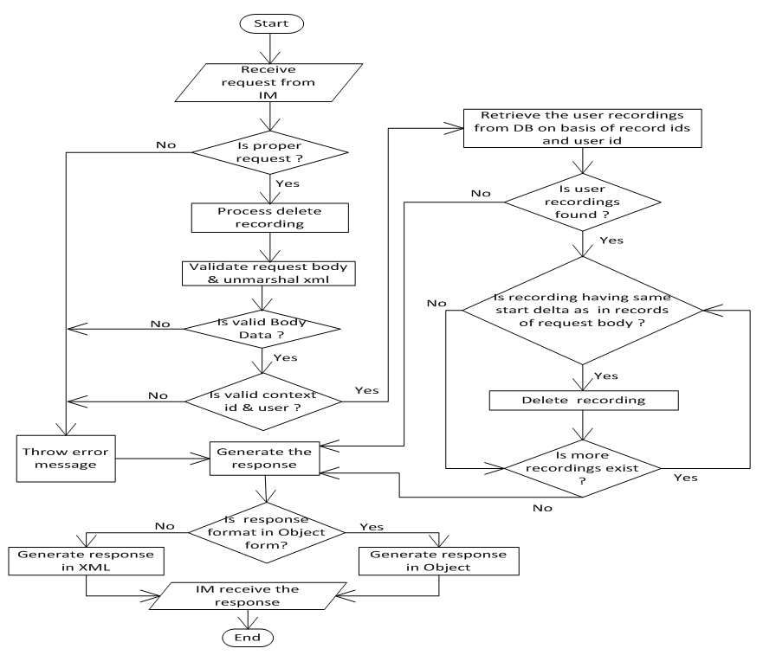

**Figure 68:** Flow Diagram: Delete nPVR Recording Request

### Sequence Diagram

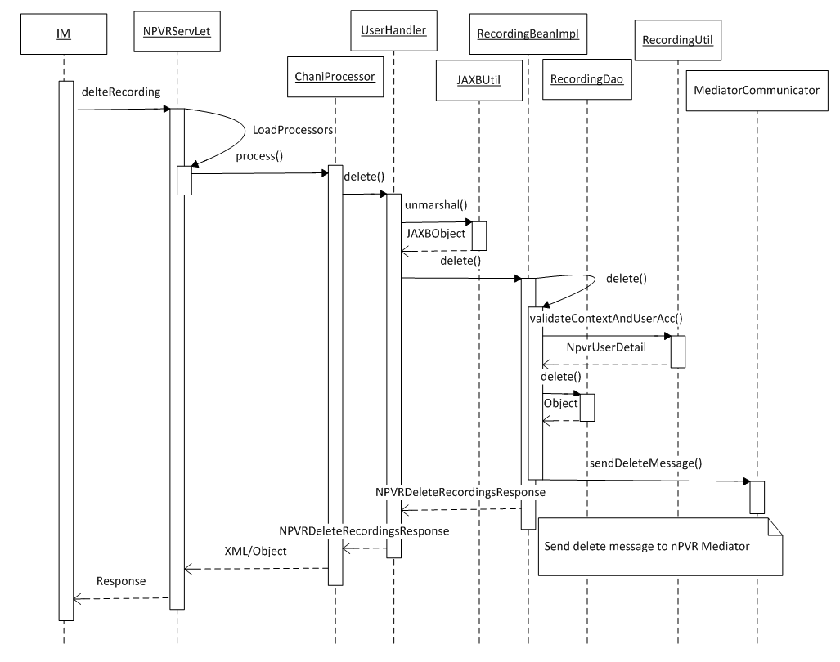

**Figure 69:** Sequence Diagram: Delete nPVR Recording Request

### Business Logic

#### com.acn.servlet.NPVRServlet.java

Refer section 5.1.3.1

#### com.acn.application.processors

Refer section 5.1.3.2

#### com.acn.handler.user.UserHandler.java

Refer section 5.9.3.3

#### com.acn.util.JAXBUtil.java

Refer section 5.2.3.3 com.acn.util.JAXBUtil.java

#### com.acn.beans.services.impl.RecordingBeanImpl.java

Refer section 5.9.3.5

### Objects to lock

None

### Exceptions

Refer section 5.1.5

### Database Classes

#### com.acn.beans.dao.impl.RecordingDaoImpl.java

Refer section 5.9.6.1

## Get User Recordings Request

### Flow Diagram

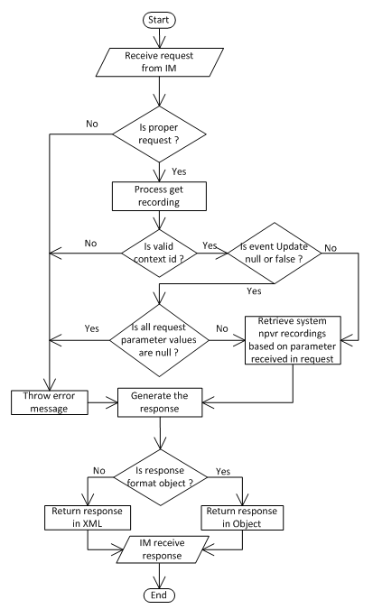

**Figure 70:** Flow Diagram: Get User Recordings Request

### Sequence Diagram

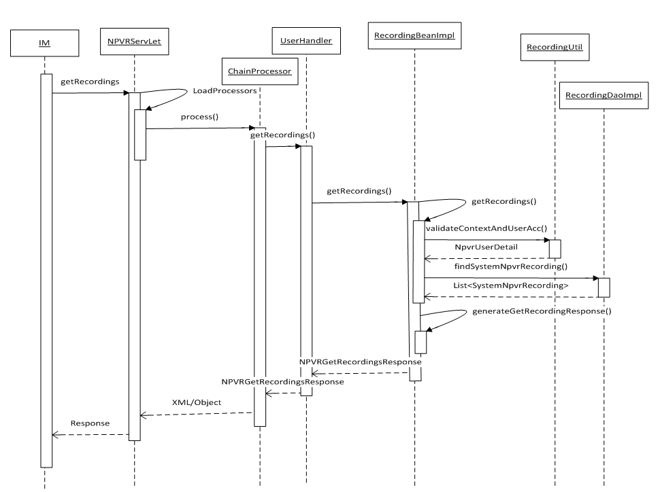

**Figure 71:** Sequence Diagram: Get User Recordings Request

### Business Logic

#### com.acn.servlet.NPVRServlet.java

Refer section 5.1.3.1

#### com.acn.application.processors

Refer section 5.1.3.2

#### com.acn.handler.user.UserHandler.java

Refer section 5.9.3.3

#### com.acn.beans.services.impl.RecordingBeanImpl.java

Refer section 5.9.3.5

### Objects to lock

None

### Exceptions

Refer section 5.1.5

### Database Classes

## Stop nPVR Recording Request

### Flow Diagram

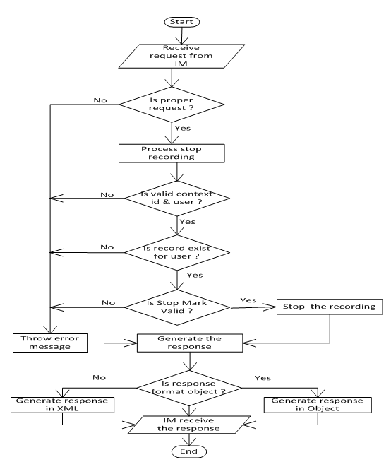

**Figure 72:** Flow Diagram: Stop nPVR Recording Request

### Sequence Diagram

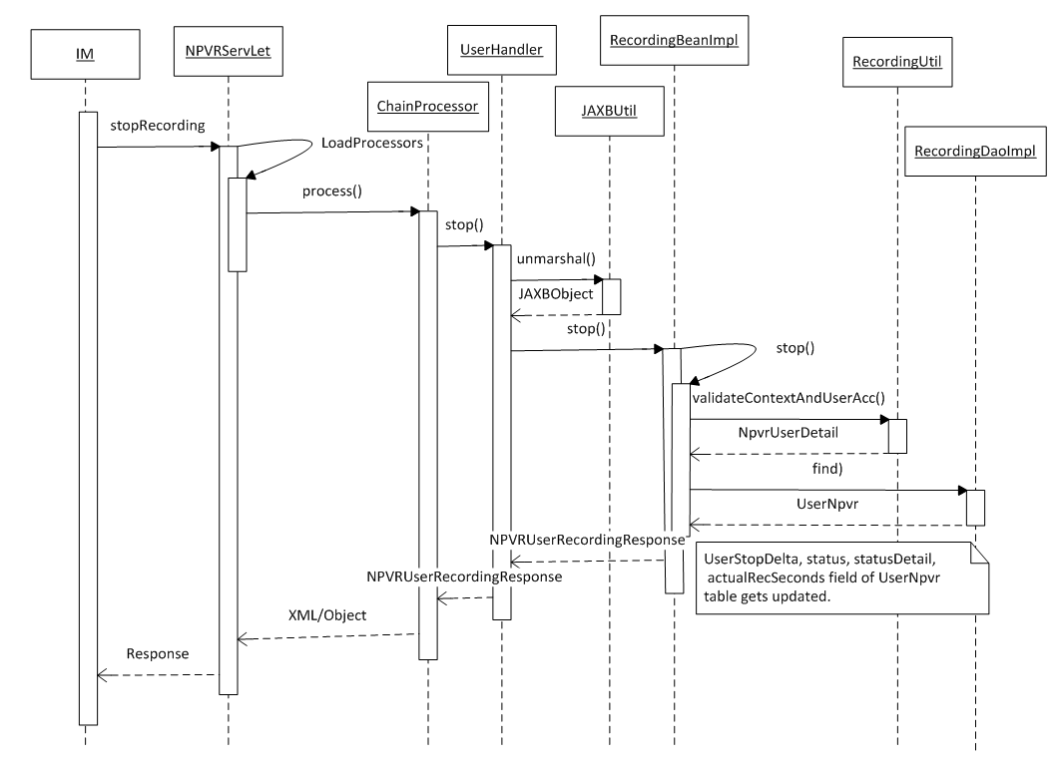

**Figure 73:** Sequence Diagram: Stop nPVR Recording Request

### Business Logic

#### com.acn.servlet.NPVRServlet.java

Refer section 5.1.3.1

#### com.acn.application.processors

Refer section 5.1.3.2

#### com.acn.handler.user.UserHandler.java

Refer section 5.9.3.3

#### com.acn.beans.services.impl.RecordingBeanImpl.java

Refer section 5.9.3.5

### Objects to lock

None

### Exceptions

Refer section 5.1.5

### Database Classes

#### com.acn.beans.dao.impl.RecordingDaoImpl.java

Refer section 5.9.6.1

## Add nPVR Series Request

### Flow Diagram

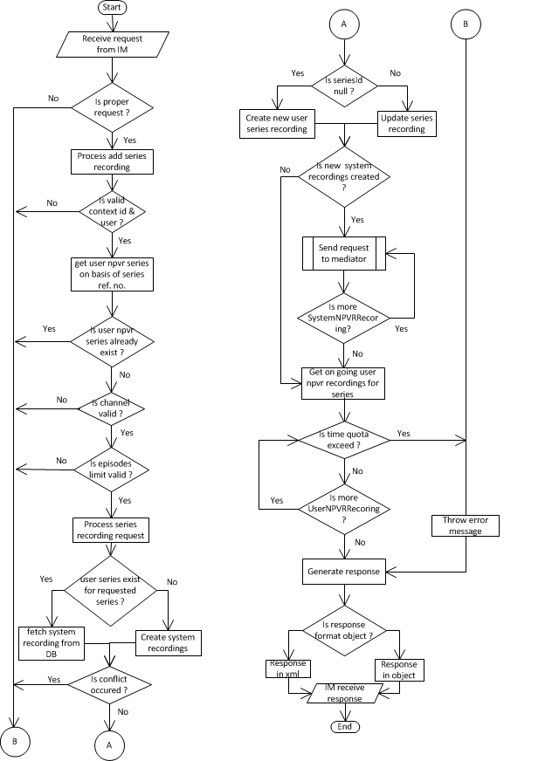

**Figure 74:** Flow Diagram: Add nPVR Series Request

### Sequence Diagram

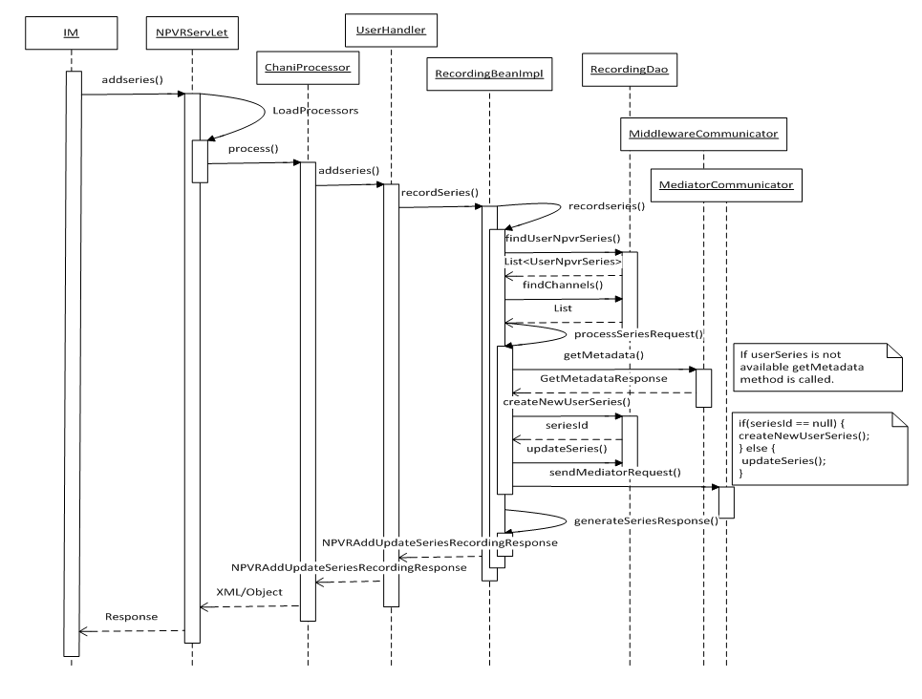

**Figure 75:** Sequence Diagram: Add nPVR Series Request

### Business Logic

#### com.acn.servlet.NPVRServlet.java

Refer section 5.1.3.1

#### com.acn.application.processors

Refer section 5.1.3.2

#### com.acn.handler.user.UserHandler.java

Refer section 5.9.3.3

#### com.acn.beans.services.impl.RecordingBeanImpl.java

Refer section 5.9.3.5

### Objects to lock

None

### Exceptions

Refer section 5.1.5

### Database Classes

#### com.acn.beans.dao.impl.RecordingDaoImpl.java

Refer section 5.9.6.1

## Update nPVR Series Request

### Flow Diagram

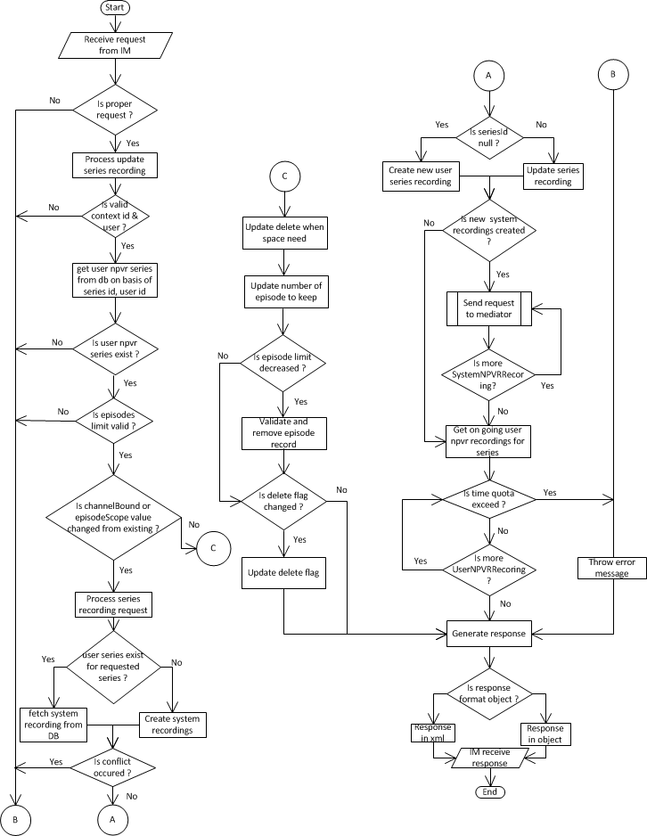

**Figure 76:** Flow Diagram: Update nPVR Series Request

### Sequence Diagram



**Figure 77:** Sequence Diagram: Update nPVR Series Request

### Business Logic

#### com.acn.servlet.NPVRServlet.java

Refer section 5.1.3.1

#### com.acn.application.processors

Refer section 5.1.3.2

#### com.acn.handler.user.UserHandler.java

Refer section 5.9.3.3

#### com.acn.beans.services.impl.RecordingBeanImpl.java

Refer section 5.9.3.5

### Objects to lock

None

### Exceptions

Refer section 5.1.5

### Database Classes

#### com.acn.beans.dao.impl.RecordingDaoImpl.java

Refer section 5.9.6.1

## Delete nPVR Series Request

### Flow Diagram

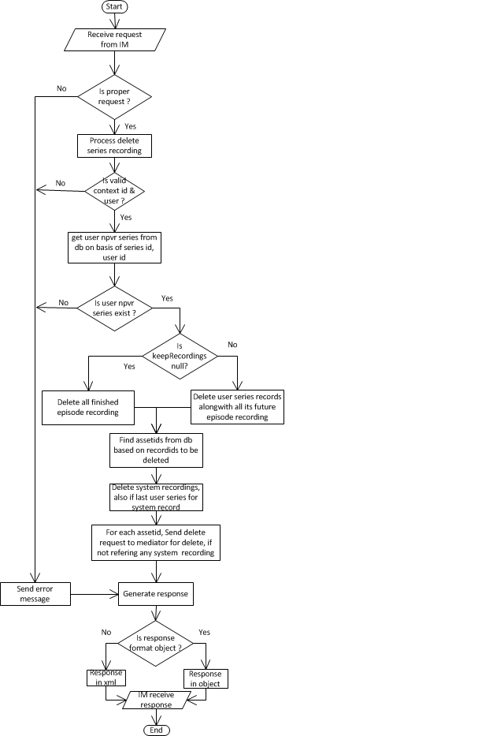

**Figure 78:** Flow Diagram: Delete nPVR Series Request

### Sequence Diagram



**Figure 79:** Sequence Diagram: Delete nPVR Series Request

### Business Logic

#### com.acn.servlet.NPVRServlet.java

Refer section 5.1.3.1

#### com.acn.application.processors

Refer section 5.1.3.2

#### com.acn.handler.user.UserHandler.java

Refer section 5.9.3.3

#### com.acn.beans.services.impl.RecordingBeanImpl.java

Refer section 5.9.3.5

### Objects to lock

None

### Exceptions

Refer section 5.1.5

### Database Classes

#### com.acn.beans.dao.impl.RecordingDaoImpl.java

Refer section 5.9.6.1

## Get Series Request

### Flow Diagram



**Figure 80:** Flow Diagram: Get Series Request

### Sequence Diagram

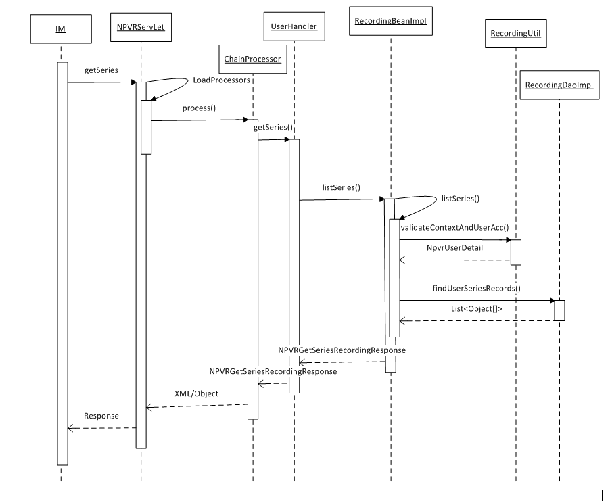

**Figure 81:** Sequence Diagram: Get Series Request

### Business Logic

#### com.acn.servlet.NPVRServlet.java

Refer section 5.1.3.1

#### com.acn.application.processors

Refer section 5.1.3.2

#### com.acn.handler.user.UserHandler.java

Refer section 5.9.3.3

#### com.acn.beans.services.impl.RecordingBeanImpl.java

Refer section 5.9.3.5

### Objects to lock

None

### Exceptions

Refer section 5.1.5

### Database Classes

Refer section 5.9.6.1

## Get Recordings Request

### Flow Diagram

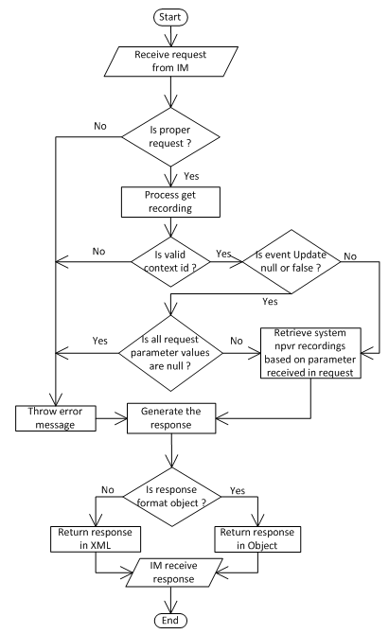

**Figure 82:** Flow Diagram: Get Recordings Request

### Sequence Diagram

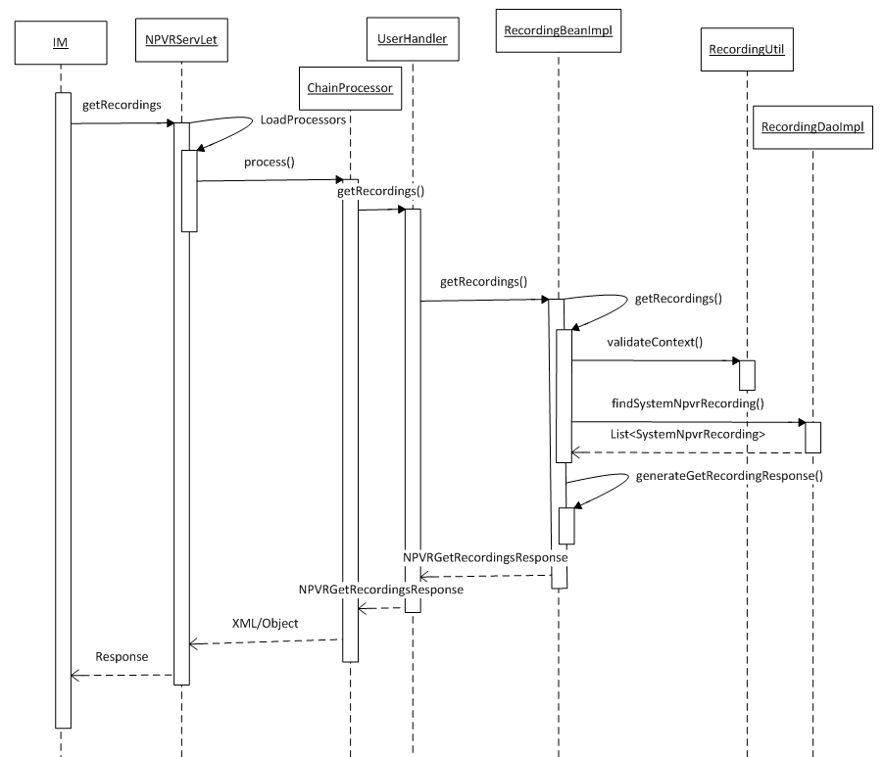

**Figure 83:** Sequence Diagram: Get Recordings Request

### Business Logic

#### com.acn.servlet.NPVRServlet.java

Refer section 5.1.3.1

#### com.acn.application.processors

Refer section 5.1.3.2

#### com.acn.handler.user.UserHandler.java

Refer section 5.9.3.3

#### com.acn.beans.services.impl.RecordingBeanImpl.java

Refer section 5.9.3.5

### Objects to lock

None

### Exceptions

Refer section 5.1.5

### Database Classes

Refer section 5.9.6.1

## Creating nPVR Reports

### Get Physical Recording List

#### Flow Diagram

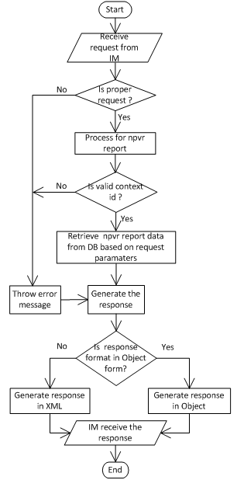

**Figure 84:** Flow Diagram: Get Physical Recording List

#### Sequence Diagram



**Figure 85:** Sequence Diagram: Get Physical Recording List

#### Business Logic

##### com.acn.handler.system.ReportHandler.java

ReportHandler class is being used to handle the request when the IM fetch the recordings in form of reports for auditing purpose.

|  |  |  |
| --- | --- | --- |
| ***Creating Method*** | ***Description*** | ***Exception*** |
| public SystemRecordingList getSystemRecordingList(String opCode, String contextId, Long startIndex, Long howMany) | This method returns a list of system recordings. | None |
| public UserRecordingList getUserRecordingList(String opCode, String contextId, Long startIndex, Long howMany) | This method returns a list of user recordings. | None |
| public SystemSeriesRecordingList getSystemSeriesRecordingList(String opCode, String contextId, Long startIndex, Long howMany) | This method returns a list of system series recordings. | None |
| public UserSeriesRecordingList getUserSeriesRecordingList(String opCode, String contextId, Long startIndex, Long howMany) | This method returns a list of user series recordings. | None |
| public PhysicalRecordingList getPhysicalRecordingList(String opCode, String contextId, Long startIndex, Long howMany) | This method returns a list of npvr assets. | None |

Table 33: ReportHandler.java

##### com.acn.servlet.NPVRServlet.java

Refer section 5.1.3.1

##### com.acn.application.processors

Refer section 5.1.3.2

##### com.acn.beans.services.impl.ReportsBeanImpl.java

ReportsBeanImpl class is being used as business logic layer for the request when the IM fetch the recordings in form of reports for auditing purpose.

|  |  |  |
| --- | --- | --- |
| Creating Method | Change Description | Exception |
| public SystemRecordingList getSystemRecordingList(String contextId, Long startIndex, Long howMany) | This method retrieves a list of system recordings on the basis of start index and number of records to return. | None |
| public UserRecordingList getUserRecordingList(String contextId, Long startIndex, Long howMany) | This method retrieves a list of user recordings on the basis of start index and number of records to return. | None |
| public SystemSeriesRecordingList getSystemSeriesRecordingList(String contextId, Long startIndex, Long howMany) | This method retrieves a list of system series recordings on the basis of start index and number of records to return. | None |
| public UserSeriesRecordingList getUserSeriesRecordingList(String contextId, Long startIndex, Long howMany) | This method retrieves a list of user series recordings on the basis of start index and number of records to return. | None |
| public PhysicalRecordingList getPhysicalRecordingList(String contextId, Long startIndex, Long howMany) | This method retrieves a list of assets on the basis of start index and number of records to return. | None |

Table 34: ReportsBeanImpl.java

#### Objects to lock

None

#### Exceptions

Refer section 5.1.5

#### Database Classes

#### com.acn.beans.dao.ReportDaoImpl.java

ReportDaoImpl class is being used as data access layer for the request when the IM fetch the recordings in form of reports for auditing purpose.

|  |  |  |
| --- | --- | --- |
| Creating Method | Change Description | Exception |
| public List getSystemRecordingList(String contextId, Long startIndex, Long howMany) | This method retrieves a list of system recordings on the basis of start index and number of records to return. | None |
| public List getUserRecordingList(String contextId, Long startIndex, Long howMany) | This method retrieves a list of user recordings on the basis of start index and number of records to return. | None |
| public List getSystemSeriesRecordingList(String contextId, Long startIndex, Long howMany) | This method retrieves a list of system series recordings on the basis of start index and number of records to return. | None |
| public List getUserSeriesRecordingList(String contextId, Long startIndex, Long howMany) | This method retrieves a list of user series recordings on the basis of start index and number of records to return. | None |
| public List getPhysicalRecordingList(String contextId, Long startIndex, Long howMany) | This method retrieves a list of assets on the basis of start index and number of records to return. | None |

Table 35: ReportDaoImpl.java

### Get System Recording List

#### Flow Diagram



**Figure 86:** Flow Diagram: Get System Recording List

#### Sequence Diagram



**Figure 87:** Sequence Diagram: Get System Recording List

#### Business Logic

##### com.acn.handler.system.ReportHandler.java

Refer section 5.19.1.3.1

##### com.acn.servlet.NPVRServlet.java

Refer section 5.1.3.1

##### com.acn.application.processors

Refer section 5.1.3.2

##### com.acn.beans.services.impl.ReportsBeanImpl.java

Refer section 5.19.1.3.4

#### Objects to lock

None

#### Exceptions

Refer section 5.1.5

#### Database Classes

#### com.acn.beans.dao.ReportDaoImpl.java

Refer section 5.19.1.7

### Get System Series Recording List

#### Flow Diagram



**Figure 88:** Flow Diagram: Get System Series Recording List

#### Sequence Diagram



**Figure 89:** Sequence Diagram: Get System Series Recording List

#### Business Logic

##### com.acn.handler.system.ReportHandler.java

Refer section 5.19.1.3.1

##### com.acn.servlet.NPVRServlet.java

Refer section 5.1.3.1

##### com.acn.application.processors

Refer section 5.1.3.2

##### com.acn.beans.services.impl.ReportsBeanImpl.java

Refer section 5.19.1.3.4

#### Objects to lock

None

#### Exceptions

Refer section 5.1.5

#### Database Classes

#### com.acn.beans.dao.ReportDaoImpl.java

Refer section 5.19.1.7

### Get User Recording List

#### Flow Diagram



**Figure 90:** Flow Diagram: Get User Recording List

#### Sequence Diagram



**Figure 91:** Sequence Diagram: Get User Recording List

#### Business Logic

##### com.acn.handler.system.ReportHandler.java

Refer section 5.19.1.3.1

##### com.acn.servlet.NPVRServlet.java

Refer section 5.1.3.1

##### com.acn.application.processors

Refer section 5.1.3.2

##### com.acn.beans.services.impl.ReportsBeanImpl.java

Refer section 5.19.1.3.4

#### Objects to lock

None

#### Exceptions

Refer section 5.1.5

#### Database Classes

#### com.acn.beans.dao.ReportDaoImpl.java

Refer section 5.19.1.7

### Get User Series Recording List

#### Flow Diagram



**Figure 92:** Flow Diagram: Get User Series Recording List

#### Sequence Diagram



**Figure 93:** Sequence Diagram: Get User Series Recording List

#### Business Logic

##### com.acn.handler.system.ReportHandler.java

Refer section 5.19.1.3.1

##### com.acn.servlet.NPVRServlet.java

Refer section 5.1.3.1

##### com.acn.application.processors

Refer section 5.1.3.2

##### com.acn.beans.services.impl.ReportsBeanImpl.java

Refer section 5.19.1.3.4

#### Objects to lock

None

#### Exceptions

Refer section 5.1.5

#### Database Classes

#### com.acn.beans.dao.ReportDaoImpl.java

Refer section 5.19.1.7

## Processing Schedule updates

### Flow Diagram

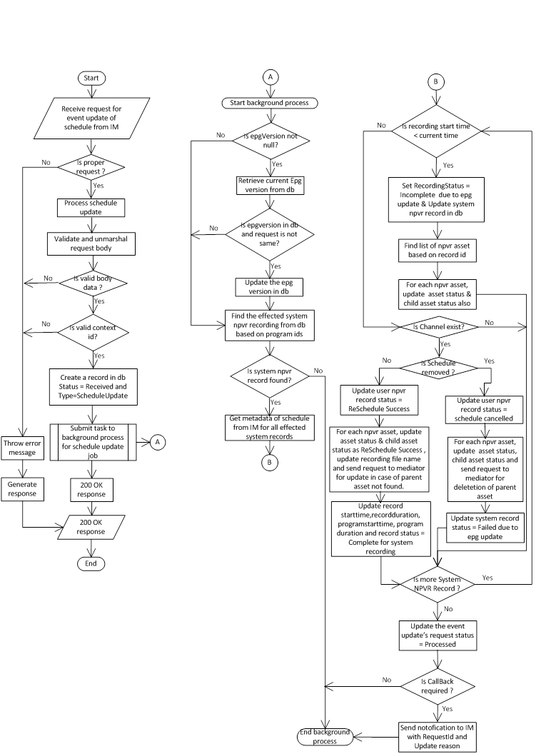

**Figure 94:** Flow Diagram: Processing Schedule updates

### Sequence Diagram



**Figure** **95**: Sequence Diagram: Processing Schedule updates

### Business Logic

#### com.acn.handler.system.EventUpdateHandler

EventUpdateHandler is used as handler class for event update, on every EPG data ingestion at IM, the IMs will notify the nPVR BE about the programs/schedules whose metadata have been updated.

|  |  |  |
| --- | --- | --- |
| ***Creating Method*** | ***Description*** | ***Exception*** |
| public void programMetadataUpdate(String opCode, String requestedId, String contextId, String postData) | This method updates the programs whose metadata have been updated along with enableNPVR update for the requesting IM on every EPG update. | None |
| public void scheduleUpdate(String opCode, String requestedId, String contextId, String postData) | This method reschedules the recordings corresponding to the updated schedules for the requesting IM on every EPG update. | None |
| public void seriesUpdate(String opCode, String requestedId, String contextId, String postData) | This method schedules the new series episodes that have been added to EPG data for the requesting IM on every EPG update. | None |

Table 36: EventUpdateHandler.java

#### com.acn.servlet.NPVRServlet.java

Refer section 5.1.3.1

#### com.acn.application.processors

Refer section 5.1.3.2

#### com.acn.beans.services.impl.BackgroundTaskBeanImpl.java

BackgroundTaskBeanImpl class is responsible to run a background task to change the metadata at npvrbe end on every EPG data ingestion at IM.

|  |  |  |
| --- | --- | --- |
| Creating Method | Change Description | Exception |
| public void scheduleJob(EPGUpdateRequest epgUpdateRequest, EventUpdate eventUpdate, String contextId, String requestId) | This method schedules a background job on the basis of requestType for requesting IM on every EPG update. If callback required is true it also notify to requesting IM wrt the request Id to indicate that process has been completed. |  |
| private void processEpgUpdate(BackgroundJob backgroundJob) | This method reschedules the recordings corresponding to the updated schedules for the requesting IM on every EPG update. This method updates EventUpdateStatus field of updated system recording. This method also calls the mediator for deleting or updating physical assets. |  |
| private void updateNpvrAsset(RecordingStatus status, List<NpvrAsset> nPVRAssets) | This method updates status of provided NPVR assets. |  |
| private GetMetadataResponse.Programs.Program.Schedules.Schedule  findSchedule(List<GetMetadataResponse.Programs.Program> programList, String progExtId, String chExtId, long startTime) | This method returns schedules of programs. |  |
| private void sortProgramAirings(List<GetMetadataResponse.Programs.Program> list) | This method sorts the program on the basis of starting time. |  |
| private void processMetaDataUpdate(BackgroundJob backgroundJob) | This method updates the programs whose metadata have been updated along with enableNPVR update for the requesting IM on every EPG update. For all system recordings failed due to disabling of nPVR on a program, it updates EventUpdateStatus. |  |
| private List<SystemNpvrRecording> findEffectedSystemRecordings(String contextId, EPGUpdateRequest epgUpdateRequest) | This method first retrieves list of effected program from EPGUpdateRequest then fetch and return list of system recordings on the basis of contextId and programIds. |  |
| private void processSeriesUpdate(BackgroundJob backgroundJob) | This method schedules the new series episodes that have been added to EPG data for the requesting IM on every EPG update. For all the new episodes system recordings, it sets EventUpdateStatus to ‘Complete’. This method also calls the mediator for creating physical assets for new episodes. |  |
| private boolean updateNpvrAsset(SystemNpvrRecording sysRec, List<NpvrAsset> nPVRAssets, SystemConfig systemConfig) | This method updates NPVR assets and returns true on successfully updation. |  |
|  |  |  |

Table 37: BackgroundTaskBeanImpl.java

#### com.acn.beans.services.EventUpdateBeanImpl.java

EventUpdateBeanImpl is used as business logic layer for event update, on every EPG data ingestion at IM, the IMs will notify the nPVR BE about the programs/schedules whose metadata have been updated.

|  |  |  |
| --- | --- | --- |
| Creating Method | Change Description | Exception |
| public void programMetadataUpdate(String requestedId, String contextId, EPGUpdateRequest epgUpdateRequest) | This method updates the programs whose metadata have been updated along with enableNPVR update for the requesting IM on every EPG update. |  |
| private void parseRequestAndScheduleJob(String requestedId, String contextId, String responseFormat,  EPGUpdateRequest epgUpdateRequest, String requestType) | This method parse the request, validates requesting IM on the basis of contextID and finally schedules a background job for requesting IM. |  |
| public void scheduleUpdate(String requestedId, String contextId, EPGUpdateRequest epgUpdateRequest) | This method reschedules the recordings corresponding to the updated schedules for the requesting IM on every EPG update. |  |
| public void seriesUpdate(String requestedId, String contextId, EPGUpdateRequest epgUpdateRequest) | This method schedules the new series episodes that have been added to EPG data for the requesting IM on every EPG update. |  |
| private EventUpdate createAndGetEventUpdate(String contextId, String responseFormat, String requestType) | This method creates and returns the EventUpdate. |  |

Table 38: EventUpdateBeanImpl.java

### Objects to lock

None

### Exceptions

Refer section 5.1.5

### Database Classes

Refer section 5.9.6.1

## Processing Series updates

### Flow Diagram



**Figure 96:** Flow Diagram: Processing Series updates

### Sequence Diagram



**Figure 97:** Sequence Diagram: Processing Series updates

### Business Logic

#### com.acn.handler.system.EventUpdateHandler

Refer section 5.20.3.1

#### com.acn.servlet.NPVRServlet.java

Refer section 5.1.3.1

#### com.acn.application.processors

Refer section 5.1.3.2

#### com.acn.beans.services.impl.BackgroundTaskBeanImpl

Refer section 5.20.3.4

#### com.acn.beans.services.EventUpdateBeanImpl

Refer section 5.20.3.5

### Objects to lock

None

### Exceptions

Refer section 5.1.5

### Database Classes

Refer section 5.9.6.1

## Processing program metadata updates

### Flow Diagram

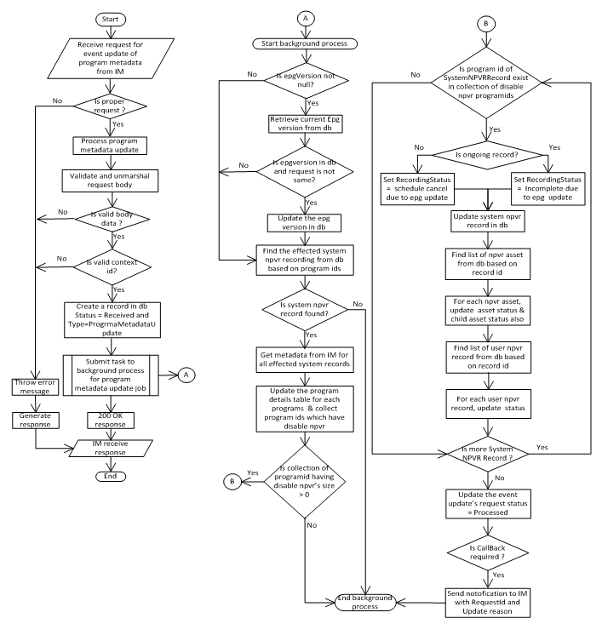

**Figure 98:** Flow Diagram: Processing program metadata updates

### Sequence Diagram

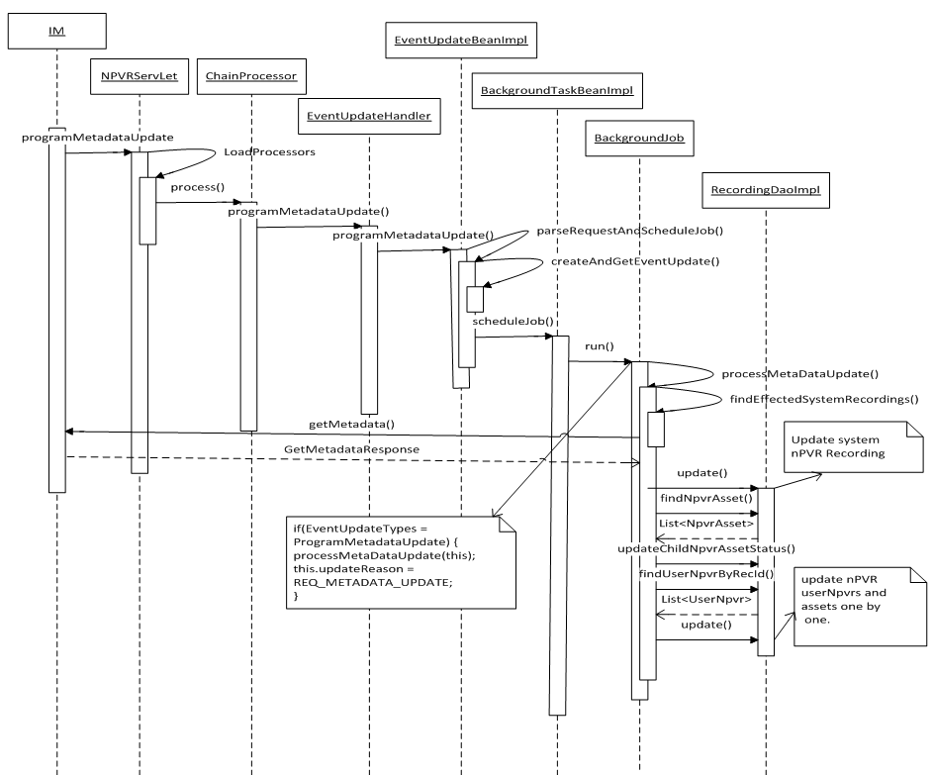

**Figure 99:** Sequence Diagram: Processing program metadata updates

### Business Logic

#### com.acn.handler.system.EventUpdateHandler.java

Refer section 5.20.3.1

#### com.acn.servlet.NPVRServlet.java

Refer section 5.1.3.1

#### com.acn.application.processors

Refer section 5.1.3.2

#### com.acn.beans.services.impl.BackgroundTaskBeanImpl.java

Refer section 5.20.3.4

#### com.acn.beans.services.EventUpdateBeanImpl.java

Refer section 5.20.3.5

### Objects to lock

None

### Exceptions

Refer section 5.1.5

### Database Classes

Refer section 5.9.6.1

## Receiving notifications from nPVR Mediator

### Receiving notifications for RecordingDetailsUpdate

#### Flow Diagram



**Figure 100:** Flow Diagram: Receiving notifications for RecordingDetailsUpdate

#### Sequence Diagram

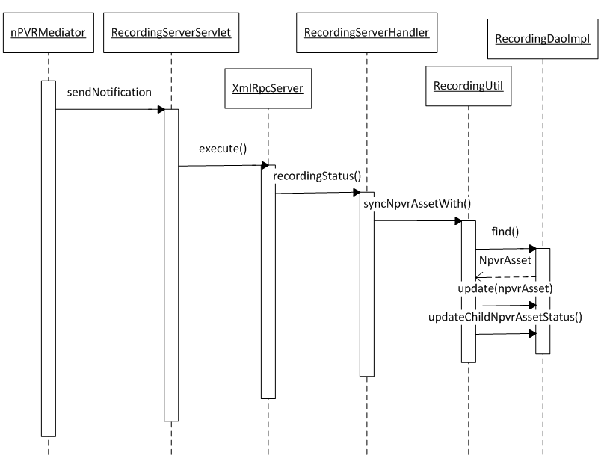

**Figure 101:** Sequence Diagram: Receiving notifications for RecordingDetailsUpdate

#### Business Logic

##### com.acn.servlet.RecordingServerServlet.java

RecordingServerServlet is used to receive request from npvr mediator server on recording details update and record status callback from recording server.

|  |  |  |
| --- | --- | --- |
| ***Creating Method*** | ***Description*** | ***Exception*** |
| public void service(HttpServletRequest request, HttpServletResponse response) | Override method HttpServlet | None |

Table 39: RecordingServerServlet.java

##### com.acn.handler.system.RecordingServerHandler.java

RecordingServerHandler class is responsible to handle the asset filename along with the startDelta in case of RecordingDetailsUpdate and also handle the scheduled asset failed in case of RecordingStatus callback.

|  |  |  |
| --- | --- | --- |
| ***Creating Method*** | ***Description*** | ***Exception*** |
| public RecordingServerHandler() | Instantiates a new Recording server handler. | None |
| public boolean RecordingStatus(int id, boolean recSuccess) | Handle callback of RecordingStatus from nPVR Mediator. | None |
| public boolean RecordingStatus(int id, boolean recSuccess, String statusDetails) | Handle callback of RecordingStatus from nPVR Mediator. | None |
| public boolean RecordingDetailsUpdate(int id, String fileName, int startDelta) | Handle callback of RecordingDetailsUpdate from nPVR Mediator | None |

Table 40: RecordingServlerHandler.java

##### com.acn.util.RecordingUtil.java

Refer section 5.9.3.7

#### Objects to lock

None

#### Exceptions

Refer section 5.1.5

#### Database Classes

##### com.acn.beans.dao.impl.RecordingDaoImpl.java

Refer section 5.9.6.1

### Receiving notifications for RecordingStatus

#### Flow Diagram



Figure 102: Flow Diagram: Receiving notifications for RecordingStatus

#### Sequence Diagram

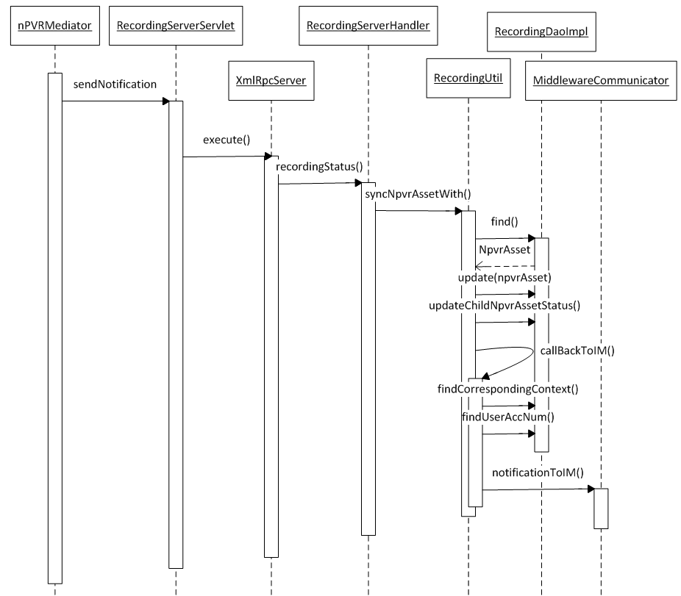

**Figure 103:** Sequence Diagram: Receiving notifications for RecordingStatus

#### Business Logic

##### com.acn.servlet.RecordingServerServlet.java

Refer section 5.23.1.3.1

##### com.acn.handler.system.RecordingServerHandler.java

Refer section 5.23.1.3.2

##### com.acn.util.RecordingUtil.java

Refer section 5.23.1.3.3

#### Objects to lock

None

#### Exceptions

Refer section 5.1.5

#### Database Classes

##### com.acn.beans.dao.impl.RecordingDaoImpl.java

Refer section 5.9.6.1

## Reprocessing of recordings on channel update

### Flow Diagram

Refer section 5.4.1 Flow Diagram

### Sequence Diagram

Refer hyperlink 5.4.2 Sequence Diagram

### Business Logic

#### com.acn.servlet.NPVRServlet.java

Refer section 5.1.3.1

#### com.acn.application.processors

Refer section 5.1.3.2

### Objects to lock

None

### Exceptions

Refer section 5.1.5

### Database Classes

## Notifications to IM on User recording update

### Flow Diagram

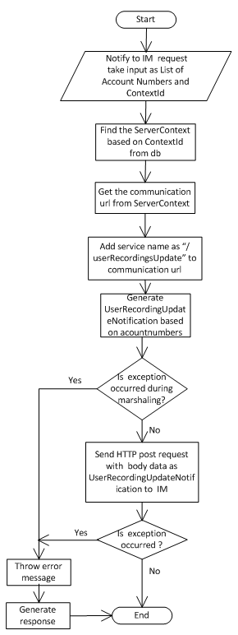

**Figure 104:** Flow Diagram: Notifications to IM on User recording update

### Sequence Diagram

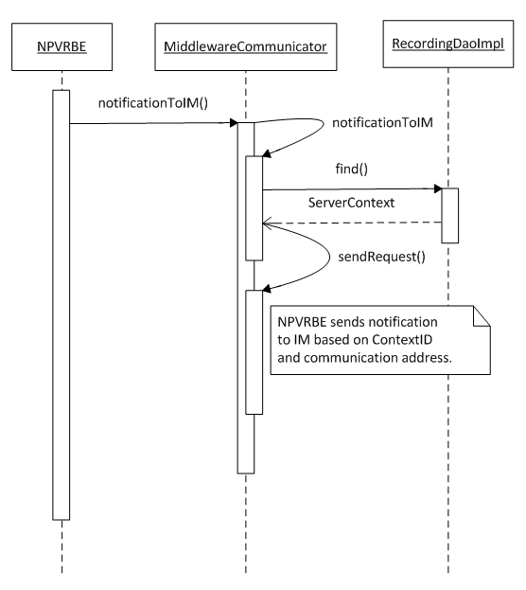

**Figure 105:** Sequence Diagram: Notifications to IM on User recording update

### Business Logic

#### com.acn.servlet.NPVRServlet.java

Refer section 5.1.3.1

#### com.acn.application.processors

Refer section 5.1.3.2

##### com.acn.communication.middleware.MiddlewareCommunicator.java

Refer section 5.9.3.6

### Objects to lock

None

### Exceptions

Refer section 5.1.5

### Database Classes

Refer section 5.9.6.1

## Get Meta Data

### Flow Diagram



**Figure 106:** Flow Diagram: Get Meta Data

### Sequence Diagram

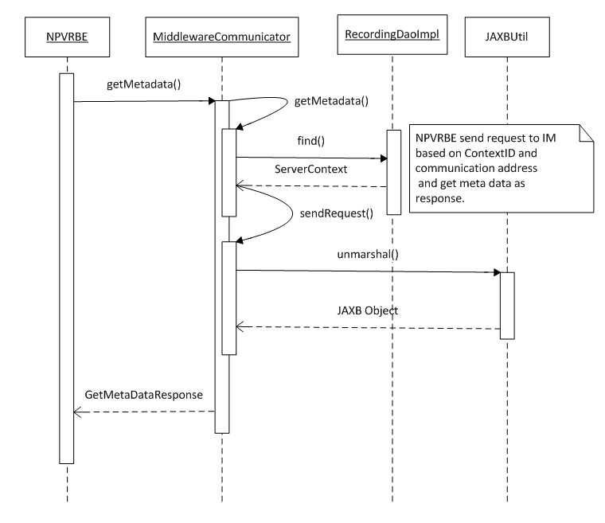

**Figure 107:** Sequence Diagram: Get Meta Data

### Business Logic

#### com.acn.servlet.NPVRServlet.java

Refer section 5.1.3.1

#### com.acn.application.processors

Refer section 5.1.3.2

#### com.acn.beans.dao.impl.RecordingDaoImpl.java

Refer section 5.9.6.1

### Objects to lock

None

### Exceptions

Refer section 5.1.5

### Database Classes

Refer section 5.9.6.1

## Get User Quota

### Flow Diagram

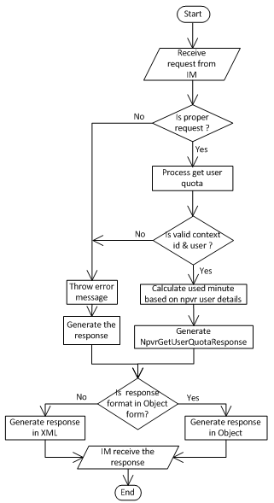

**Figure 108:** Flow Diagram: Get User Quota

### Sequence Diagram

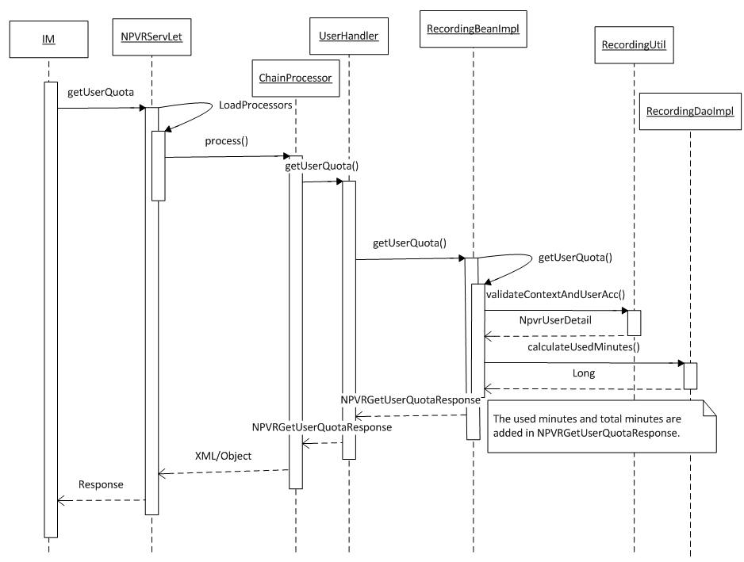

**Figure 109:** Sequence Diagram: Get User Quota

### Business Logic

#### com.acn.servlet.NPVRServlet.java

Refer section 5.1.3.1

#### com.acn.application.processors

Refer section 5.1.3.2

#### com.acn.handler.user.UserHandler.java

Refer section 5.9.3.3

#### com.acn.beans.services.impl.RecordingBeanImpl.java

Refer section 5.9.3.5

### Objects to lock

None

### Exceptions

Refer section 5.1.5

### Database Classes

Refer section 5.9.6.1

## Implementation for NPVR BE Components and Processes

### Communication with nPVR Mediator

#### Create Recording

##### Flow Diagram



**Figure 110:** Flow Diagram: Communication with nPVR Mediator for Create Recording

##### Sequence Diagram

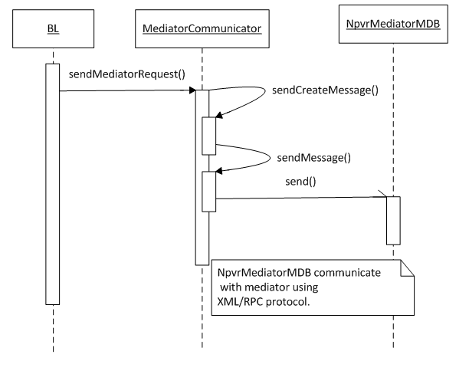

**Figure 111:** Sequence Diagram: Create Recording

##### Business Logic

###### com.acn.servlet.NPVRServlet.java

Refer section 5.1.3.1

###### com.acn.application.processors

Refer section 5.1.3.2

###### Objects to lock

None

###### Exceptions

Refer section 5.1.5

###### Database Classes

None

#### Delete Recording

##### Flow Diagram



**Figure 112:** Flow Diagram: Communication with nPVR Mediator for Delete Recording

##### Sequence Diagram

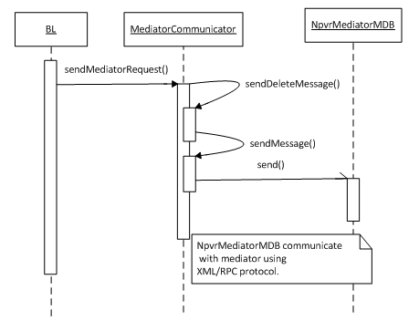

**Figure 113:** Sequence Diagram: Delete Recording

##### Business Logic

###### com.acn.servlet.NPVRServlet.java

Refer section 5.1.3.1

###### com.acn.application.processors

Refer section 5.1.3.2

###### Objects to lock

None

###### Exceptions

Refer section 5.1.5

###### Database Classes

None

#### Update Recording

##### Flow Diagram



**Figure 114:** Flow Diagram: Communication with nPVR Mediator for Update Recording

##### Sequence Diagram

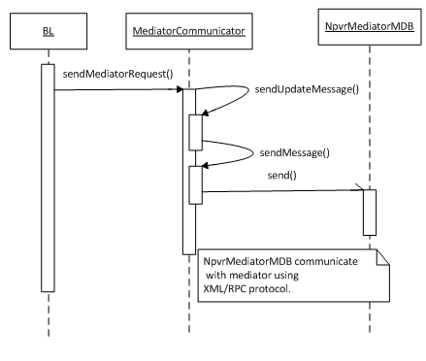

**Figure 115:** Sequence Diagram: Update Recording

##### Business Logic

###### com.acn.servlet.NPVRServlet.java

Refer section 5.1.3.1

###### com.acn.application.processors

Refer section 5.1.3.2

###### Objects to lock

None

###### Exceptions

Refer section 5.1.5

###### Database Classes

None

#### Recording Status

##### Flow Diagram



**Figure 116:** Flow Diagram: nPVR Mediator communication with BE for Recording Status

##### Sequence Diagram

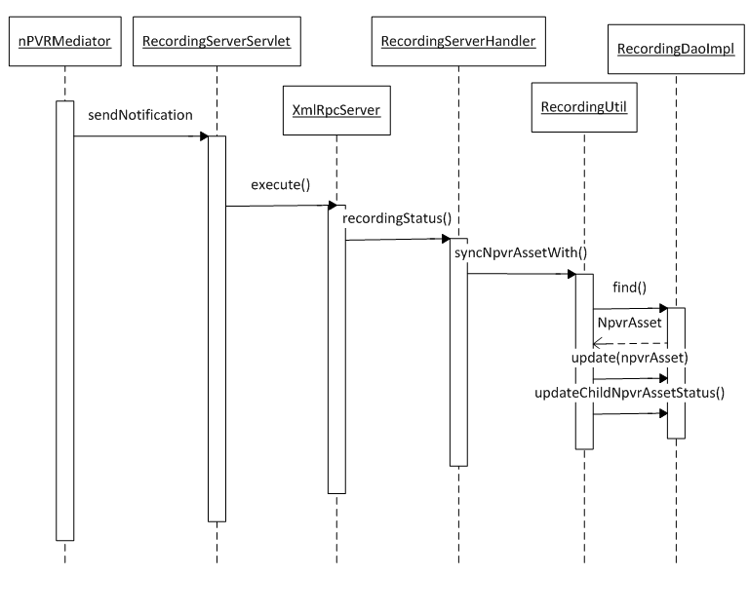

**Figure 117:** Sequence Diagram: Recording Status

##### Business Logic

###### com.acn.servlet.NPVRServlet.java

Refer section 5.1.3.1

###### com.acn.application.processors

Refer section 5.1.3.2

###### Objects to lock

None

###### Exceptions

Refer section 5.1.5

###### Database Classes

None

#### Recording Details Update

##### Flow Diagram



**Figure 118:** Flow Diagram: nPVR Mediator communication with BE for Recording Detail Update

##### Sequence Diagram

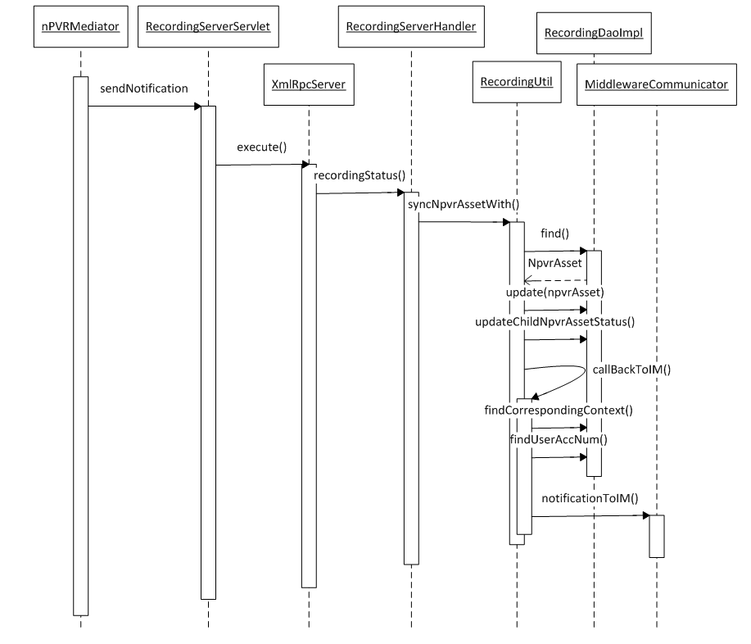

**Figure 119:** Sequence Diagram: Recording Details Update

##### Business Logic

###### com.acn.servlet.NPVRServlet.java

Refer section 5.1.3.1

###### com.acn.application.processors

Refer section 5.1.3.2

###### Objects to lock

None

###### Exceptions

Refer section 5.1.5

###### Database Classes

### Background Processes

#### Manage expired recording cleanup

##### Flow Diagram



**Figure 120:** Flow Diagram: Manage expired recording cleanup

##### Sequence Diagram



**Figure 121:** Sequence Diagram: Manage expired recording cleanup

##### Business Logic

###### com.acn.processes.impl.BackgroundProcess.java

BackgroundProcess class is used to process a background job running at a configurable interval. Singleton service will start the background process. Configurable parameters are done in npvr.properties file.

|  |  |  |
| --- | --- | --- |
| Creating Method | Change Description | Exception |
| public void startProcesses() | This method starts background process. | None |
| public void stopProcesses() | This method stops background process. | None |
| private void scheduleProcess(Process process, String firstStartTimeStr, String intervalStr) | This method schedules background process. | None |

Table 41: BackgroundProcess.java

###### com.acn.processes.impl.MidnightProcess.java

MidnightProcess job delete the expired recordings and send delete request to mediator.

|  |  |  |
| --- | --- | --- |
| Creating Method | Change Description | Exception |
| public void start(long startTime, long interval, RecordingDao recordingDao) | This method starts background process at specific time and at regular interval. | None |
| public void stop() | This method stops background process. | None |
| public void run() | This method executes background process. | None |

Table 42: MidnightProcess.java

###### Objects to lock

None

###### Exceptions

Refer section 5.1.5

###### Database Classes

Refer section 5.9.6.1

#### nPVR user quota check process

##### Flow Diagram

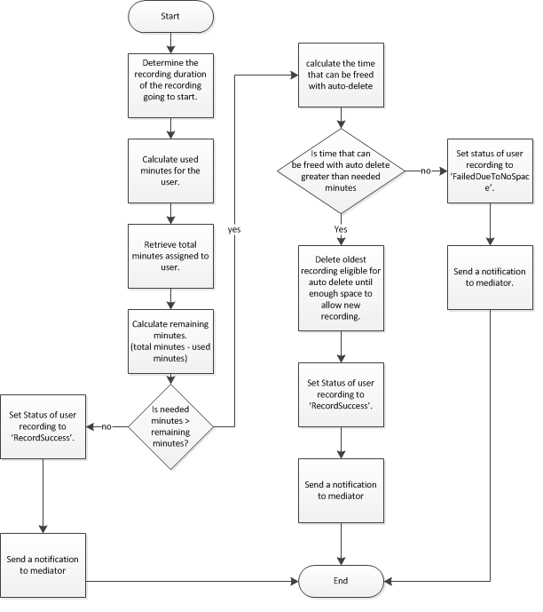

**Figure 122:** Flow Diagram: nPVR user quota check process

##### Sequence Diagram



**Figure 123:** Sequence Diagram: nPVR user quota check process

##### Business Logic

###### com.acn.processes.impl.BackgroundProcess.java

Refer section 5.28.2.1.3.1

###### com.acn.processes.impl.QuotaCheckProcess.java

|  |  |  |
| --- | --- | --- |
| Creating Method | Change Description | Exception |
| public void start(long startTime, long interval, RecordingDao recordingDao) | This method starts background process at specific time and at regular interval. | None |
| public void stop() | This method stops background process. | None |
| public void run() | This method executes background process. | None |

Table 43: QuotaCheckProcess.java

###### Objects to lock

None

###### Exceptions

Refer section 5.1.5

###### Database Classes

Refer section 5.9.6.1

#### nPVR Failed Recordings Retrial Process

##### Flow Diagram



**Figure 124:** Flow Diagram: nPVR Failed recordings retrial process

##### Sequence Diagram



**Figure 125:** Sequence Diagram: nPVR Failed recordings retrial process

##### Business Logic

###### com.acn.processes.impl.BackgroundProcess.java

Refer section 5.28.2.1.3.1

###### com.acn.processes.impl.FailedRecordRetryProcess.java

|  |  |  |
| --- | --- | --- |
| Creating Method | Change Description | Exception |
| public void start(long startTime, long interval, RecordingDao recordingDao) | This method starts background process at specific time and at regular interval. | None |
| public void stop() | This method stops background process. | None |
| private void process() | This method retrieves scheduled failed recordings and retry to schedule these failed recordings. | None |
| public void run() | This method executes background process. | None |

Table 44: FailedRecordRetryProcess.java

###### Objects to lock

None

###### Exceptions

Refer section 5.1.5

###### Database Classes

Refer section 5.9.6.1

#### Reprocessing of recordings on Channel Configuration update

##### Flow Diagram



**Figure 126:** Flow Diagram: Reprocessing of recordings on Channel configuration update

##### Sequence Diagram

Refer section 5.4.2 Sequence Diagram

##### Business Logic

###### Objects to lock

None

###### Exceptions

Refer section 5.1.5

###### Database Classes

None

#### Manage Channel update and User update changes

##### Flow Diagram

Refer section 5.4.1 Flow Diagram and 5.7.1 Flow Diagram

##### Sequence Diagram

Refer section **5.4.2 Sequence Diagram** and **5.7.2 Sequence Diagram**

##### Business Logic

###### Objects to lock

None

###### Exceptions

Refer section 5.1.5

###### Database Classes

None

# Configuration

## JBoss 7.1.1 Configuration

Unzip the JBoss7 package to any location; from now on that location will be referred in this document as ‘JBOSS_HOME’.

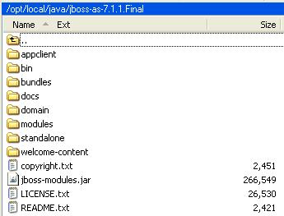

**Figure 127:** Directory structure of JBoss 7.1.1 Final

Application can be deployed in either in standalone (using standalone-full.xml) or clustered mode (using standalone-full-ha.xml)

### Running JBoss 7

* JBoss 7 can be run in standalone mode just by running the following file:-
  + JBOSS_HOME\bin\standalone.sh -c standalone-full.xml
  + Standalone mode configuration and deployment files resides at location - JBOSS_HOME\ standalone
* JBoss 7 can be run in clustered mode just by running the following file:-
  + JBOSS_HOME\bin\standalone.sh -c standalone-full-ha.xml -b 0.0.0.0 -Djboss.server.base.dir=/opt/local/java/jboss-as-7.1.1.Final/standalone -Djboss.node.name=node1 -Djboss.socket.binding.port-offset=100
  + Standalone mode configuration and deployment files resides at location - JBOSS_HOME\ standalone
* Test JBoss by hitting URL – <http://127.0.0.1:8080/>. Welcome page will be displayed.
* JBoss 7 Admin console can be reached at - <http://127.0.0.1:9990/>. But you need to add a management user first by running the following script:-
  + JBOSS_HOME\bin\add-user.sh
  + Add a ‘Management User’ and provide a user / password through which you can later access the JBoss Admin Console for making any changes in the configuration of running mode.

### JBoss 7 – Standalone/Clustered Mode Deployment

1. Go into the directory JBOSS_HOME\standalone\deployments\
2. Copy the “nPVRBackend.ear”
3. Verify that – “JBOSS_HOME\modules\com\mysql\main\” should contain the following files:-

|  |
| --- |
|  |

**Figure 128:** Contents of module – com.mysql.main

1. Verify that – “JBOSS_HOME\modules\org\apache\xmlrpc\main\” should contain the following files:-

|  |
| --- |
|  |

**Figure 129:** Contents of module – org.apache.xmlrpc.main

1. Go to “*JBOSS_HOME\standalone\configuration*” and copy/replace all the files provided with the existing ones:
   * standalone-full.xml – Contains standalone mode configurations.
   * standalone-full-ha.xml - Contains standalone mode HA configurations.
   * npvr.properties - Contains npvr be specific configurational properties.
2. Open console and navigate to “JBOSS_HOME\bin”.
3. Run the following command - ./standalone.sh -c standalone-full.xml” or “./standalone.sh -c standalone-full-ha.xml -b 0.0.0.0 -Djboss.server.base.dir=/opt/local/java/jboss-as-7.1.1.Final/standalone -Djboss.node.name=node1 -Djboss.socket.binding.port-offset=100”

Please refer the JBoss Admin Guide and following links for setting up environment correctly:-

* <https://community.jboss.org/wiki/JBossAdminGuide>
* [https://docs.jboss.org/author/display/AS71/Admin+Guide#AdminGuide-StandaloneServer](https://docs.jboss.org/author/display/AS71/Admin+Guide%23AdminGuide-StandaloneServer)

## MySQL Configuration

1. Install “MySQL 5.6.19 Community Server” package.
2. Open mysql console and run the provided sql scripts in following order:-
   1. nPVR_DB_UserCreation_mysql.sql
   2. nPVR_DB_HE4.0.01-mysql.sql

Note: First sql script creates specific user / password that will be used to authenticate datasource connection between JBoss and MySql. If you are changing the user/password here, you have to provide to the same user/password in “standalone-full.xml” and “standalone-full-ha.xml” file under <datasources> subsystem section for MySql Datasource.

Find below the extract of the standard Datasources subsystem configuration under *standalone-full.xml* & standalone-full-ha.xml profile:

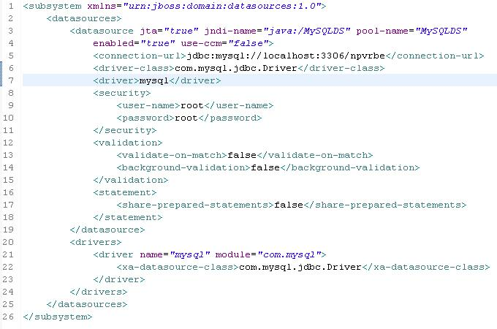

Figure 130: Datasource configuration in standalone-full.xml / standalone-full-ha.xml

* Note that the above datasource setting uses the driver - “mysql” located under JBoss module - “com.mysql”. Make sure that module already exists.
* If both MySQL DB and JBoss are **NOT** installed of same machine, then make sure that ***<connection-url>*** depicted above correctly reflects the ***IP:Port*** where MySQL is located, instead of *localhost*.

## Trigger Server External Configuration

### JBoss 7 - JMS configuration

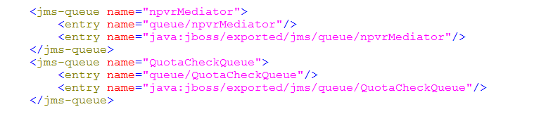

**Figure 131** JMS Queue Settings

### JBoss 7 - Logging Configuration

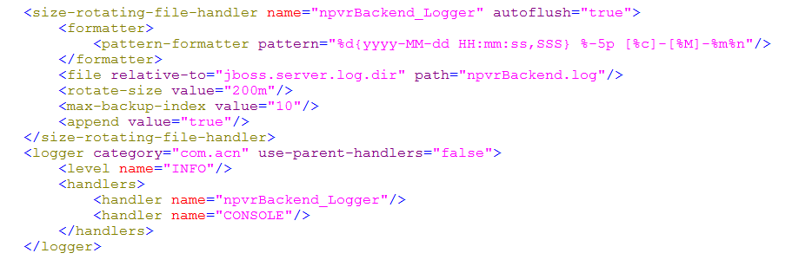

**Figure 132:** JBoss - Logging Configuration

### JBoss 7 – Interfaces and Ports Configuration

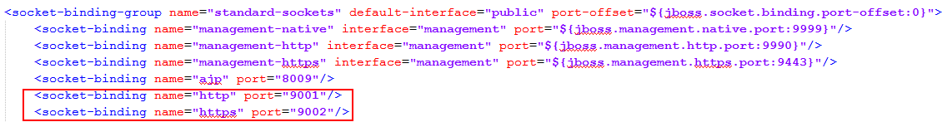

**Figure 133:** JBoss Interfaces and Port settings (in standalone-full.xml/standalone-full-ha.xml)

* Change the default standard JBoss ports here specific to JBoss mode, if required.

|  |
| --- |
|  |

**Figure 134:** Cluster Settings

|  |
| --- |
|  |

**Figure 135** Jboss Availability from different machine

In order to make JBOSS accessible from different machines, we have changed the public interface settings from “127.0.0.1” to “0.0.0.0”.

### JBoss 7 – Security Settings

|  |
| --- |
|  |

**Figure 136**: Security Settings

# Imported Interfaces

None

# Database Migration/Upgrade

|  |  |  |  |  |  |
| --- | --- | --- | --- | --- | --- |
| **Feature** | **DB schema has new classes** | **DB Schema update old  classes** | **Migration Instantiate new objects** | **Migration update old objects** | **Tool required** |
| nPVR Backend DB | Yes | No | No | No | No |

Table 45: DB Migration effects

## nPVR BE Data Model

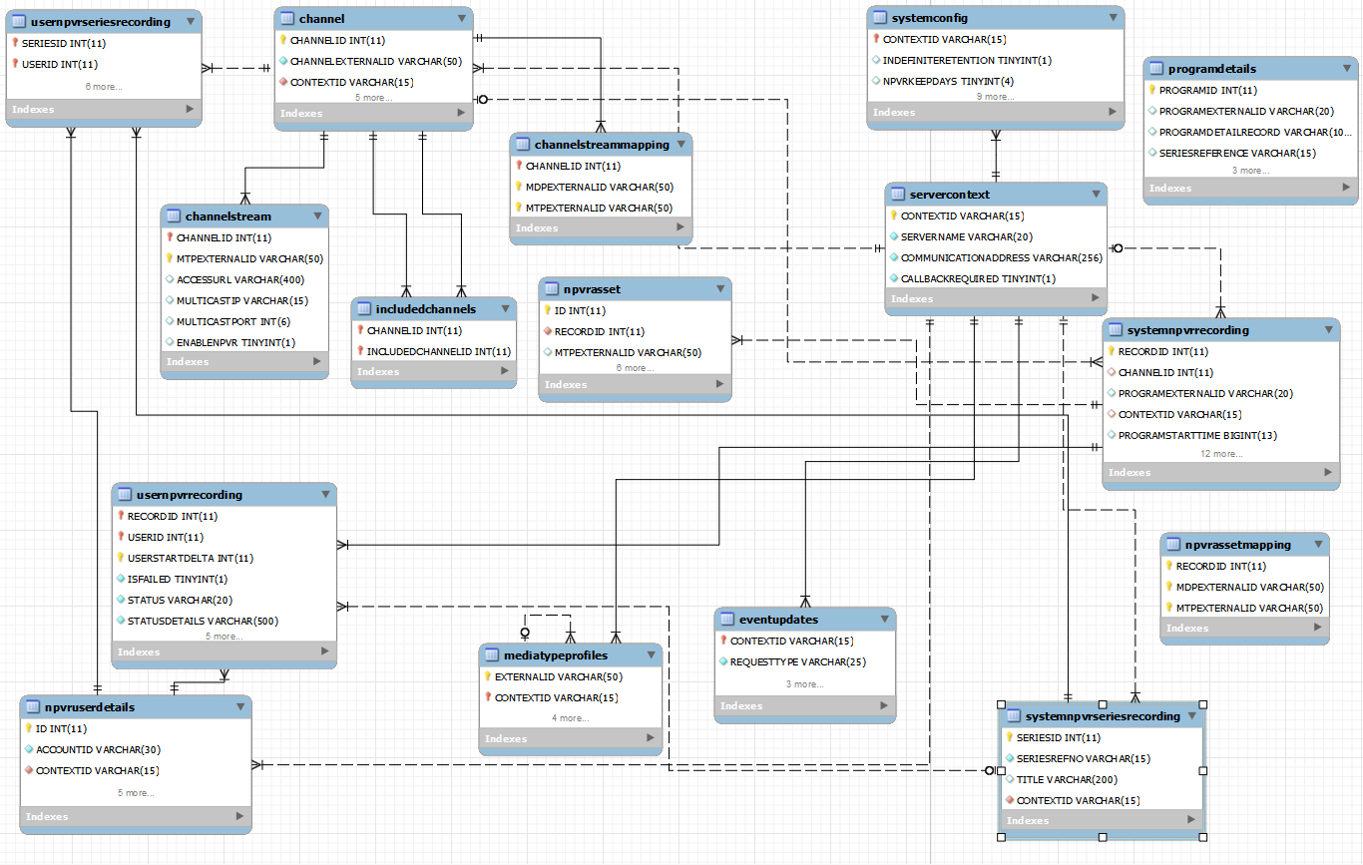

### Schema

The schema name of nPVR Backend Server is named as ‘**npvrbe**’.

|  |  |
| --- | --- |
| **nPVR BE SCHEMA Properties** | |
|  |  |
| Name | **nPVRBE** |
| Collation | Utf8 – default collation |

Table 46: nPVR Backend Scheme properties

.

### Tables

The following database tables are required under schema – ‘**npvrbe**’.

|  |  |  |  |
| --- | --- | --- | --- |
| **Table Name:** SYSTEMNPVRRECORDING | | | |
| **Field** | **Type** | **Constraints** | **Description** |
| RECORDID | INT(11) | PK | System generated identifier of system recording. |
| CHANNELID | INT (11) | FK | System generated channel identifier. |
| PROGRAMEXTERNALID | VARCHAR(20) | NOT NULL | Program external Id as recognized by IM. |
| CONTEXTID | VARCHAR(15) | FK | IM context Id |
| PROGRAMSTARTTIME | BIGINT(13) | NOT NULL |  |
| PROGRAMDURATION | SMALLINT (3) | NOT NULL |  |
| RECORDINGDURATION | SMALLINT (3) | NOT NULL |  |
| ENABLENPVRTRICKPLAY | TINYINT (1) |  |  |
| ENABLENPVRSKIPJUMP | TINYINT (1) |  |  |
| EVENTUPDATESTATUS | VARCHAR(10) |  |  |
| SCHEDULEQUALIFIER1 | VARCHAR(640) |  |  |
| SCHEDULEQUALIFIER2 | VARCHAR(640) |  |  |
| SCHEDULEQUALIFIER3 | VARCHAR(640) |  |  |
| SCHEDULEQUALIFIER4 | VARCHAR(640) |  |  |
| SCHEDULEQUALIFIER5 | VARCHAR(640) |  |  |
| EPISODESCOPE | VARCHAR(5) |  |  |
| CHANNELLANGUAGE | VARCHAR(20) |  |  |
| RECORDINGSTARTTIME | BIGINT(13) | NOT NULL |  |

|  |  |  |  |
| --- | --- | --- | --- |
| **Table Name:** USERNPVRRECORDING | | | |
| **Field** | **Type** | **Constraints** | **Description** |
| RECORDID | BIGINT (11) | PK, FK | Composite Key for USERNPVRRECORDING table.  User start delta in Milliseconds |
| USERID | BIGINT (11) | PK, FK |
| USERSTARTDELTA | BIGINT (11) | PK |
| ISFAILED | TINYINT (1) | NOT NULL |  |
| STATUS | VARCHAR(20) | NOT NULL |  |
| STATUSDETAILS | VARCHAR(500) | NOT NULL |  |
| DELETEWHENSPACENEEDED | TINYINT (1) | NOT NULL |  |
| SERIESID | BIGINT (11) |  |  |
| USERSTOPDELTA | BIGINT (11) | NOT NULL | User stop delta in Milliseconds |
| MARKEDFORDELETE | TINYINT (1) | NOT NULL | Default 0 |
| ACTUALRECORDINGSECONDS | BIGINT (11) | NOT NULL |  |

|  |  |  |  |
| --- | --- | --- | --- |
| **Table Name:** SYSTEMNPVRSERIESRECORDING | | | |
| **Field** | **Type** | **Constraints** | **Description** |
| SERIESID | BIGINT (11) | PK | System generated unique identifier. |
| SERIESREFNO | VARCHAR(15) | NOT NULL | Series unique identifier as recognized by IM |
| TITLE | VARCHAR(200) |  |  |
| CONTEXTID | VARCHAR(15) | FK | IM context Id |

|  |  |  |  |
| --- | --- | --- | --- |
| **Table Name:** USERNPVRSERIESRECORDING | | | |
| **Field** | **Type** | **Constraints** | **Description** |
| SERIESID | BIGINT (11) | PK, FK | Composite Key |
| USERID | BIGINT (11) | PK, FK |
| CHANNELID | BIGINT (11) | FK |  |
| DELETEWHENSPACENEEDED | TINYINT (1) | NOT NULL |  |
| CHANNELBOUND | TINYINT (1) | NOT NULL |  |
| EPISODESCOPE | VARCHAR(8) | NOT NULL |  |
| EPISODESTOKEEP | SMALLINT (4) | NOT NULL |  |
| SCHEDULETIMESTAMP | TIMESTAMP(6) | NOT NULL |  |

|  |  |  |  |
| --- | --- | --- | --- |
| **Table Name:** NPVRASSET | | | |
| **Field** | **Type** | **Constraints** | **Description** |
| ID | BIGINT(11) | PK | System generated recording asset identifier. |
| RECORDID | BIGINT(11) | FK |  |
| MTPEXTERNALID | VARCHAR(50) | NOT NULL |  |
| ASSETURL | VARCHAR(450) | NOT NULL |  |
| STATUS | VARCHAR(20) | NOT NULL |  |
| STATUSDETAIL | VARCHAR(500) | NOT NULL |  |
| ASSETSTARTDELTA | BIGINT(11) |  |  |
| ASSETPROFILE | VARCHAR(500) |  |  |
| PARENTASSETID | BIGINT(11) |  | Reference to parent asset ID. |

|  |  |  |  |
| --- | --- | --- | --- |
| **Table Name:** PROGRAMDETAILS | | | |
| **Field** | **Type** | **Constraints** | **Description** |
| PROGRAMID | BIGINT (11) | PK | System generated unique identifier |
| PROGRAMEXTERNALID | VARCHAR(20) | NOT NULL | External unique identifier as recognized by IM. |
| PROGRAMTITLE | VARCHAR(128) | NOT NULL | Title of the program |
| PROGRAMDETAILRECORD | VARCHAR(1000) | NOT NULL | Pipe separated program metdata string. |
| SERIESREFERENCE | VARCHAR(15) |  | Series reference as recognized by IM. |
| EPISODEID | VARCHAR(5) |  | Episode Id corresponding to the series as recognized by IM. |
| CONTEXTID | VARCHAR(15) | FK |  |

|  |  |  |  |
| --- | --- | --- | --- |
| **Table Name:** CHANNEL | | | |
| **Field** | **Type** | **Constraints** | **Description** |
| CHANNELID | BIGINT (11) | PK | System generated unique identifier. |
| CHANNELEXTERNALID | VARCHAR(50) | NOT NULL | Channel external Id as recognized by IM |
| CONTEXTID | VARCHAR(15) | FK |  |
| ENABLENPVR | TINYINT (1) |  |  |
| ENABLETRICKPLAY | TINYINT (1) |  |  |
| ENABLESKIPJUMP | TINYINT (1) |  |  |
| ASSETPROFILE | VARCHAR(500) |  |  |
| LANGUAGE | VARCHAR(20) |  |  |

|  |  |  |  |
| --- | --- | --- | --- |
| **Table Name:** CHANNELSTREAMMAPPING | | | |
| **Field** | **Type** | **Constraints** | **Description** |
| CHANNELID | BIGINT (11) | PK | Composite Key |
| MDPEXTERNALID | VARCHAR(50) | PK |
| MTPEXTERNALID | VARCHAR(50) | PK |

|  |  |  |  |
| --- | --- | --- | --- |
| **Table Name:** CHANNELSTREAM | | | |
| **Field** | **Type** | **Constraints** | **Description** |
| CHANNELID | BIGINT (11) | PK, FK | Composite Key |
| MTPEXTERNALID | VARCHAR(50) | PK |
| ACCESSURL | VARCHAR(400) |  |  |
| MULTICASTIP | VARCHAR(15) |  |  |
| MULTICASTPORT | INT (6) |  |  |
| ENABLENPVR | TINYINT (1) | NOT NULL | Default 1 |

|  |  |  |  |
| --- | --- | --- | --- |
| **Table Name:** INCLUDEDCHANNELS | | | |
| **Field** | **Type** | **Constraints** | **Description** |
| CHANNELID | BIGINT (11) | PK, FK | Composite Key |
| INCLUDEDCHANNELID | BIGINT (11) | PK, FK |

|  |  |  |  |
| --- | --- | --- | --- |
| **Table Name:** SERVERCONTEXT | | | |
| **Field** | **Type** | **Constraints** | **Description** |
| CONTEXTID | VARCHAR(15) | PK | Context Id of the registered IM.  For default context, context Id will be ‘Default’ |
| SERVERNAME | VARCHAR(20) | NOT NULL | Name of the registered IM  For default context, value will be ‘Default’ |
| COMMUNICATIONADDRESS | VARCHAR(256) | NOT NULL | Fully qualified address URL of the IM interface to communicate back,  For default context, value will be ‘Default’ |
| CALLBACKREQUIRED | TINYINT (1) | NOT NULL | Default 0 |

|  |  |  |  |
| --- | --- | --- | --- |
| **Table Name:** EVENTUPDATES | | | |
| **Field** | **Type** | **Constraints** | **Description** |
| CONTEXTID | VARCHAR(15) | FK | Context Id of the registered IM. |
| REQUESTTYPE | VARCHAR(25) | NOT NULL | Its value can be one of the following:   * ScheduleUpdate * SeriesUpdate * ProgramMetadataUpdate |
| REQUESTTIME | TIMESTAMP(6) | NOT NULL | Time of notification received. |
| REQUESTSTATUS | VARCHAR(20) | NOT NULL | Current state of notification processing   * Received * Processed |
| RESPONSEFORMAT | VARCHAR(20) | NOT NULL |  |

|  |  |  |  |
| --- | --- | --- | --- |
| **Table Name:** SYSTEMCONFIG | | | |
| **Field** | **Type** | **Constraints** | **Description** |
| CONTEXTID | VARCHAR(15) | PK | For default context, value will be ‘Default’ |
| INDEFINITERETENTION | TINYINT (1) |  | For default context, value will be 0 |
| NPVRKEEPDAYS | SMALLINT (3) |  | For default context, value will be 30 |
| PREMINUTES | SMALLINT (3) |  | For default context, value will be 5 |
| POSTMINUTES | SMALLINT (3) |  | For default context, value will be 5 |
| ENABLESTARTSTOPMARK | TINYINT (1) |  | For default context, value will be 1 |
| CONCURRENTRECORDINGSLIMIT | TINYINT (2) |  | For default context, value will be 0 |
| NPVRFINITERETENTIONTIMESTAMP | TIMESTAMP(6) |  |  |
| KEEPFAILEDRECORDINGDAYS | SMALLINT (3) |  | For default context, value will be 0 |
| HTTPRECORDINGPATH | VARCHAR(256) |  |  |
| SMOOTHSTREAMINGRECORDINGPATH | VARCHAR(256) |  |  |
| PRECORDINGPATH3GP | VARCHAR(256) |  |  |
| CURRENTEPGVERSION | VARCHAR(20) |  | The version of the last updated EPG in nPVR BE corresponding to an IM. |

|  |  |  |  |
| --- | --- | --- | --- |
| **Table Name:** MEDIATYPEPROFILES | | | |
| **Field** | **Type** | **Constraints** | **Description** |
| EXTERNALID | VARCHAR(50) | PK | Composite Key |
| CONTEXTID | VARCHAR(15) | PK, FK |
| PROTOCOL | VARCHAR(55) | NOT NULL |  |
| BITRATE | VARCHAR(55) | NOT NULL |  |
| NPVRKEEPDAYS | SMALLINT (3) |  |  |
| PARENTEXTERNALID | VARCHAR(50) |  | Reference to ExternalID of parent MTP. |

|  |  |  |  |
| --- | --- | --- | --- |
| **Table Name:** NPVRUSERDETAILS | | | |
| **Field** | **Type** | **Constraints** | **Description** |
| ID | BIGINT(11) | PK | System generated unique user identifier. |
| ACCOUNTID | VARCHAR(30) | NOT NULL | Unique user identifier as recognized by IM. |
| CONTEXTID | VARCHAR(15) | FK |  |
| CONCURRENTRECORDINGSLIMIT | TINYINT (2) |  |  |
| TOTALMINUTES | INT (6) | NOT NULL |  |
| NPVRKEEPDAYS | TINYINT (3) |  |  |
| ENABLEDSERIES | TINYINT (1) | NOT NULL | Default 0 |

|  |  |  |  |
| --- | --- | --- | --- |
| **Table Name:** USERCHANNELS | | | |
| **Field** | **Type** | **Constraints** | **Description** |
| USERID | BIGINT(11) | PK, FK | Composite key  USERID: System generated unique user identifier referring to NPVRUSERDETAILS table.  CHANNELID: System generated unique channel identifier referring to CHANNEL table. |
| CHANNELID | BIGINT(11) | PK, FK |

### DB Script

|  |
| --- |
|  |

Table 47: Attachement: DB Script - nPVR Backend

### Database Patch

Refer section 7.1.3

# Installation

## nPVR BE Deployment

1. Create database schema using dbpatch nPVR_DB_HE4.0.01mysql.sql. Download it from <https://10.196.5.10/builds.acn/he40.dev/npvrBackend/>[he40.dev-npvrBackenddbpatches-2.tar](https://10.196.5.10/builds.acn/he40.dev/npvrBackend/he40.dev-npvrBackenddbpatches-1.tar)
2. Create user in npvrbe database.

DROP USER 'root'@'localhost';

CREATE USER 'root'@'%' IDENTIFIED BY 'root';

GRANT ALL PRIVILEGES ON *.* TO 'root'@'%'  WITH GRANT OPTION;

1. Update jboss config directories “**standalone**” and “**modules**” in /opt/local/java/jboss-as-7.1.1.Final directory. Download it from <https://10.196.5.10/builds.acn/he40.dev/npvrBackend/he40.dev-npvrBackendjbossconfig-2.tar>
2. Download latest build npvrbe  from <https://10.196.5.10/builds.acn/he40.dev/npvrBackend/>[he40.dev-npvrBackend-1.tar.gz](https://10.196.5.10/builds.acn/he40.dev/npvrBackend/he40.dev-npvrBackend-1.tar.gz)  and copy file  “**nPVRBackend.ear**” in /opt/local/java/jboss-as-7.1.1.Final/standalone/deployments directory.
3. Change DB data source in /opt/local/java/jboss-as-7.1.1.Final/standalone/Configuration/standalone-full-ha.xml file

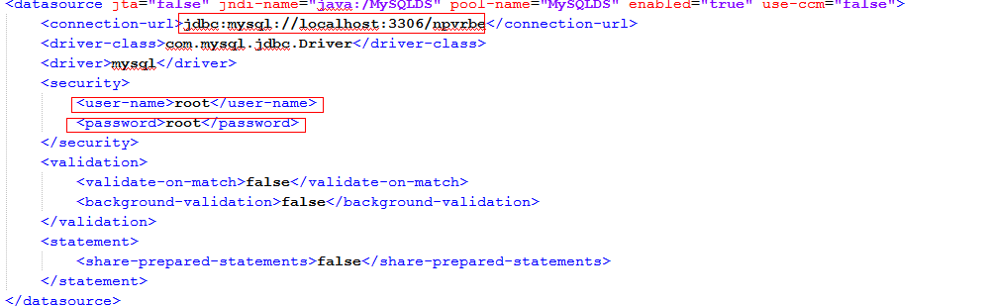

1. For secure communication create the keystore using the command  keytool for e.g.

#keytool -genkey -alias tomcat -keyalg RSA –keystore https.keystore

1. Create Keypair  using the JDK key tool
2. Then cd to the  following location in the server : /opt/local/java/jboss-as-7.1.1.Final/standalone/configuration
3. Vi standalone-full-ha.xml
4. Provide the following entry in this file:

<connector name="https" protocol="HTTP/1.1" scheme="https" socket-binding="https" secure="true">

<ssl password="mykeystore" certificate-key-file="/${jboss.server.config.dir}/https.keystore" protocol="TLSv1" verify-client="false" certificate-file="/${jboss.server.config.dir}/https.keystore"/>

</connector>

1. Restart the standalone service
2. Check : netstat –an | grep 9001

& netstat –an | grep 9002

1. It should show both the ports in listening stage.
2. Check the url  : <http://10.125.133.202:9001/nPVRBackend/userConfiguration>

<https://10.125.133.202:9002/nPVRBackend/userConfiguration>

1. It should give a response.
2. To setup communication in multiple nPVRBE, update following entries in “standalone-full-ha.xml”

<protocol type="TCPPING">

<property name="initial_hosts">

10.10.10.10[7600],10.10.10.10[7600]

</property>

<property name="num_initial_members">

2

</property>

<property name="port_range">

0

</property>

<property name="timeout">

2000

</property>

</protocol>

1. Start Application

**Run Single NPVRBE**

standalone.bat -c standalone-full-ha.xml -b 10.125.133.98 -Djboss.server.base.dir=C:/jboss7/standalone -Djboss.node.name=node2

**Run Multiple NPVRBE in cluster**

./standalone.sh -c standalone-full-ha.xml -b 0.0.0.0 -Djboss.server.base.dir=/opt/local/java/jboss-as-7.1.1.Final/standalone -Djboss.node.name=node2 -Djboss.socket.binding.port-offset=100

Use different port offset for each instance of jboss if running on same machine

1. Check “/opt/local/java/jboss-as-7.1.1.Final/standalone/log/server.log” for deployment. Search for log [org.jboss.as.server]-[execute]-JBAS018559: Deployed "nPVRBackend.ear". It confirms that build deployed successfully.

# Unit Tests

|  |
| --- |
| **Error! Not a valid link.** **Error! Not a valid link.** |

Figure 137: nPVRBE Unit Test

|  |  |  |  |
| --- | --- | --- | --- |
| *Test Class* | **Test Case**  **(method name)** | **Functional Description**  **(what is going to be tested)** | **Sprint number**  **(note: sprint (s) when it’s planned to run the test)** |
|  |  |  |  |
|  |  |  |  |

Table 48: Unit Tests

# Design Specification Reviewers List & Template

*********** This chapter is Mandatory ***********************

The scope of the next file is to identify specific Design Specifications mandatory and optional reviewers.

Next document refers to Review Report Template.